JAVA SCRIPT

# WEEK1

## JavaScript Introduction

### Overview

JavaScript is a popular, well-supported programming language that is used to create interactive and dynamic web pages and applications. It is used to create web, mobile, and desktop applications. It is a high-level, interpreted language that is designed to run in web browsers. JavaScript can also be used on the server-side with the help of Node.js.

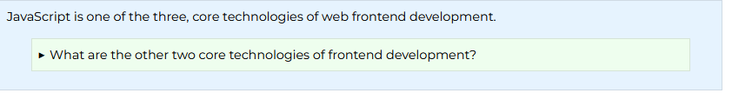

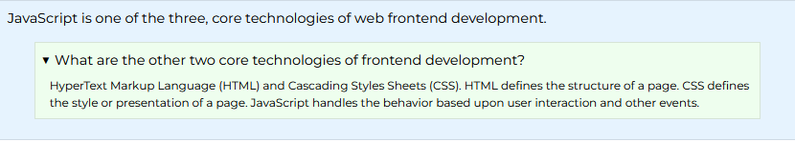

### Prepare

**What is JavaScript?**

A high-level definition

JavaScript is a scripting or programming language that allows you to implement complex features on web pages — every time a web page does more than just sit there and display static information for you to look at — displaying timely content updates, interactive maps, animated 2D/3D graphics, scrolling video jukeboxes, etc. — you can bet that JavaScript is probably involved. It is the third layer of the layer cake of standard web technologies, two of which ([HTML](https://developer.mozilla.org/en-US/docs/Learn/HTML) and [CSS](https://developer.mozilla.org/en-US/docs/Learn/CSS)) we have covered in much more detail in other parts of the Learning Area.

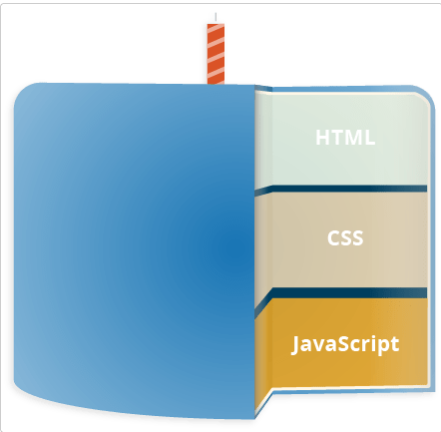

[HTML](https://developer.mozilla.org/en-US/docs/Glossary/HTML) is the markup language that we use to structure and give meaning to our web content, for example defining paragraphs, headings, and data tables, or embedding images and videos in the page.

[CSS](https://developer.mozilla.org/en-US/docs/Glossary/CSS) is a language of style rules that we use to apply styling to our HTML content, for example setting background colors and fonts, and laying out our content in multiple columns.

[JavaScript](https://developer.mozilla.org/en-US/docs/Glossary/JavaScript) is a scripting language that enables you to create dynamically updating content, control multimedia, animate images, and pretty much everything else. (Okay, not everything, but it is amazing what you can achieve with a few lines of JavaScript code.)

The three layers build on top of one another nicely. Let's take a button as an example. We can mark it up using HTML to give it structure and purpose:

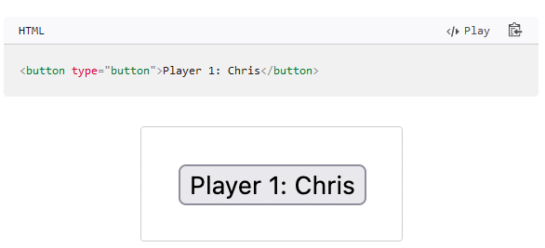

Then we can add some CSS into the mix to get it looking nice:

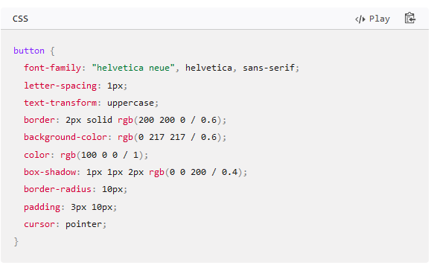

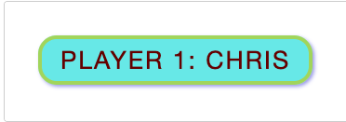

And finally, we can add some JavaScript to implement dynamic behavior:

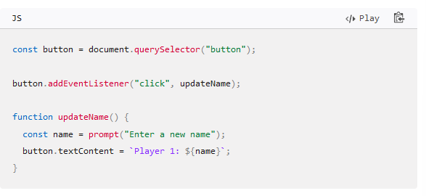

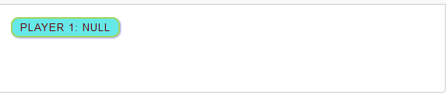

Try clicking on this last version of the text label to see what happens (note also that you can find this demo on GitHub — see the [source code](https://github.com/mdn/learning-area/blob/main/javascript/introduction-to-js-1/what-is-js/javascript-label.html), or [run it live](https://mdn.github.io/learning-area/javascript/introduction-to-js-1/what-is-js/javascript-label.html))!

JavaScript can do a lot more than that — let's explore what in more detail.

**So what can it really do?**

The core client-side JavaScript language consists of some common programming features that allow you to do things like:

* Store useful values inside variables. In the above example for instance, we ask for a new name to be entered then store that name in a variable called name.
* Operations on pieces of text (known as "strings" in programming). In the above example we take the string "Player 1: " and join it to the name variable to create the complete text label, e.g. "Player 1: Chris".
* Running code in response to certain events occurring on a web page. We used a [click](https://developer.mozilla.org/en-US/docs/Web/API/Element/click_event) event in our example above to detect when the label is clicked and then run the code that updates the text label.
* And much more!

What is even more exciting however is the functionality built on top of the client-side JavaScript language. So-called Application Programming Interfaces (APIs) provide you with extra superpowers to use in your JavaScript code.

APIs are ready-made sets of code building blocks that allow a developer to implement programs that would otherwise be hard or impossible to implement. They do the same thing for programming that ready-made furniture kits do for home building — it is much easier to take ready-cut panels and screw them together to make a bookshelf than it is to work out the design yourself, go and find the correct wood, cut all the panels to the right size and shape, find the correct-sized screws, and then put them together to make a bookshelf.

They generally fall into two categories.

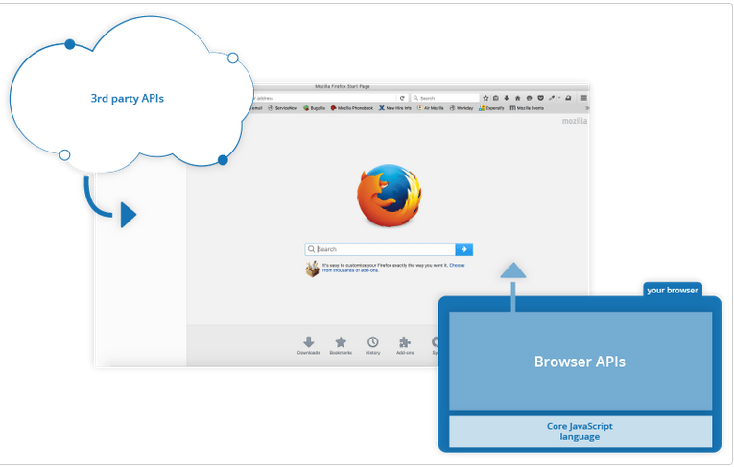

**Browser APIs** are built into your web browser, and are able to expose data from the surrounding computer environment, or do useful complex things. For example:

* The [DOM (Document Object Model) API](https://developer.mozilla.org/en-US/docs/Web/API/Document_Object_Model) allows you to manipulate HTML and CSS, creating, removing and changing HTML, dynamically applying new styles to your page, etc. Every time you see a popup window appear on a page, or some new content displayed (as we saw above in our simple demo) for example, that's the DOM in action.
* The [Geolocation API](https://developer.mozilla.org/en-US/docs/Web/API/Geolocation) retrieves geographical information. This is how [Google Maps](https://www.google.com/maps) is able to find your location and plot it on a map.
* The [Canvas](https://developer.mozilla.org/en-US/docs/Web/API/Canvas_API) and [WebGL](https://developer.mozilla.org/en-US/docs/Web/API/WebGL_API) APIs allow you to create animated 2D and 3D graphics. People are doing some amazing things using these web technologies — see [Chrome Experiments](https://experiments.withgoogle.com/collection/chrome) and [webglsamples](https://webglsamples.org/).
* [Audio and Video APIs](https://developer.mozilla.org/en-US/docs/Web/Media/Audio_and_video_delivery) like [HTMLMediaElement](https://developer.mozilla.org/en-US/docs/Web/API/HTMLMediaElement) and [WebRTC](https://developer.mozilla.org/en-US/docs/Web/API/WebRTC_API) allow you to do really interesting things with multimedia, such as play audio and video right in a web page, or grab video from your web camera and display it on someone else's computer (try our simple [Snapshot demo](https://chrisdavidmills.github.io/snapshot/) to get the idea).

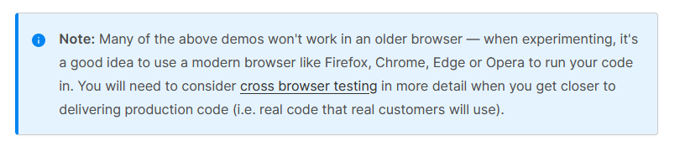

**Third party APIs** are not built into the browser by default, and you generally have to grab their code and information from somewhere on the Web. For example:

* The [Twitter API](https://developer.twitter.com/en/docs) allows you to do things like displaying your latest tweets on your website.
* The [Google Maps API](https://developers.google.com/maps/) and [OpenStreetMap API](https://wiki.openstreetmap.org/wiki/API) allows you to embed custom maps into your website, and other such functionality.

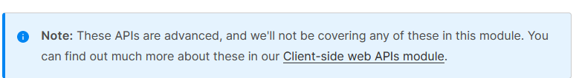

There's a lot more available, too! However, don't get over excited just yet. You won't be able to build the next Facebook, Google Maps, or Instagram after studying JavaScript for 24 hours — there are a lot of basics to cover first. And that's why you're here — let's move on!.

[**What is JavaScript doing on your page?**](https://developer.mozilla.org/en-US/docs/Learn/JavaScript/First_steps/What_is_JavaScript#what_is_javascript_doing_on_your_page)

Here we'll actually start looking at some code, and while doing so, explore what actually happens when you run some JavaScript in your page.

Let's briefly recap the story of what happens when you load a web page in a browser (first talked about in our [How CSS works](https://developer.mozilla.org/en-US/docs/Learn/CSS/First_steps/How_CSS_works#how_does_css_actually_work) article). When you load a web page in your browser, you are running your code (the HTML, CSS, and JavaScript) inside an execution environment (the browser tab). This is like a factory that takes in raw materials (the code) and outputs a product (the web page).

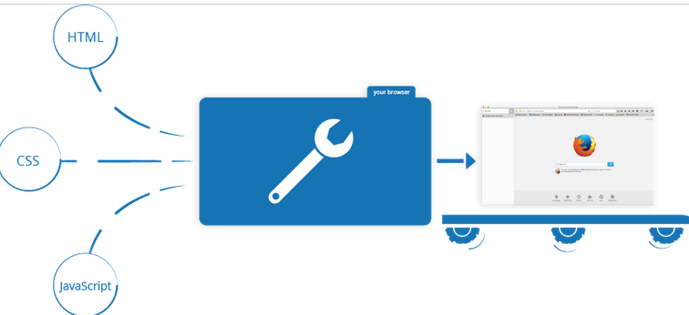

A very common use of JavaScript is to dynamically modify HTML and CSS to update a user interface, via the Document Object Model API (as mentioned above). Note that the code in your web documents is generally loaded and executed in the order it appears on the page. Errors may occur if JavaScript is loaded and run before the HTML and CSS that it is intended to modify. You will learn ways around this later in the article, in the [Script loading strategies](https://developer.mozilla.org/en-US/docs/Learn/JavaScript/First_steps/What_is_JavaScript#script_loading_strategies) section.

[**Browser security**](https://developer.mozilla.org/en-US/docs/Learn/JavaScript/First_steps/What_is_JavaScript#browser_security)

Each browser tab has its own separate bucket for running code in (these buckets are called "execution environments" in technical terms) — this means that in most cases the code in each tab is run completely separately, and the code in one tab cannot directly affect the code in another tab — or on another website. This is a good security measure — if this were not the case, then pirates could start writing code to steal information from other websites, and other such bad things.

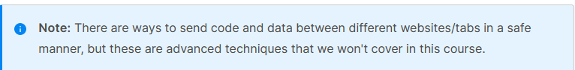

[**JavaScript running order**](https://developer.mozilla.org/en-US/docs/Learn/JavaScript/First_steps/What_is_JavaScript#javascript_running_order)

When the browser encounters a block of JavaScript, it generally runs it in order, from top to bottom. This means that you need to be careful what order you put things in. For example, let's return to the block of JavaScript we saw in our first example:

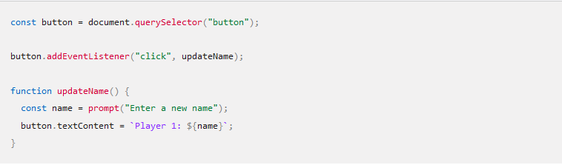

Here we are selecting a button (line 1), then attaching an event listener to it (line 3) so that when the button is clicked, the updateName() code block (lines 5–8) is run. The updateName() code block (these types of reusable code blocks are called "functions") asks the user for a new name, and then inserts that name into the button text to update the display.

If you swapped the order of the first two lines of code, it would no longer work — instead, you'd get an error returned in the [browser developer console](https://developer.mozilla.org/en-US/docs/Learn/Common_questions/Tools_and_setup/What_are_browser_developer_tools) — Uncaught ReferenceError: Cannot access 'button' before initialization. This means that the button object has not been initialized yet, so we can't add an event listener to it.

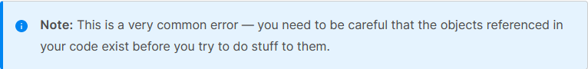

**Interpreted versus compiled code**

You might hear the terms **interpreted** and **compiled** in the context of programming. In interpreted languages, the code is run from top to bottom and the result of running the code is immediately returned. You don't have to transform the code into a different form before the browser runs it. The code is received in its programmer-friendly text form and processed directly from that.

Compiled languages on the other hand are transformed (compiled) into another form before they are run by the computer. For example, C/C++ are compiled into machine code that is then run by the computer. The program is executed from a binary format, which was generated from the original program source code.

JavaScript is a lightweight interpreted programming language. The web browser receives the JavaScript code in its original text form and runs the script from that. From a technical standpoint, most modern JavaScript interpreters actually use a technique called **just-in-time compiling** to improve performance; the JavaScript source code gets compiled into a faster, binary format while the script is being used, so that it can be run as quickly as possible. However, JavaScript is still considered an interpreted language, since the compilation is handled at run time, rather than ahead of time.

There are advantages to both types of language, but we won't discuss them right now.

[**Server-side versus client-side code**](https://developer.mozilla.org/en-US/docs/Learn/JavaScript/First_steps/What_is_JavaScript#server-side_versus_client-side_code)

You might also hear the terms **server-side** and **client-side** code, especially in the context of web development. Client-side code is code that is run on the user's computer — when a web page is viewed, the page's client-side code is downloaded, then run and displayed by the browser. In this module we are explicitly talking about **client-side JavaScript**.

Server-side code on the other hand is run on the server, then its results are downloaded and displayed in the browser. Examples of popular server-side web languages include PHP, Python, Ruby, ASP.NET, and even JavaScript! JavaScript can also be used as a server-side language, for example in the popular Node.js environment — you can find out more about server-side JavaScript in our [Dynamic Websites – Server-side programming](https://developer.mozilla.org/en-US/docs/Learn/Server-side) topic.

[**Dynamic versus static code**](https://developer.mozilla.org/en-US/docs/Learn/JavaScript/First_steps/What_is_JavaScript#dynamic_versus_static_code)

The word **dynamic** is used to describe both client-side JavaScript, and server-side languages — it refers to the ability to update the display of a web page/app to show different things in different circumstances, generating new content as required. Server-side code dynamically generates new content on the server, e.g. pulling data from a database, whereas client-side JavaScript dynamically generates new content inside the browser on the client, e.g. creating a new HTML table, filling it with data requested from the server, then displaying the table in a web page shown to the user. The meaning is slightly different in the two contexts, but related, and both approaches (server-side and client-side) usually work together.

A web page with no dynamically updating content is referred to as **static** — it just shows the same content all the time.

[**How do you add JavaScript to your page?**](https://developer.mozilla.org/en-US/docs/Learn/JavaScript/First_steps/What_is_JavaScript#how_do_you_add_javascript_to_your_page)

JavaScript is applied to your HTML page in a similar manner to CSS. Whereas CSS uses [<link>](https://developer.mozilla.org/en-US/docs/Web/HTML/Element/link) elements to apply external stylesheets and [<style>](https://developer.mozilla.org/en-US/docs/Web/HTML/Element/style) elements to apply internal stylesheets to HTML, JavaScript only needs one friend in the world of HTML — the [<script>](https://developer.mozilla.org/en-US/docs/Web/HTML/Element/script) element. Let's learn how this works.

[**Internal JavaScript**](https://developer.mozilla.org/en-US/docs/Learn/JavaScript/First_steps/What_is_JavaScript#internal_javascript)

1. First of all, make a local copy of our example file [apply-javascript.html](https://github.com/mdn/learning-area/blob/main/javascript/introduction-to-js-1/what-is-js/apply-javascript.html). Save it in a directory somewhere sensible.
2. Open the file in your web browser and in your text editor. You'll see that the HTML creates a simple web page containing a clickable button.
3. Next, go to your text editor and add the following in your head — just before your closing </head> tag:

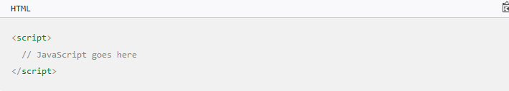

1. Now we'll add some JavaScript inside our [<script>](https://developer.mozilla.org/en-US/docs/Web/HTML/Element/script) element to make the page do something more interesting — add the following code just below the "// JavaScript goes here" line:

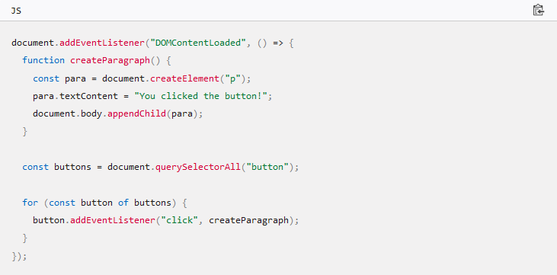

1. Save your file and refresh the browser — now you should see that when you click the button, a new paragraph is generated and placed below.

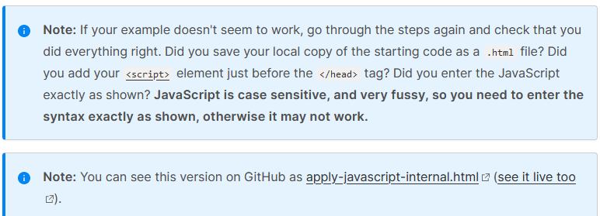

**External JavaScript**

This works great, but what if we wanted to put our JavaScript in an external file? Let's explore this now.

1. First, create a new file in the same directory as your sample HTML file. Call it script.js — make sure it has that .js filename extension, as that's how it is recognized as JavaScript.
2. Replace your current [<script>](https://developer.mozilla.org/en-US/docs/Web/HTML/Element/script) element with the following:

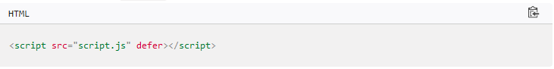

1. Inside script.js, add the following script:

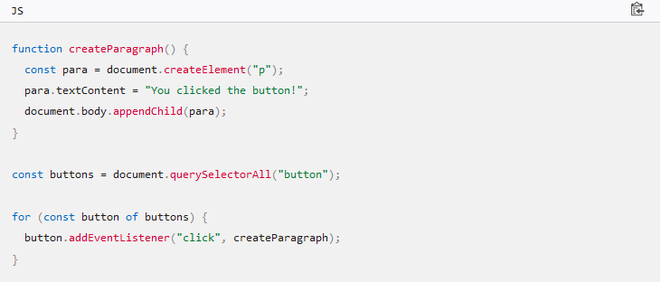

1. Save and refresh your browser, and you should see the same thing! It works just the same, but now we've got our JavaScript in an external file. This is generally a good thing in terms of organizing your code and making it reusable across multiple HTML files. Plus, the HTML is easier to read without huge chunks of script dumped in it.

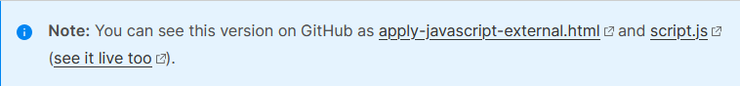

**Inline JavaScript handlers**

Note that sometimes you'll come across bits of actual JavaScript code living inside HTML. It might look something like this:

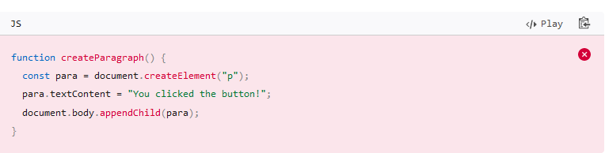

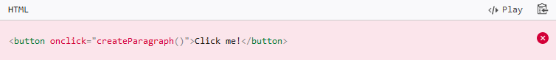

You can try this version of our demo below.

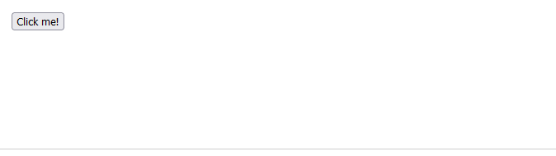

This demo has exactly the same functionality as in the previous two sections, except that the [<button>](https://developer.mozilla.org/en-US/docs/Web/HTML/Element/button) element includes an inline onclick handler to make the function run when the button is pressed.

**Please don't do this, however.** It is bad practice to pollute your HTML with JavaScript, and it is inefficient — you'd have to include the onclick="createParagraph()" attribute on every button you want the JavaScript to apply to.

**Using addEventListener instead**

Instead of including JavaScript in your HTML, use a pure JavaScript construct. The querySelectorAll() function allows you to select all the buttons on a page. You can then loop through the buttons, assigning a handler for each using addEventListener(). The code for this is shown below:

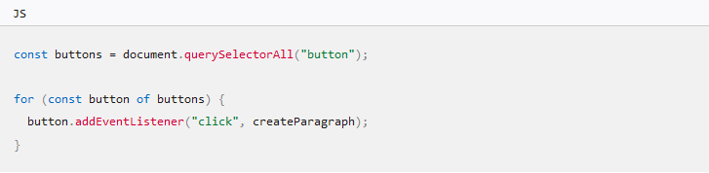

This might be a bit longer than the onclick attribute, but it will work for all buttons — no matter how many are on the page, nor how many are added or removed. The JavaScript does not need to be changed.

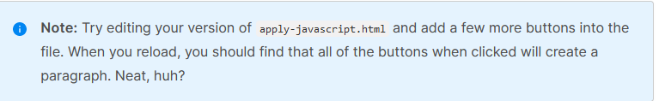

**Script loading strategies**

There are a number of issues involved with getting scripts to load at the right time. Nothing is as simple as it seems! A common problem is that all the HTML on a page is loaded in the order in which it appears. If you are using JavaScript to manipulate elements on the page (or more accurately, the [Document Object Model](https://developer.mozilla.org/en-US/docs/Learn/JavaScript/Client-side_web_APIs/Manipulating_documents#the_document_object_model)), your code won't work if the JavaScript is loaded and parsed before the HTML you are trying to do something to.

In the above code examples, in the internal and external examples the JavaScript is loaded and run in the head of the document, before the HTML body is parsed. This could cause an error, so we've used some constructs to get around it.

In the internal example, you can see this structure around the code:

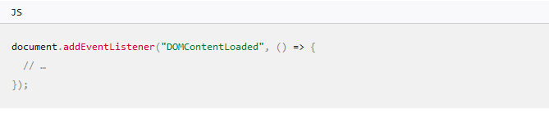

This is an event listener, which listens for the browser's DOMContentLoaded event, which signifies that the HTML body is completely loaded and parsed. The JavaScript inside this block will not run until after that event is fired, therefore the error is avoided (you'll [learn about events](https://developer.mozilla.org/en-US/docs/Learn/JavaScript/Building_blocks/Events) later in the course).

In the external example, we use a more modern JavaScript feature to solve the problem, the defer attribute, which tells the browser to continue downloading the HTML content once the <script> tag element has been reached.

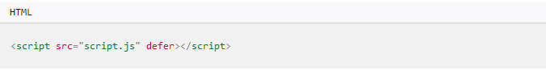

In this case both the script and the HTML will load simultaneously and the code will work.

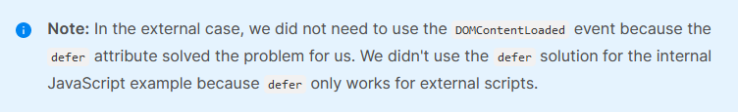

An old-fashioned solution to this problem used to be to put your script element right at the bottom of the body (e.g. just before the </body> tag), so that it would load after all the HTML has been parsed. The problem with this solution is that loading/parsing of the script is completely blocked until the HTML DOM has been loaded. On larger sites with lots of JavaScript, this can cause a major performance issue, slowing down your site.

**async and defer**

There are actually two modern features we can use to bypass the problem of the blocking script — async and defer (which we saw above). Let's look at the difference between these two.

Scripts loaded using the async attribute will download the script without blocking the page while the script is being fetched. However, once the download is complete, the script will execute, which blocks the page from rendering. This means that the rest of the content on the web page is prevented from being processed and displayed to the user until the script finishes executing. You get no guarantee that scripts will run in any specific order. It is best to use async when the scripts in the page run independently from each other and depend on no other script on the page.

Scripts loaded with the defer attribute will load in the order they appear on the page. They won't run until the page content has all loaded, which is useful if your scripts depend on the DOM being in place (e.g. they modify one or more elements on the page).

Here is a visual representation of the different script loading methods and what that means for your page:

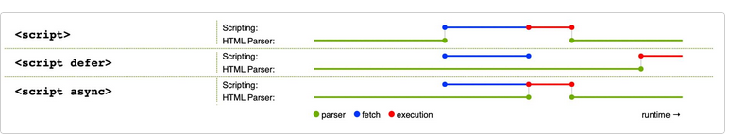

This image is from the [HTML spec](https://html.spec.whatwg.org/images/asyncdefer.svg), copied and cropped to a reduced version, under [CC BY 4.0](https://creativecommons.org/licenses/by/4.0/) license terms.

For example, if you have the following script elements:

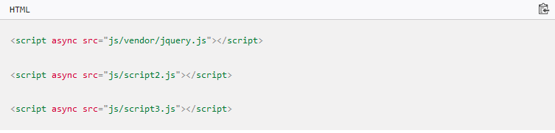

You can't rely on the order the scripts will load in. jquery.js may load before or after script2.js and script3.js and if this is the case, any functions in those scripts depending on jquery will produce an error because jquery will not be defined at the time the script runs.

async should be used when you have a bunch of background scripts to load in, and you just want to get them in place as soon as possible. For example, maybe you have some game data files to load, which will be needed when the game actually begins, but for now you just want to get on with showing the game intro, titles, and lobby, without them being blocked by script loading.

Scripts loaded using the defer attribute (see below) will run in the order they appear in the page and execute them as soon as the script and content are downloaded:

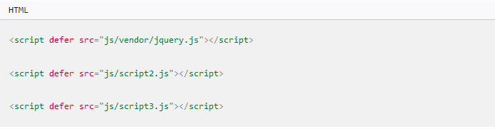

In the second example, we can be sure that jquery.js will load before script2.js and script3.js and that script2.js will load before script3.js. They won't run until the page content has all loaded, which is useful if your scripts depend on the DOM being in place (e.g. they modify one or more elements on the page).

To summarize:

* async and defer both instruct the browser to download the script(s) in a separate thread, while the rest of the page (the DOM, etc.) is downloading, so the page loading is not blocked during the fetch process.
* scripts with an async attribute will execute as soon as the download is complete. This blocks the page and does not guarantee any specific execution order.
* scripts with a defer attribute will load in the order they are in and will only execute once everything has finished loading.
* If your scripts should be run immediately and they don't have any dependencies, then use async.
* If your scripts need to wait for parsing and depend on other scripts and/or the DOM being in place, load them using defer and put their corresponding <script> elements in the order you want the browser to execute them.

**Comments**

As with HTML and CSS, it is possible to write comments into your JavaScript code that will be ignored by the browser, and exist to provide instructions to your fellow developers on how the code works (and you, if you come back to your code after six months and can't remember what you did). Comments are very useful, and you should use them often, particularly for larger applications. There are two types:

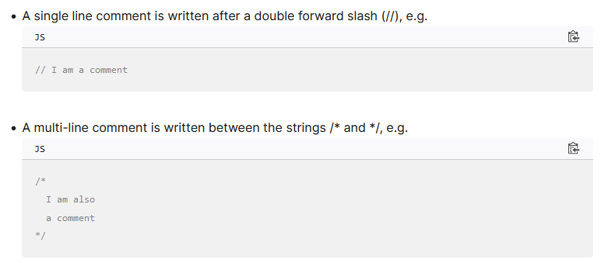

So for example, we could annotate our last demo's JavaScript with comments like so:

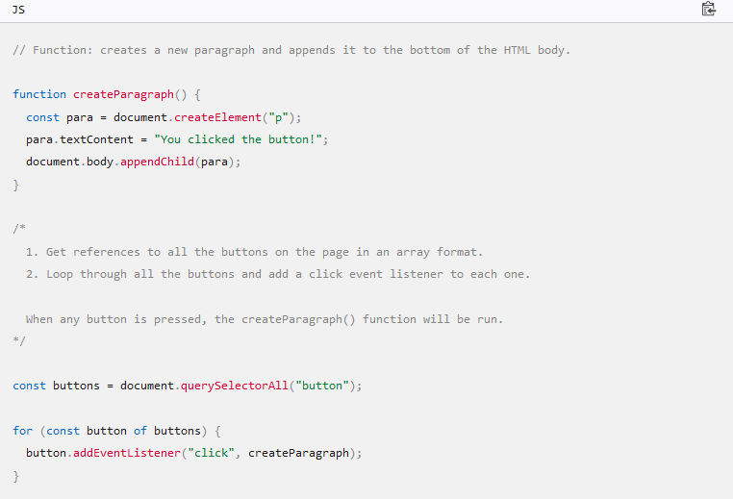

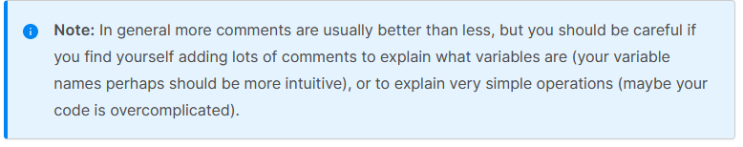

[**Summary**](https://developer.mozilla.org/en-US/docs/Learn/JavaScript/First_steps/What_is_JavaScript#summary)

So there you go, your first step into the world of JavaScript. We've begun with just theory, to start getting you used to why you'd use JavaScript and what kind of things you can do with it. Along the way, you saw a few code examples and learned how JavaScript fits in with the rest of the code on your website, amongst other things.

JavaScript may seem a bit daunting right now, but don't worry — in this course, we will take you through it in simple steps that will make sense going forward. In the next article, we will [plunge straight into the practical](https://developer.mozilla.org/en-US/docs/Learn/JavaScript/First_steps/A_first_splash), getting you to jump straight in and build your own JavaScript examples.

How CSS Works

We have learned the basics of CSS, what it is for and how to write simple stylesheets. In this lesson we will take a look at how a browser takes CSS and HTML and turns that into a webpage.

[**How does CSS actually work?**](https://developer.mozilla.org/en-US/docs/Learn/CSS/First_steps/How_CSS_works#how_does_css_actually_work)

When a browser displays a document, it must combine the document's content with its style information. It processes the document in a number of stages, which we've listed below. Bear in mind that this is a very simplified version of what happens when a browser loads a webpage, and that different browsers will handle the process in different ways. But this is roughly what happens.

1. The browser loads the HTML (e.g. receives it from the network).
2. It converts the [HTML](https://developer.mozilla.org/en-US/docs/Glossary/HTML) into a [DOM](https://developer.mozilla.org/en-US/docs/Glossary/DOM) (*Document Object Model*). The DOM represents the document in the computer's memory. The DOM is explained in a bit more detail in the next section.
3. The browser then fetches most of the resources that are linked to by the HTML document, such as embedded images, videos, and even linked CSS! JavaScript is handled a bit later on in the process, and we won't talk about it here to keep things simpler.
4. The browser parses the fetched CSS, and sorts the different rules by their selector types into different "buckets", e.g. element, class, ID, and so on. Based on the selectors it finds, it works out which rules should be applied to which nodes in the DOM, and attaches style to them as required (this intermediate step is called a render tree).
5. The render tree is laid out in the structure it should appear in after the rules have been applied to it.
6. The visual display of the page is shown on the screen (this stage is called painting).

The following diagram also offers a simple view of the process.

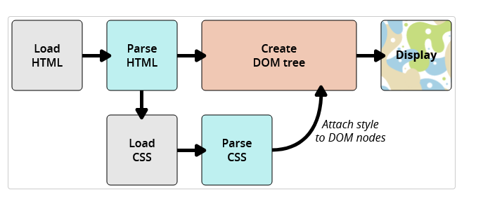

[**About the DOM**](https://developer.mozilla.org/en-US/docs/Learn/CSS/First_steps/How_CSS_works#about_the_dom)

A DOM has a tree-like structure. Each element, attribute, and piece of text in the markup language becomes a [DOM node](https://developer.mozilla.org/en-US/docs/Glossary/Node/DOM) in the tree structure. The nodes are defined by their relationship to other DOM nodes. Some elements are parents of child nodes, and child nodes have siblings.

Understanding the DOM helps you design, debug and maintain your CSS because the DOM is where your CSS and the document's content meet up. When you start working with browser DevTools you will be navigating the DOM as you select items in order to see which rules apply.

[**A real DOM representation**](https://developer.mozilla.org/en-US/docs/Learn/CSS/First_steps/How_CSS_works#a_real_dom_representation)

Rather than a long, boring explanation, let's look at an example to see how a real HTML snippet is converted into a DOM.

Take the following HTML code:

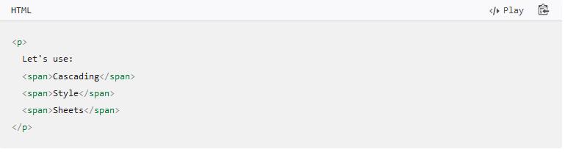

In the DOM, the node corresponding to our <p> element is a parent. Its children are a text node and the three nodes corresponding to our <span> elements. The SPAN nodes are also parents, with text nodes as their children:

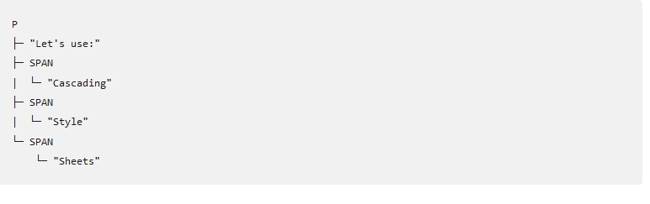

This is how a browser interprets the previous HTML snippet — it renders the above DOM tree and then outputs it in the browser like so:

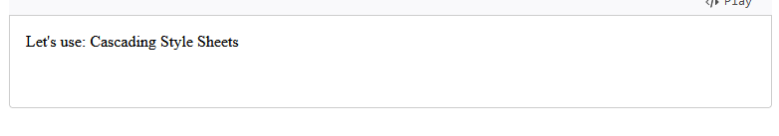

[**Applying CSS to the DOM**](https://developer.mozilla.org/en-US/docs/Learn/CSS/First_steps/How_CSS_works#applying_css_to_the_dom)

Let's say we add some CSS to our document, to style it. Again, the HTML is as follows:

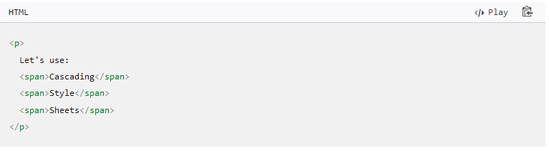

Let's suppose we apply the following CSS to it:

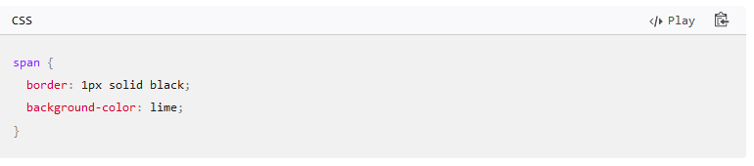

The browser parses the HTML and creates a DOM from it. Next, it parses the CSS. Since the only rule available in the CSS has a span selector, the browser sorts the CSS very quickly! It applies that rule to each one of the three <span>s, then paints the final visual representation to the screen.

The updated output is as follows:

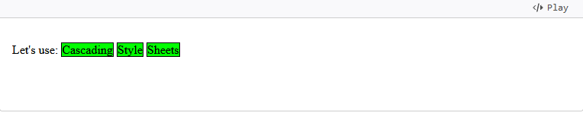

In our [Debugging CSS](https://developer.mozilla.org/en-US/docs/Learn/CSS/Building_blocks/Debugging_CSS) article in the next module we will be using browser DevTools to debug CSS problems, and will learn more about how the browser interprets CSS.

[**What happens if a browser encounters CSS it doesn't understand?**](https://developer.mozilla.org/en-US/docs/Learn/CSS/First_steps/How_CSS_works#what_happens_if_a_browser_encounters_css_it_doesnt_understand)

The ["Browser support information" section in the "What is CSS" article](https://developer.mozilla.org/en-US/docs/Learn/CSS/First_steps/What_is_CSS#browser_support_information) mentioned that browsers do not necessarily implement new CSS features at the same time. In addition, many people are not using the latest version of a browser. Given that CSS is being developed all the time, and is therefore ahead of what browsers can recognize, you might wonder what happens if a browser encounters a CSS selector or declaration it doesn't recognize.

The answer is that it does nothing, and just moves on to the next bit of CSS!

If a browser is parsing your rules, and encounters a property or value that it doesn't understand, it ignores it and moves on to the next declaration. It will do this if you have made an error and misspelled a property or value, or if the property or value is just too new and the browser doesn't yet support it.

Similarly, if a browser encounters a selector that it doesn't understand, it will just ignore the whole rule and move on to the next one.

In the example below I have used the British English spelling for color, which makes that property invalid as it is not recognized. So my paragraph has not been colored blue. All of the other CSS have been applied however; only the invalid line is ignored.

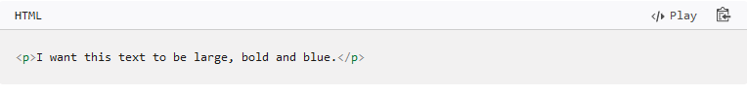

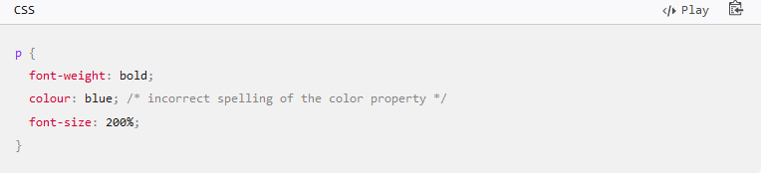

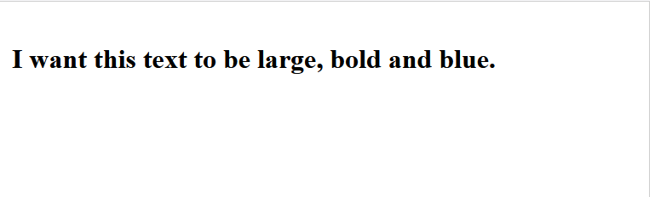

This behavior is very useful. It means that you can use new CSS as an enhancement, knowing that no error will occur if it is not understood — the browser will either get the new feature or not. This enables basic fallback styling.

This works particularly well when you want to use a value that is quite new and not supported everywhere. For example, some older browsers do not support calc() as a value. I might give a fallback width for a box in pixels, then go on to give a width with a calc() value of 100% - 50px. Old browsers will use the pixel version, ignoring the line about calc() as they don't understand it. New browsers will interpret the line using pixels, but then override it with the line using calc() as that line appears later in the cascade.

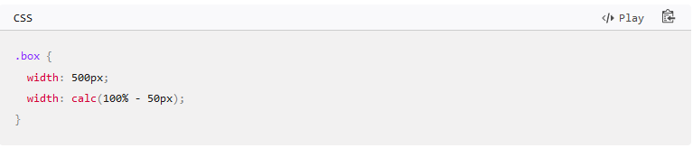

### Common Misconceptions and Language Issues

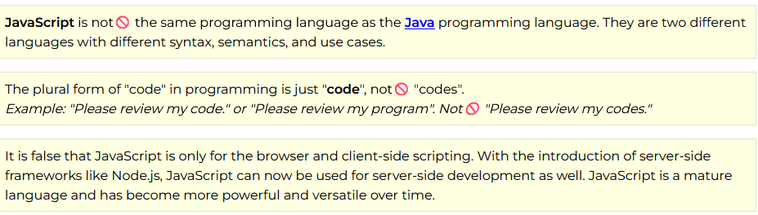

## Variables

### Overview

Variables are used to **store** data / values. These values can be **primitive** like a number, string, Boolean, or null or they can be **objects** like a function, class, or literal object. The values can be used as input to expressions, used in processing, or used in output to display information.

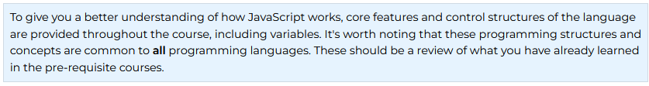

### Prepare

#### JavaSccript variables



**JavaScript basics**

JavaScript is a programming language that adds interactivity to your website. This happens in games, in the behavior of responses when buttons are pressed or with data entry on forms; with dynamic styling; with animation, etc. This article helps you get started with JavaScript and furthers your understanding of what is possible.

**What is JavaScript?**

JavaScript is a powerful programming language that can add interactivity to a website. It was invented by Brendan Eich.

JavaScript is versatile and beginner-friendly. With more experience, you'll be able to create games, animated 2D and 3D graphics, comprehensive database-driven apps, and much more!

JavaScript itself is relatively compact, yet very flexible. Developers have written a variety of tools on top of the core JavaScript language, unlocking a vast amount of functionality with minimum effort. These include:

Browser Application Programming Interfaces ([APIs](https://developer.mozilla.org/en-US/docs/Glossary/API)) built into web browsers, providing functionality such as dynamically creating HTML and setting CSS styles; collecting and manipulating a video stream from a user's webcam, or generating 3D graphics and audio samples.

Third-party APIs that allow developers to incorporate functionality in sites from other content providers, such as Twitter or Facebook.

Third-party frameworks and libraries that you can apply to HTML to accelerate the work of building sites and applications.

It's outside the scope of this article—as a light introduction to JavaScript—to present the details of how the core JavaScript language is different from the tools listed above. You can learn more in MDN's [JavaScript learning area](https://developer.mozilla.org/en-US/docs/Learn/JavaScript), as well as in other parts of MDN.

The section below introduces some aspects of the core language and offers an opportunity to play with a few browser API features too. Have fun!

**A "Hello world!" example**

JavaScript is one of the most popular modern web technologies! As your JavaScript skills grow, your websites will enter a new dimension of power and creativity.

However, getting comfortable with JavaScript is more challenging than getting comfortable with HTML and CSS. You may have to start small, and progress gradually. To begin, let's examine how to add JavaScript to your page for creating a *Hello world!* example. (*Hello world!* is [the standard for introductory programming examples](https://en.wikipedia.org/wiki/%22Hello,_World!%22_program).)

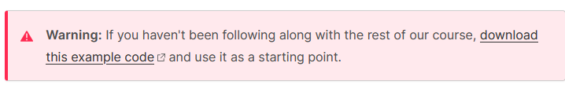

1. Go to your test site and create a new folder named scripts. Within the scripts folder, create a new text document called main.js, and save it.
2. In your index.html file, enter this code on a new line, just before the closing </body> tag:

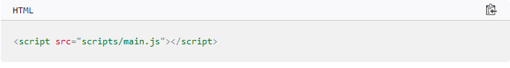

1. This is doing the same job as the <link> element for CSS. It applies the JavaScript to the page, so it can have an effect on the HTML (along with the CSS, and anything else on the page).
2. Add this code to the main.js file:

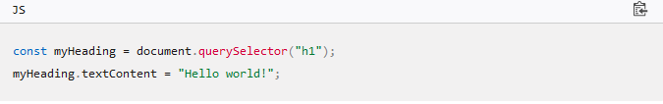

1. Make sure the HTML and JavaScript files are saved. Then load index.html in your browser. You should see something like this:



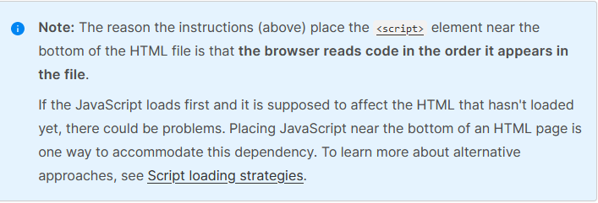

**What happened?**

The heading text changed to Hello world! using JavaScript. You did this by using a function called [querySelector()](https://developer.mozilla.org/en-US/docs/Web/API/Document/querySelector) to grab a reference to your heading, and then store it in a variable called myHeading. This is similar to what we did using CSS selectors. When you want to do something to an element, you need to select it first.

Following that, the code set the value of the myHeading variable's [textContent](https://developer.mozilla.org/en-US/docs/Web/API/Node/textContent) property (which represents the content of the heading) to Hello world!.

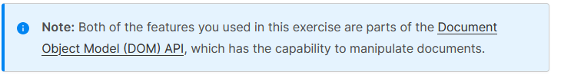

**Language basics crash course**

To give you a better understanding of how JavaScript works, let's explain some of the core features of the language. It's worth noting that these features are common to all programming languages. If you master these fundamentals, you have a head start on coding in other languages too!

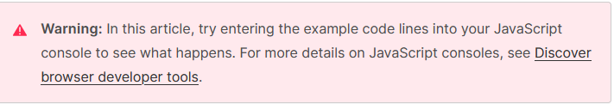

**Variables**

[Variables](https://developer.mozilla.org/en-US/docs/Glossary/Variable) are containers that store values. You start by declaring a variable with the [let](https://developer.mozilla.org/en-US/docs/Web/JavaScript/Reference/Statements/let) keyword, followed by the name you give to the variable:

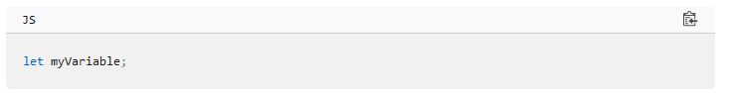

A semicolon at the end of a line indicates where a statement ends. It is only required when you need to separate statements on a single line. However, some people believe it's good practice to have semicolons at the end of each statement. There are other rules for when you should and shouldn't use semicolons. For more details, see [Your Guide to Semicolons in JavaScript](https://www.codecademy.com/resources/blog/your-guide-to-semicolons-in-javascript/).

You can name a variable nearly anything, but there are some restrictions. (See [this section about naming rules](https://developer.mozilla.org/en-US/docs/Web/JavaScript/Guide/Grammar_and_types#variables).) If you are unsure, you can [check your variable name](https://mothereff.in/js-variables) to see if it's valid.

JavaScript is case sensitive. This means myVariable is not the same as myvariable. If you have problems in your code, check the case!

After declaring a variable, you can give it a value:

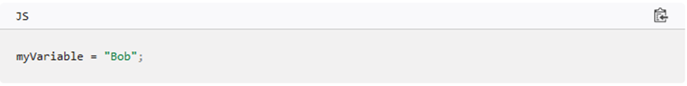

Also, you can do both these operations on the same line:

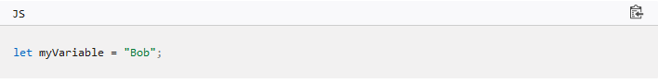

You retrieve the value by calling the variable name:

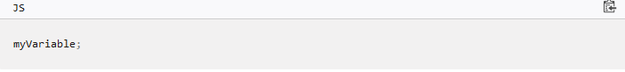

After assigning a value to a variable, you can change it later in the code:

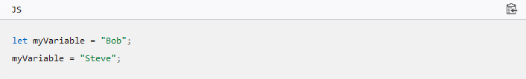

Note that variables may hold values that have different [data types](https://developer.mozilla.org/en-US/docs/Web/JavaScript/Data_structures):

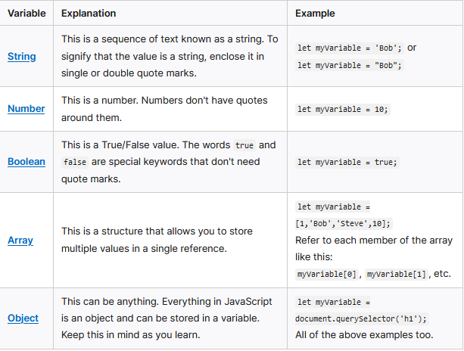

So why do we need variables? Variables are necessary to do anything interesting in programming. If values couldn't change, then you couldn't do anything dynamic, like personalize a greeting message or change an image displayed in an image gallery.

[**Comments**](https://developer.mozilla.org/en-US/docs/Learn/Getting_started_with_the_web/JavaScript_basics#comments)

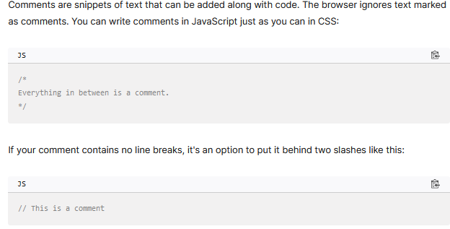

**Operators**

An operator is a mathematical symbol that produces a result based on two values (or variables). In the following table, you can see some of the simplest operators, along with some examples to try in the JavaScript console.

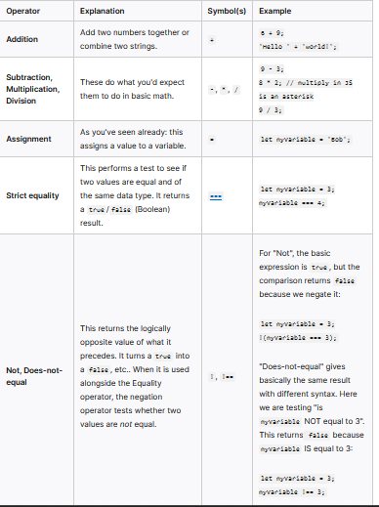

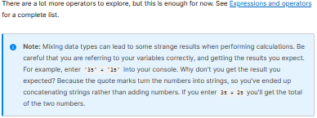

**Conditionals**

Conditionals are code structures used to test if an expression returns true or not. A very common form of conditionals is the if...else statement. For example:

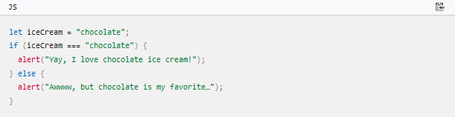

The expression inside the if () is the test. This uses the strict equality operator (as described above) to compare the variable iceCream with the string chocolate to see if the two are equal. If this comparison returns true, the first block of code runs. If the comparison is not true, the second block of code—after the else statement—runs instead.

[**Functions**](https://developer.mozilla.org/en-US/docs/Learn/Getting_started_with_the_web/JavaScript_basics#functions)

Functions are a way of packaging functionality that you wish to reuse. It's possible to define a body of code as a function that executes when you call the function name in your code. This is a good alternative to repeatedly writing the same code. You have already seen some uses of functions. For example:

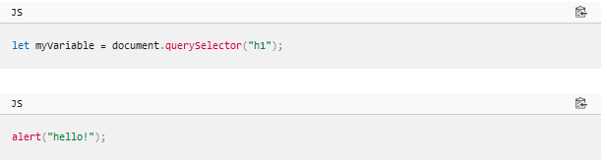

These functions, document.querySelector and alert, are built into the browser.

If you see something which looks like a variable name, but it's followed by parentheses— () —it is likely a function. Functions often take [arguments](https://developer.mozilla.org/en-US/docs/Glossary/Argument): bits of data they need to do their job. Arguments go inside the parentheses, separated by commas if there is more than one argument.

For example, the alert() function makes a pop-up box appear inside the browser window, but we need to give it a string as an argument to tell the function what message to display.

You can also define your own functions. In the next example, we create a simple function which takes two numbers as arguments and multiplies them:

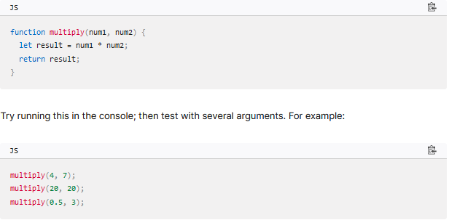

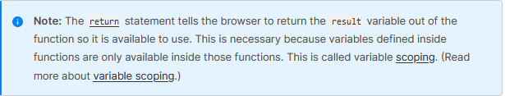

**Events**

Real interactivity on a website requires event handlers. These are code structures that listen for activity in the browser, and run code in response. The most obvious example is handling the [click event](https://developer.mozilla.org/en-US/docs/Web/API/Element/click_event), which is fired by the browser when you click on something with your mouse. To demonstrate this, enter the following into your console, then click on the current webpage:

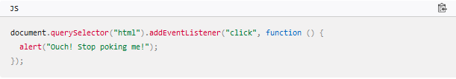

There are a number of ways to attach an event handler to an element. Here we select the [<html>](https://developer.mozilla.org/en-US/docs/Web/HTML/Element/html) element. We then call its [addEventListener()](https://developer.mozilla.org/en-US/docs/Web/API/EventTarget/addEventListener) function, passing in the name of the event to listen to ('click') and a function to run when the event happens.

The function we just passed to addEventListener() here is called an anonymous function, because it doesn't have a name. There's an alternative way of writing anonymous functions, which we call an arrow function. An arrow function uses () => instead of function ():

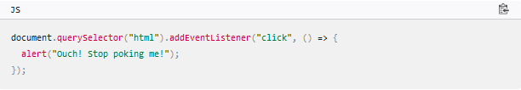

[**Supercharging our example website**](https://developer.mozilla.org/en-US/docs/Learn/Getting_started_with_the_web/JavaScript_basics#supercharging_our_example_website)

With this review of JavaScript basics completed (above), let's add some new features to our example site.

Before going any further, delete the current contents of your main.js file — the bit you added earlier during the "Hello world!" example — and save the empty file. If you don't, the existing code will clash with the new code you are about to add.

**Adding an image changer**

In this section, you will learn how to use JavaScript and DOM API features to alternate the display of one of two images. This change will happen as a user clicks the displayed image.

1. Choose an image you want to feature on your example site. Ideally, the image will be the same size as the image you added previously, or as close as possible.
2. Save this image in your images folder.
3. Rename the image firefox2.png.
4. Add the following JavaScript code to your main.js file.

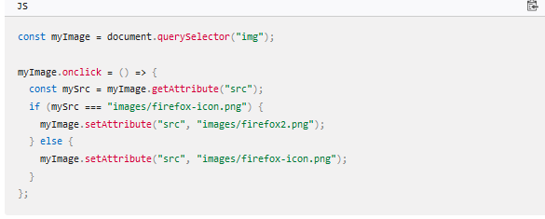

1. Save all files and load index.html in the browser. Now when you click the image, it should change to the other one.

This is what happened. You stored a reference to your [<img>](https://developer.mozilla.org/en-US/docs/Web/HTML/Element/img) element in myImage. Next, you made its onclick event handler property equal to a function with no name (an "anonymous" function). So every time this element is clicked:

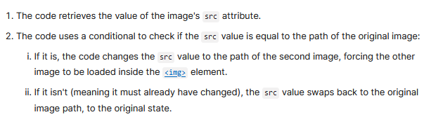

**Adding a personalized welcome message**

Next, let's change the page title to a personalized welcome message when the user first visits the site. This welcome message will persist. Should the user leave the site and return later, we will save the message using the [Web Storage API](https://developer.mozilla.org/en-US/docs/Web/API/Web_Storage_API). We will also include an option to change the user, and therefore, the welcome message.

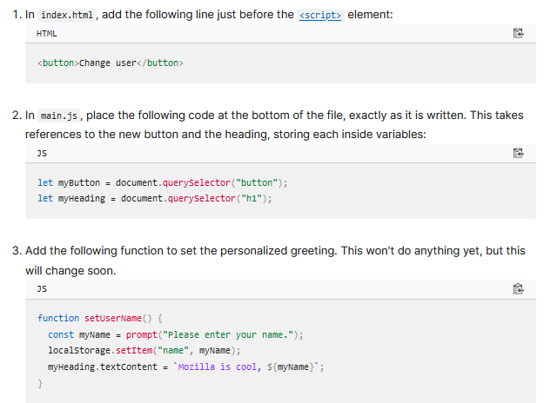

The setUserName() function contains a [prompt()](https://developer.mozilla.org/en-US/docs/Web/API/Window/prompt) function, which displays a dialog box, similar to alert(). This prompt() function does more than alert(), asking the user to enter data, and storing it in a variable after the user clicks OK. In this case, we are asking the user to enter a name. Next, the code calls on an API localStorage, which allows us to store data in the browser and retrieve it later. We use localStorage's setItem() function to create and store a data item called 'name', setting its value to the myName variable which contains the user's entry for the name. Finally, we set the textContent of the heading to a string, plus the user's newly stored name.

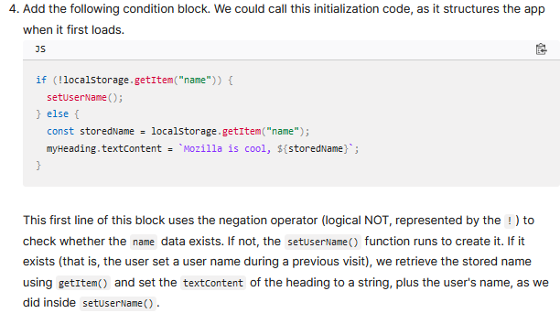

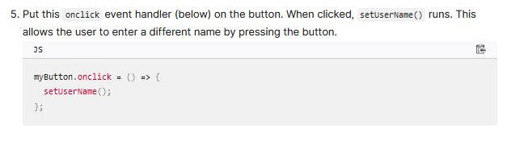

**A user name of null?**

When you run the example and get the dialog box that prompts you to enter your user name, try pressing the Cancel button. You should end up with a title that reads Mozilla is cool, null. This happens because—when you cancel the prompt—the value is set as [null](https://developer.mozilla.org/en-US/docs/Web/JavaScript/Reference/Operators/null). Null is a special value in JavaScript that refers to the absence of a value.

Also, try clicking OK without entering a name. You should end up with a title that reads Mozilla is cool, for fairly obvious reasons.

To avoid these problems, you could check that the user hasn't entered a blank name. Update your setUserName() function to this:

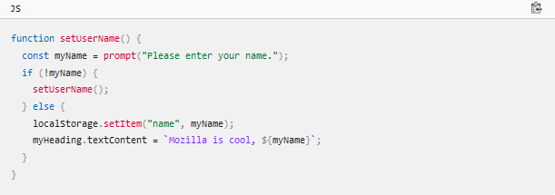

In human language, this means: If myName has no value, run setUserName() again from the start. If it does have a value (if the above statement is not true), then store the value in localStorage and set it as the heading's text.

**Conclusion**

If you have followed all the instructions in this article, you should end up with a page that looks something like the image below. You can also [view our version](https://mdn.github.io/beginner-html-site-scripted/).

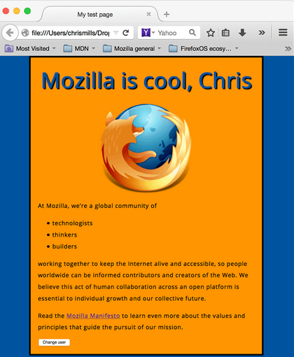

#### Understanding variables in JavaScript



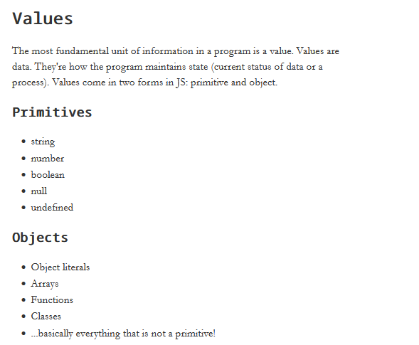

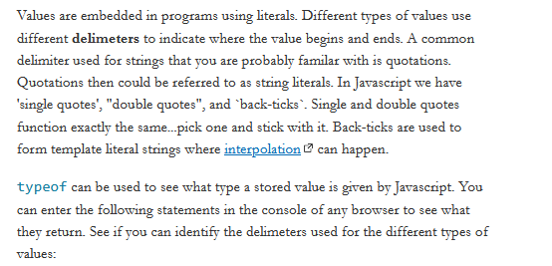

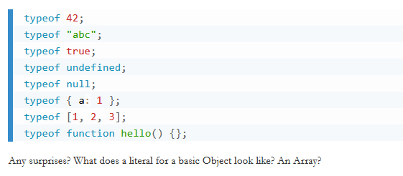

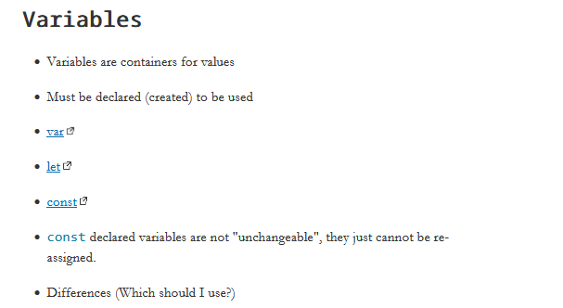

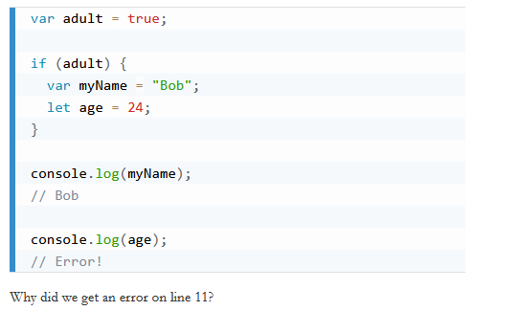

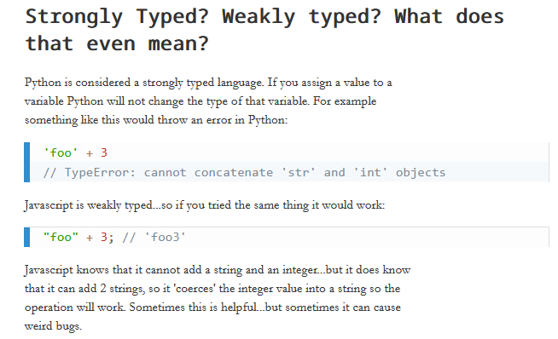

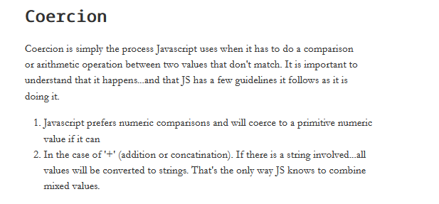

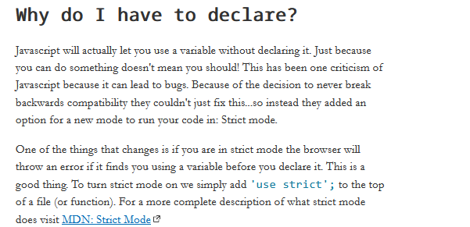

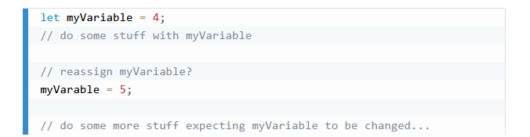

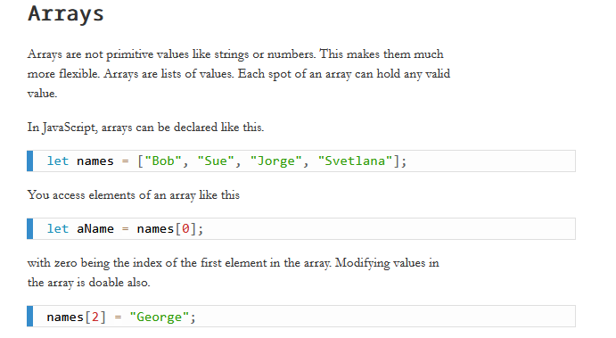

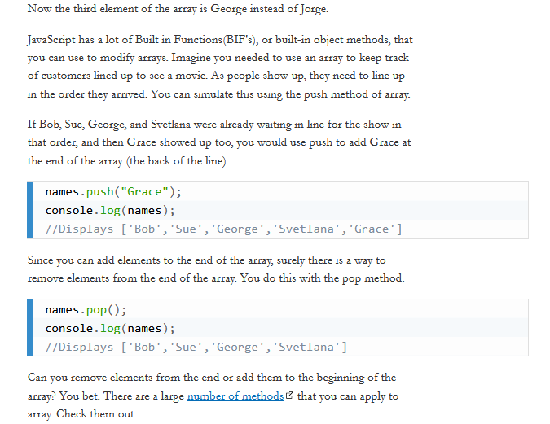

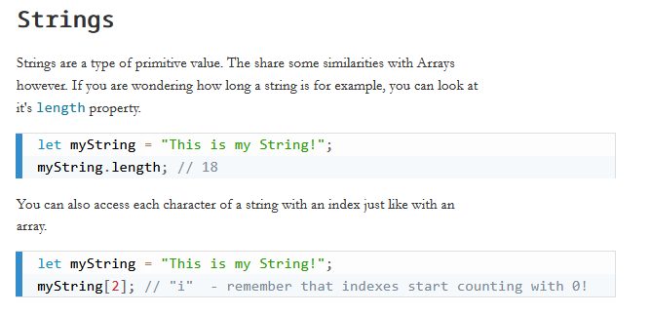

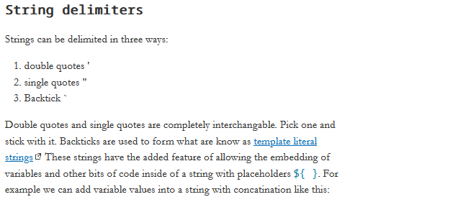

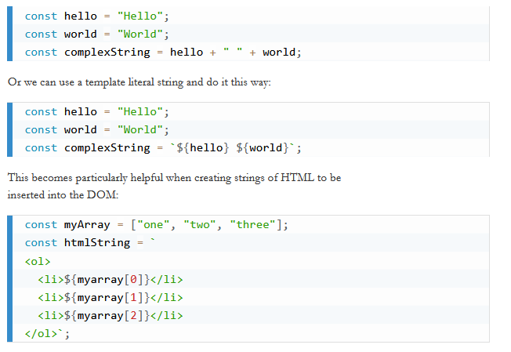

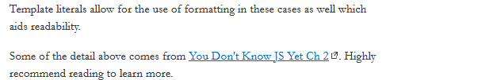

#### Check Your Understanding

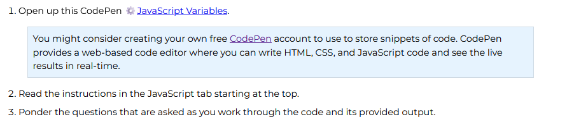

## JavaScript Debugging

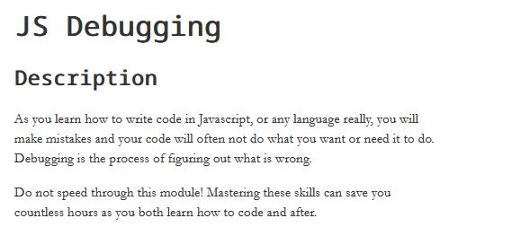

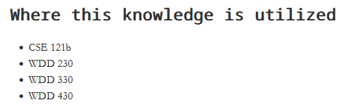



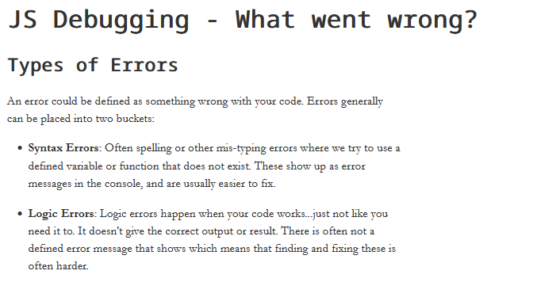

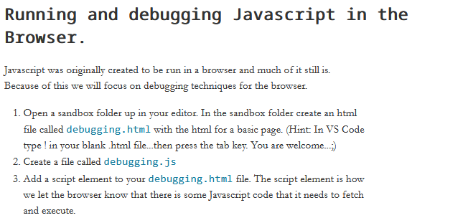

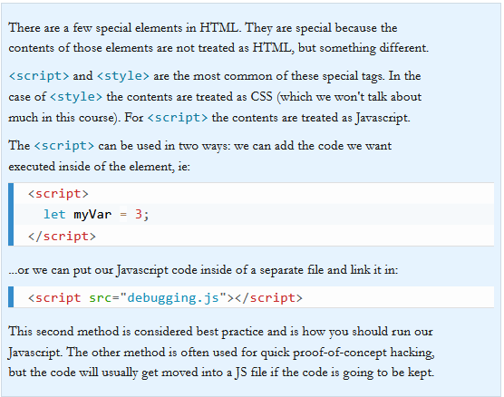

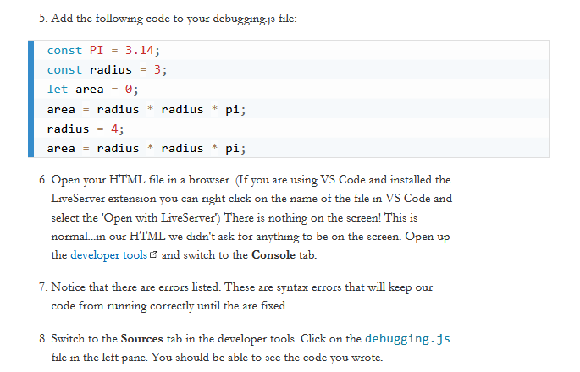

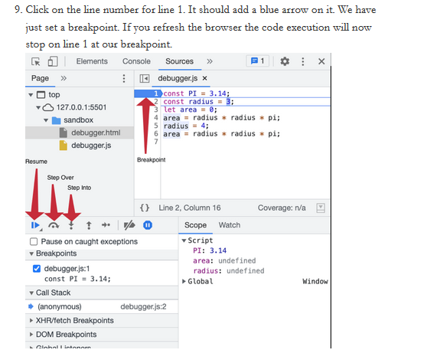

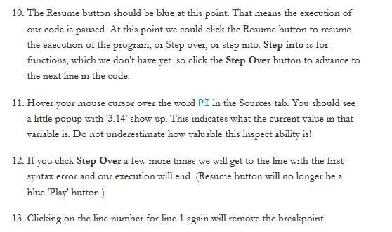



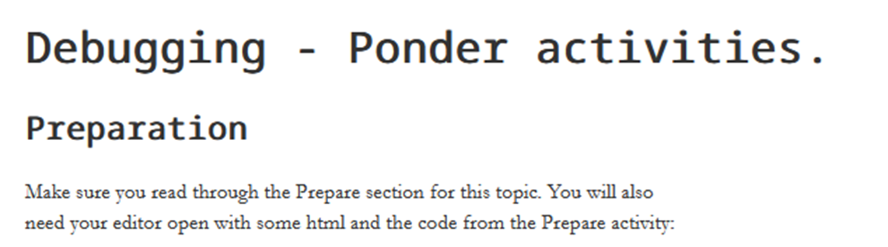

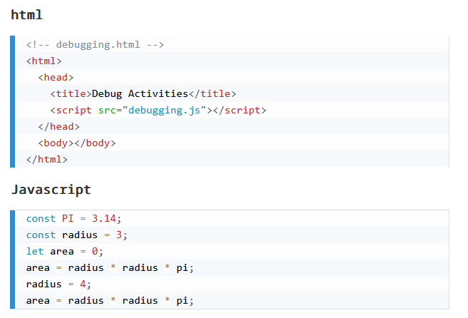

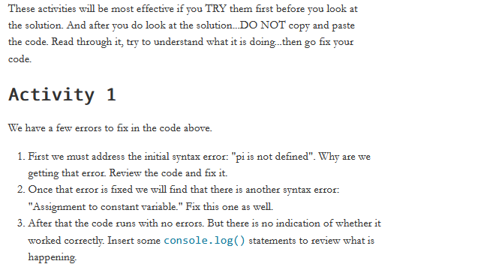



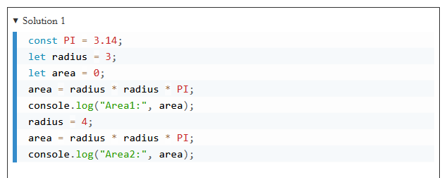

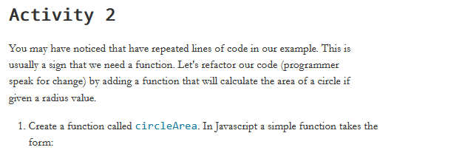

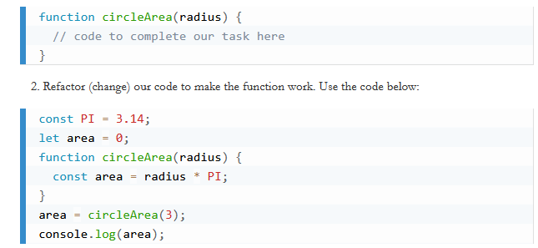

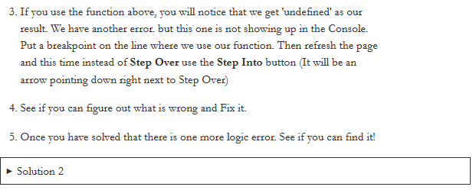

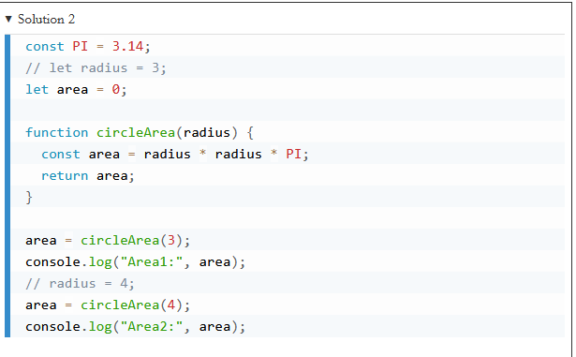

# WEEK 2

## JavaScript Operators

### Overview

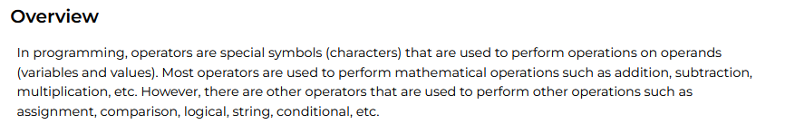

### Prepare



It is essential if fundamental programming that you understand the available operators.

#### JavaScript Operators Reference



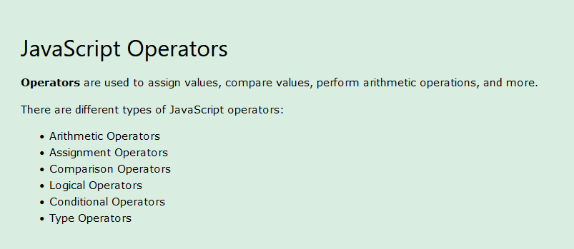

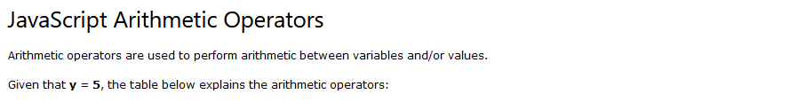

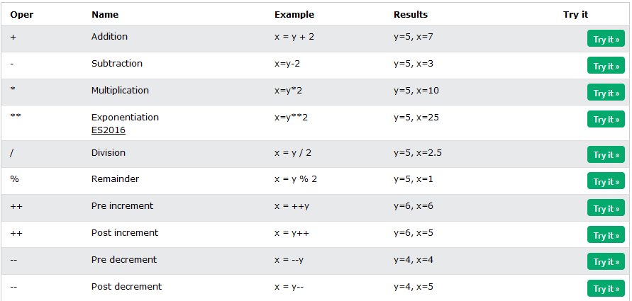

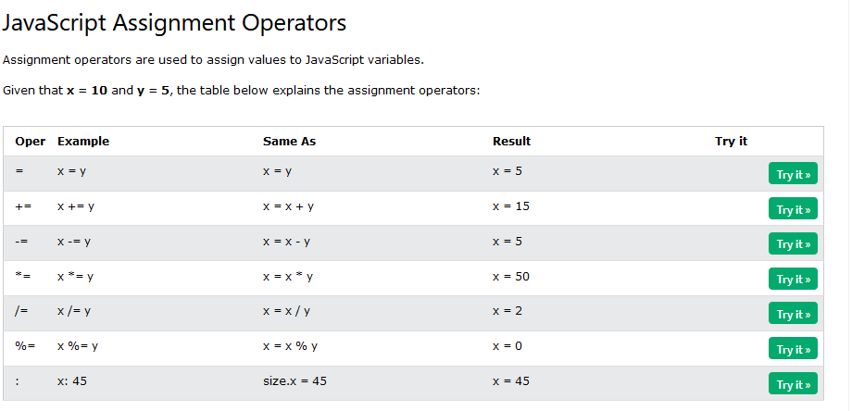

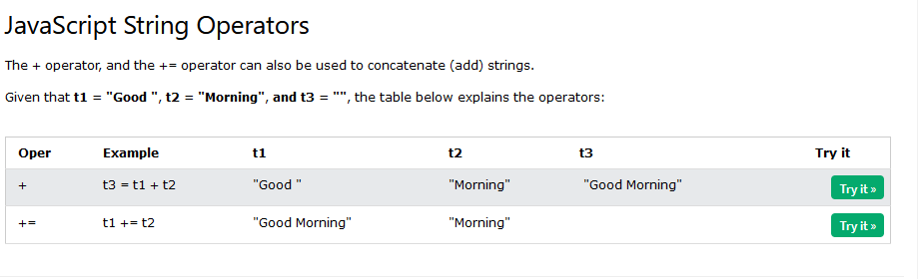

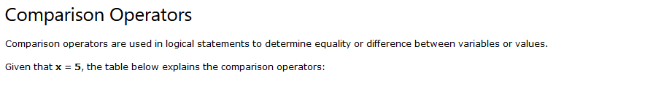

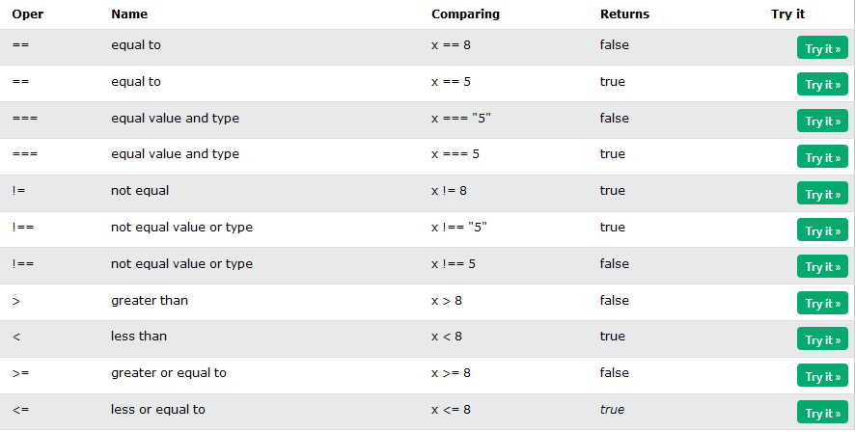

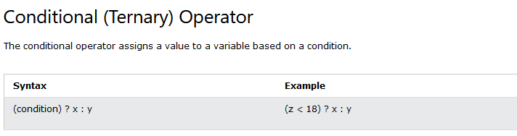

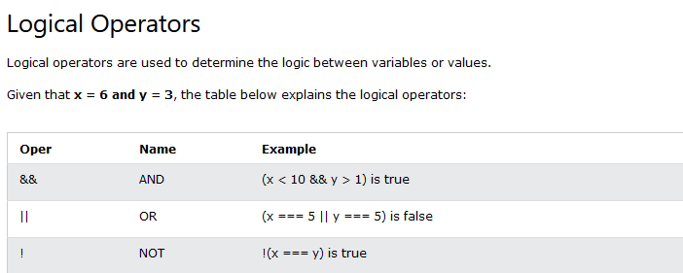

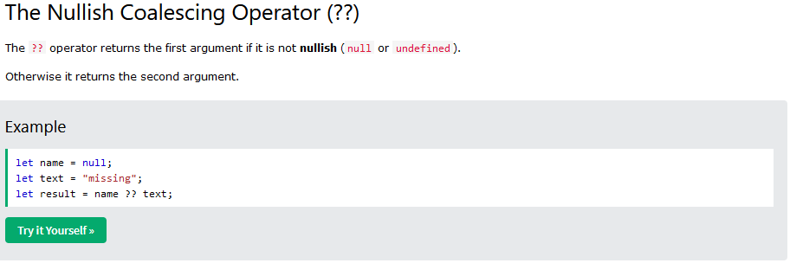

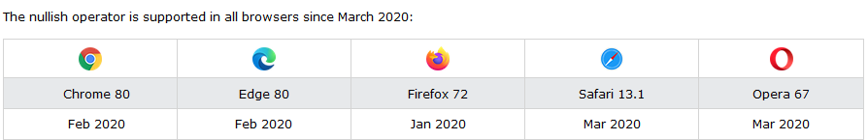

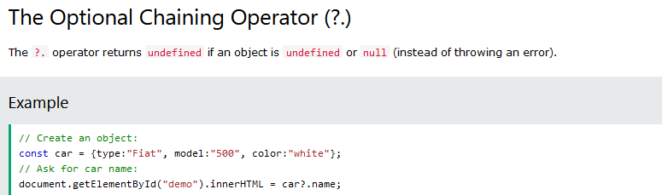

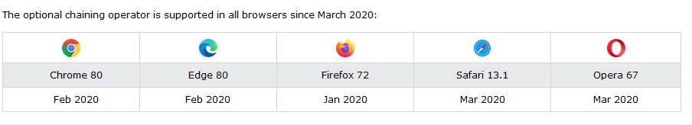

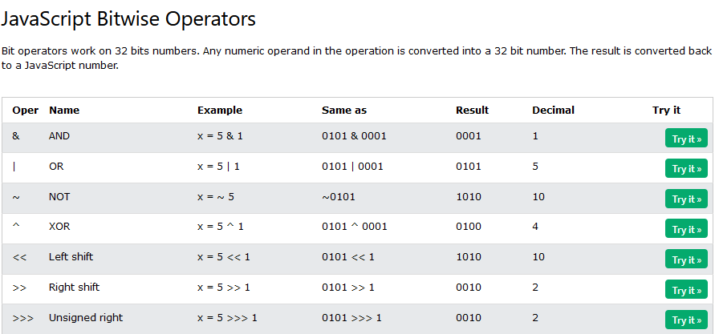

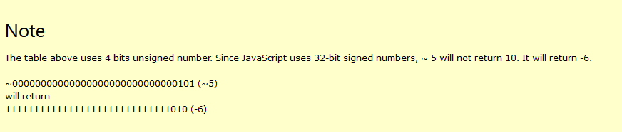

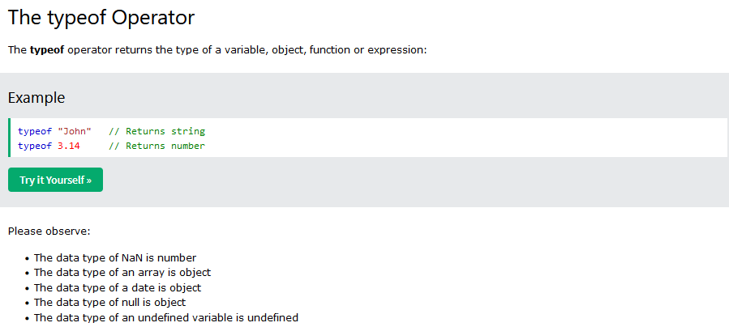

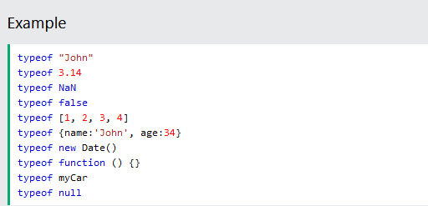

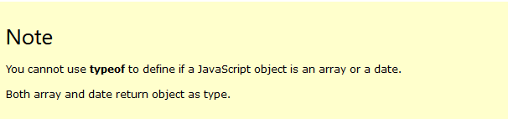

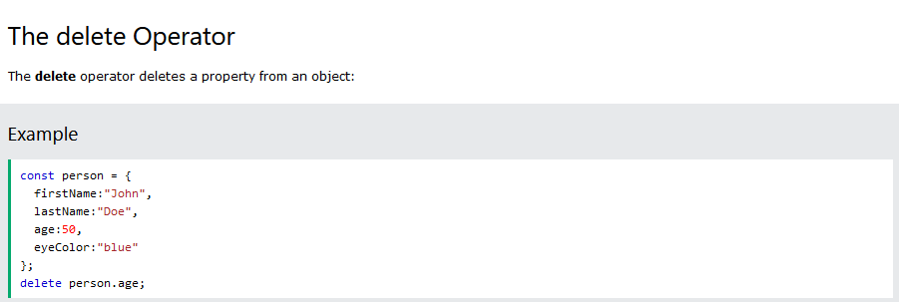

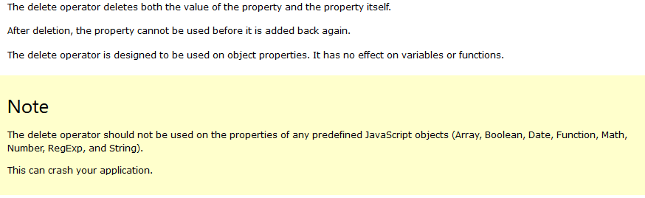

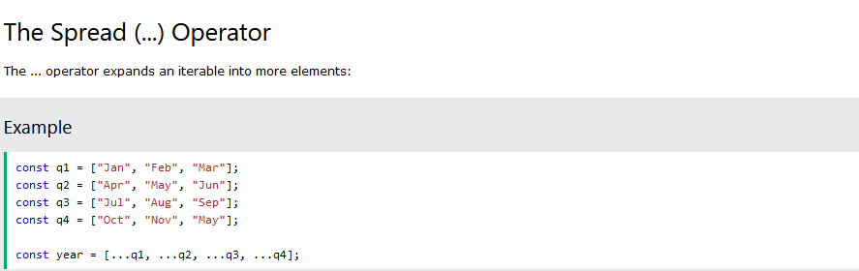

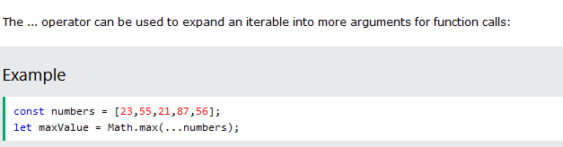

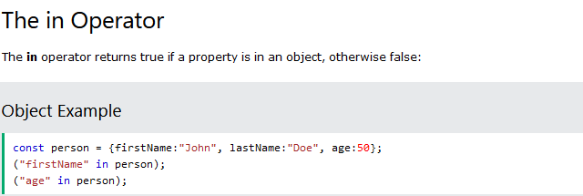

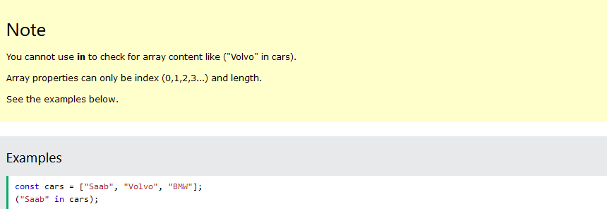

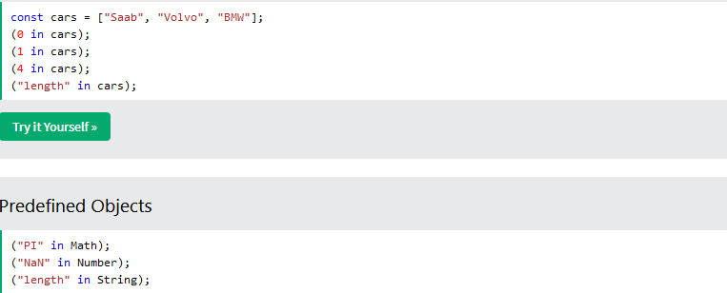

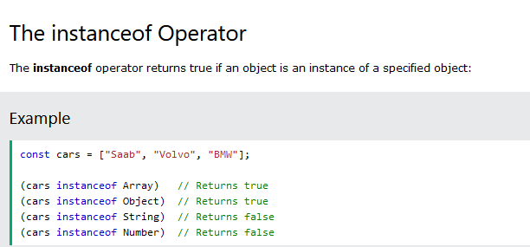

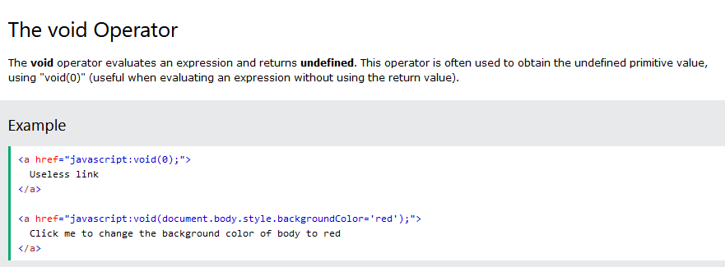

#### More depth reference on Expressions and Operators



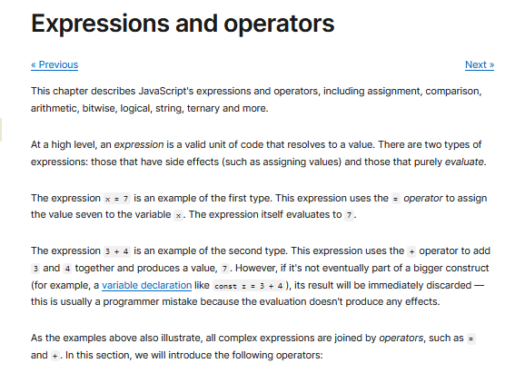

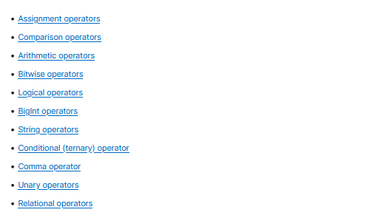

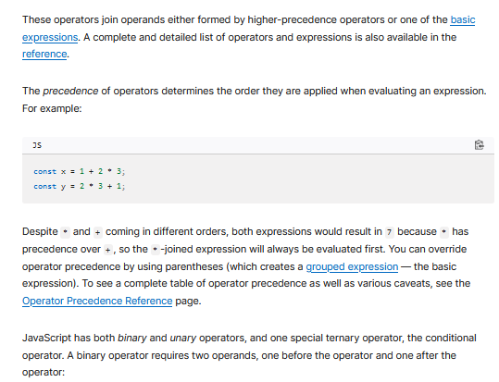

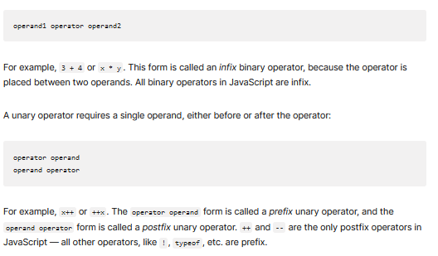

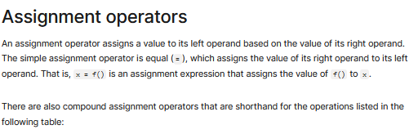

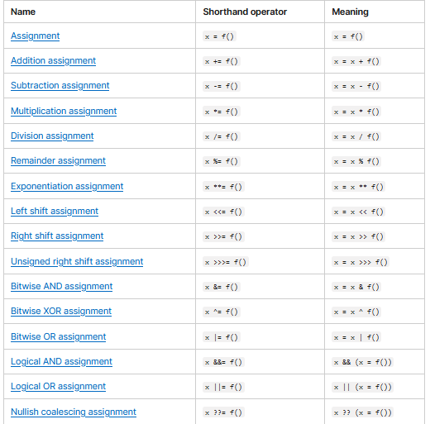

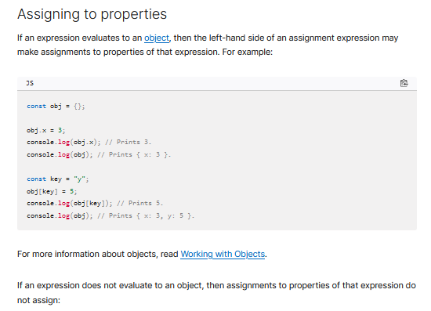

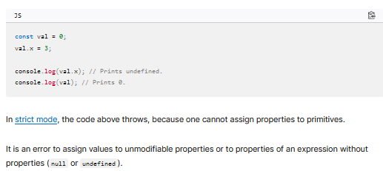

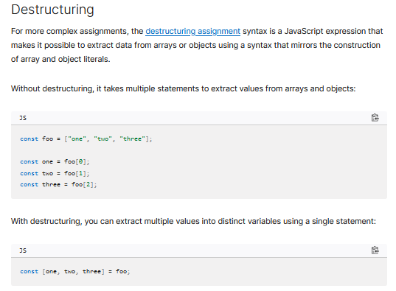

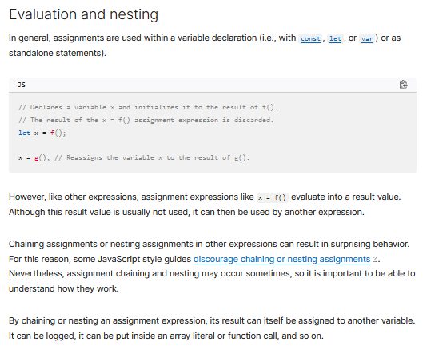

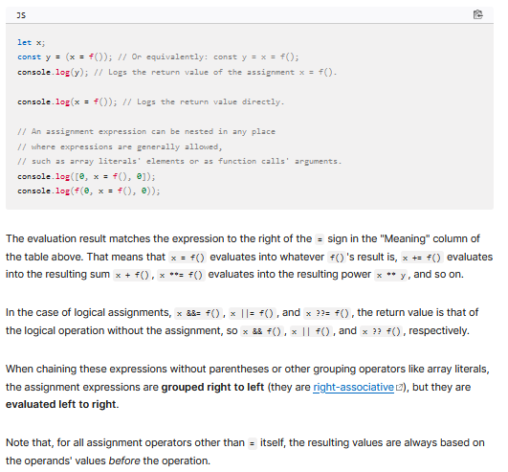

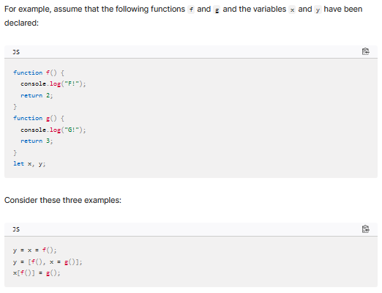

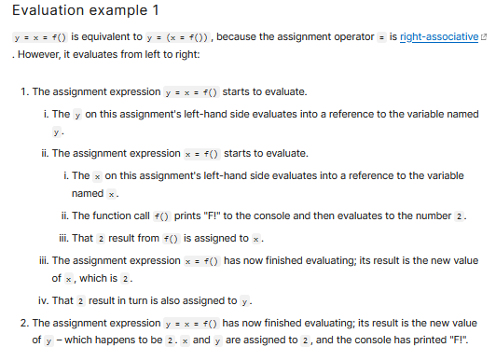

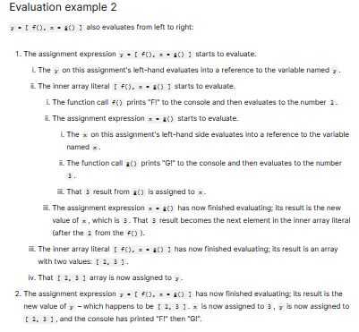

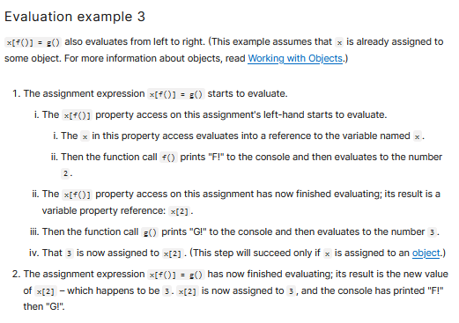

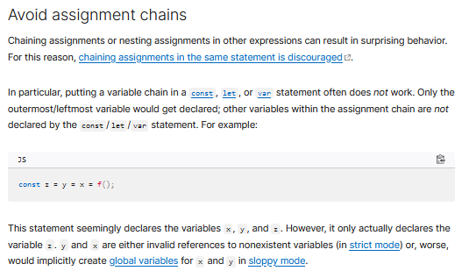

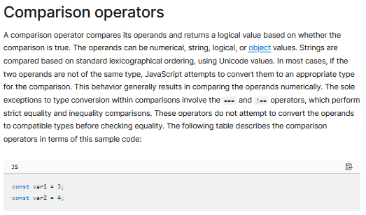

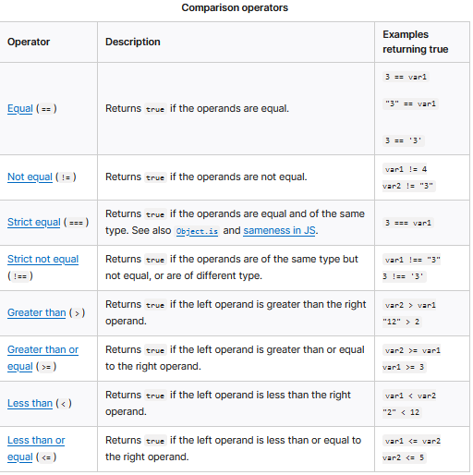



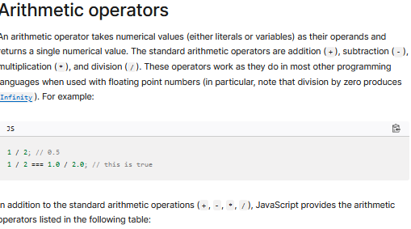

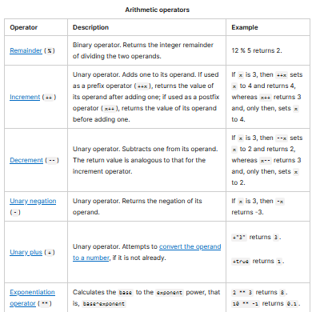

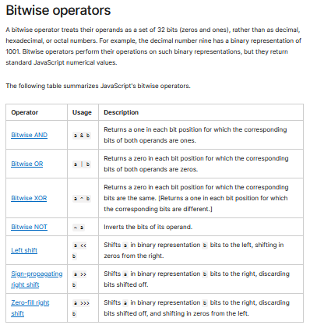

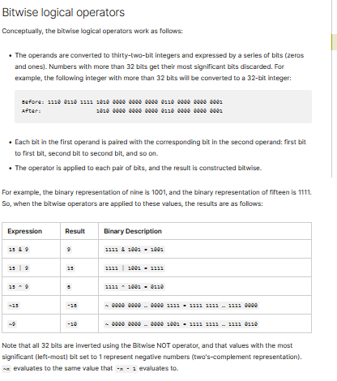

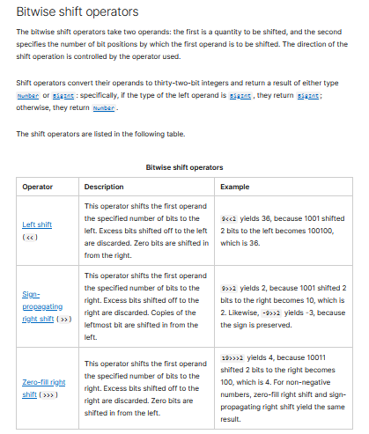

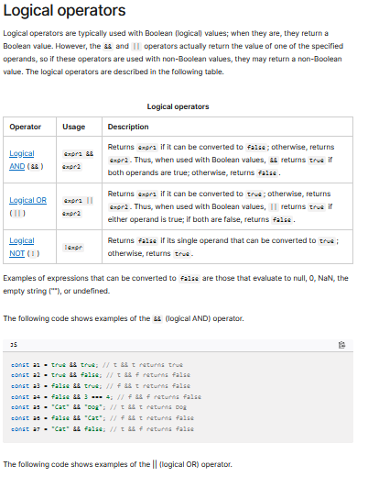

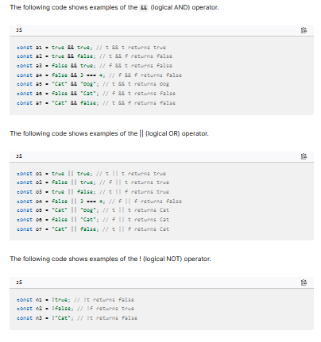

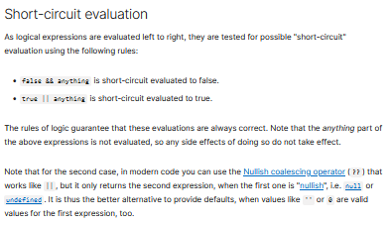

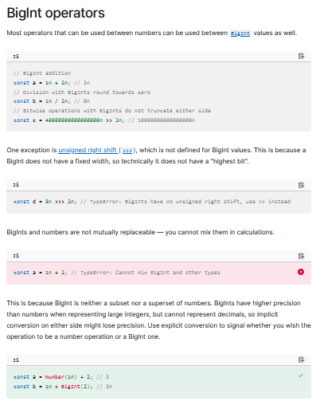

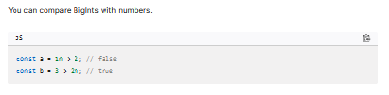

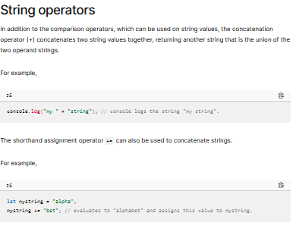

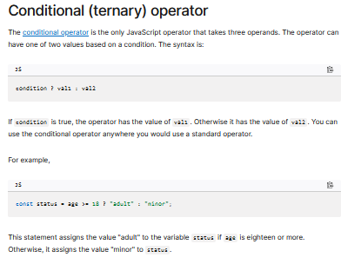

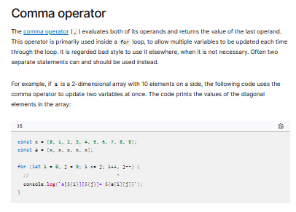

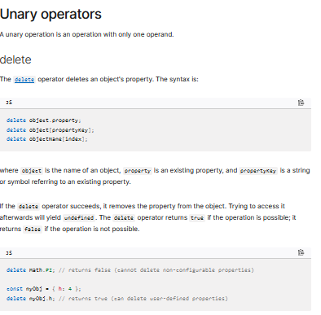

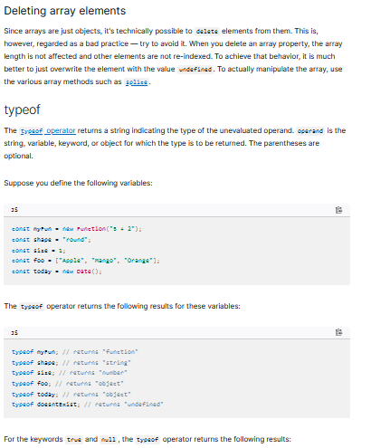

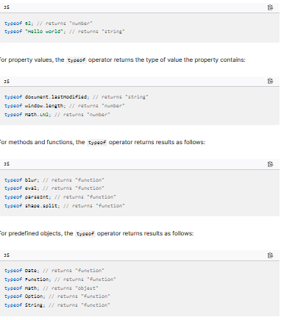

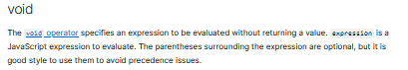

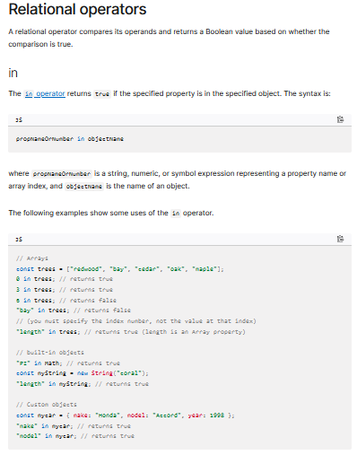

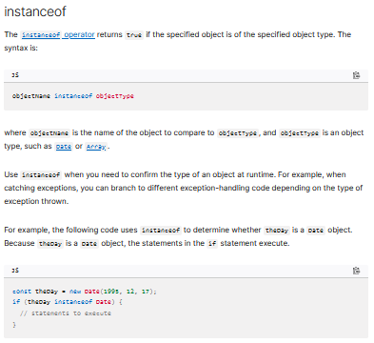

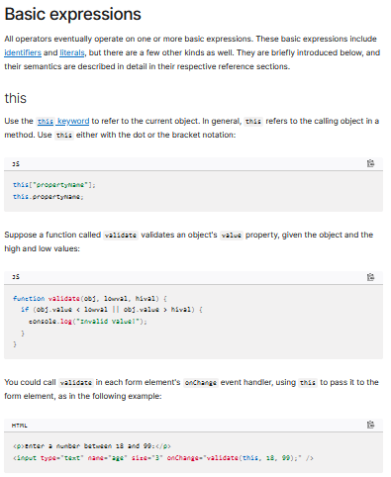

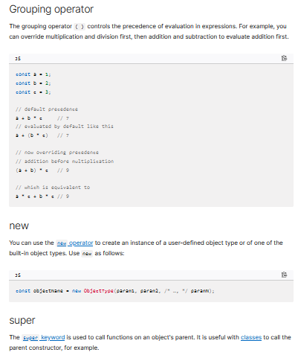

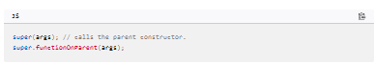

### Check Your Understanding

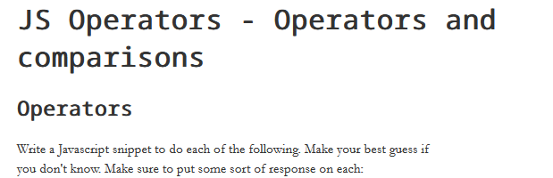

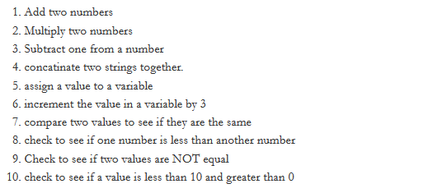

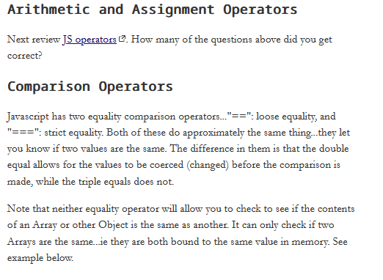

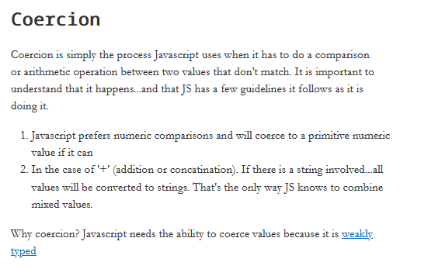

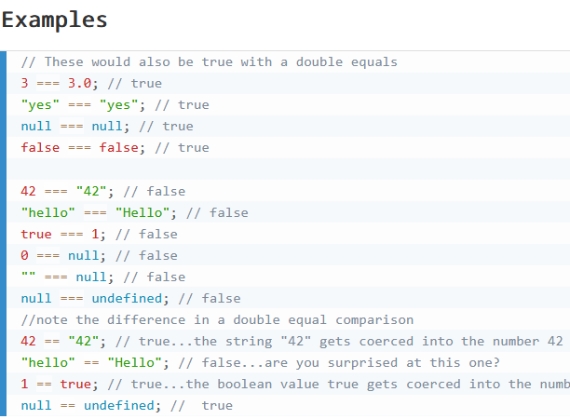

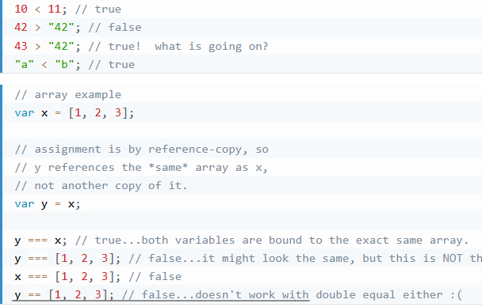

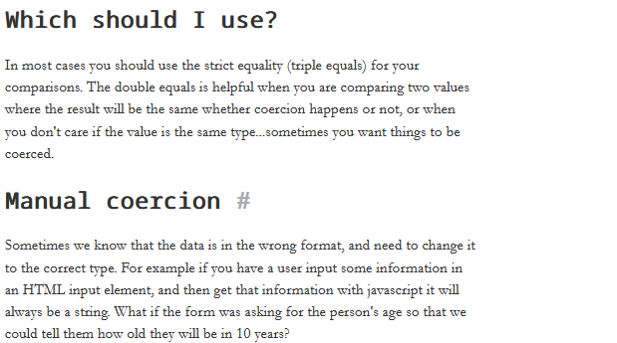

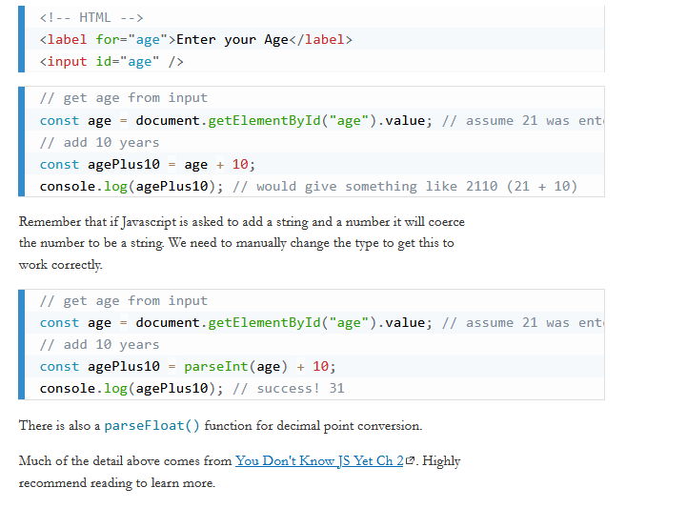

## JavaScript Arrays and Array Methods

### Overview

An array is a data structure that contains a list of elements which store multiple values in a single variable. Arrays are used to store multiple values in a single variable, instead of declaring separate variables for each value.

### Prepare

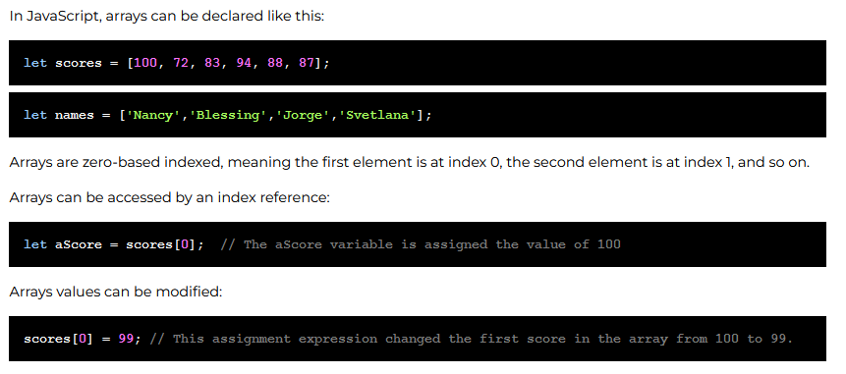

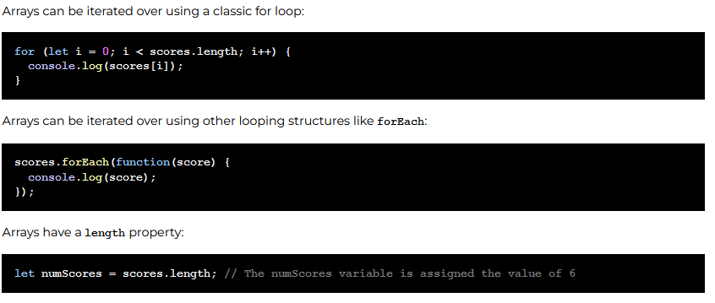

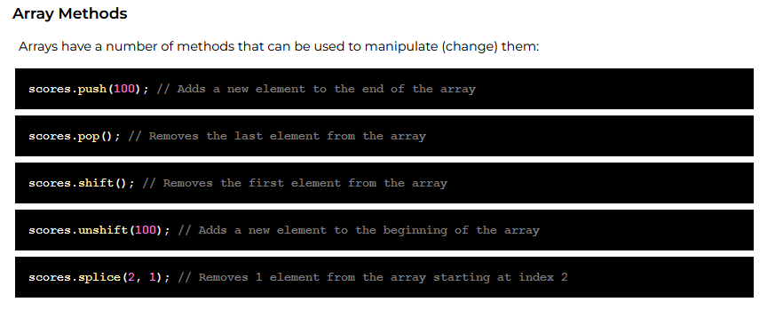

### Check Your Understanding

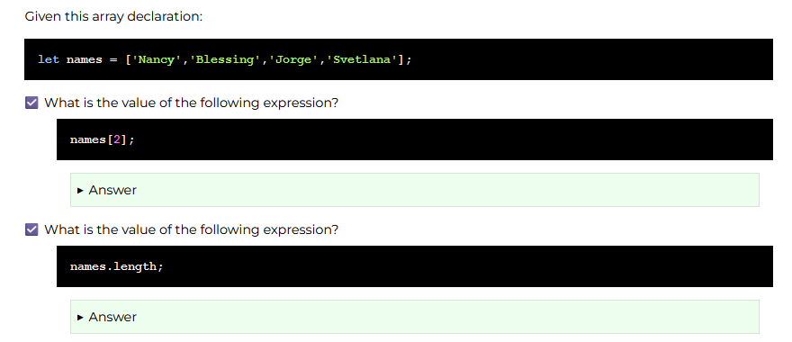

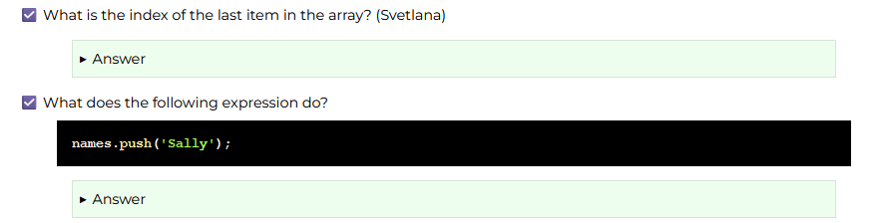

## Template Literals (Template Strings)

### Overview

JavaScript template literals are string literals allowing embedded expressions. You can use multi-line strings and string interpolation features with them. They were called "template strings" in prior editions of the ES2015 specification.



### Prepare

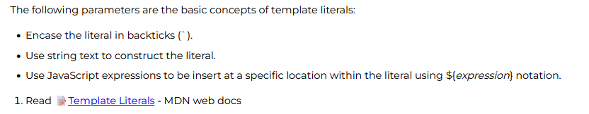

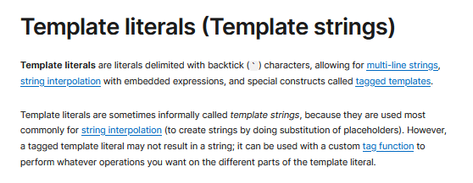

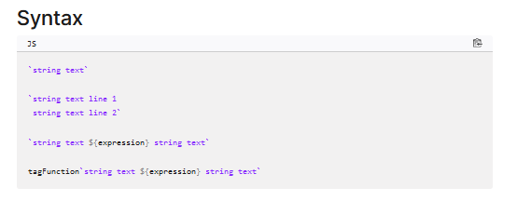

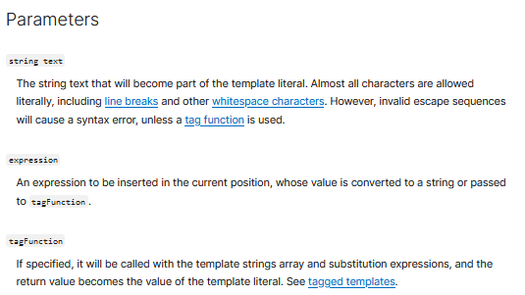

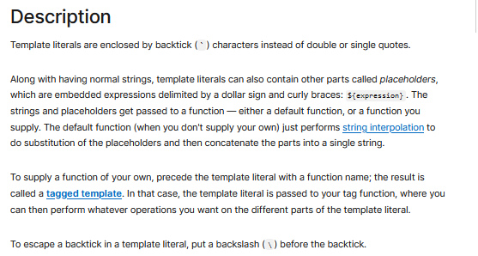

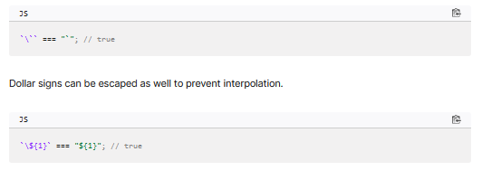

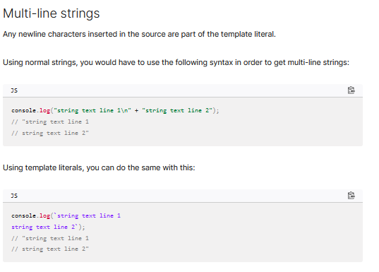

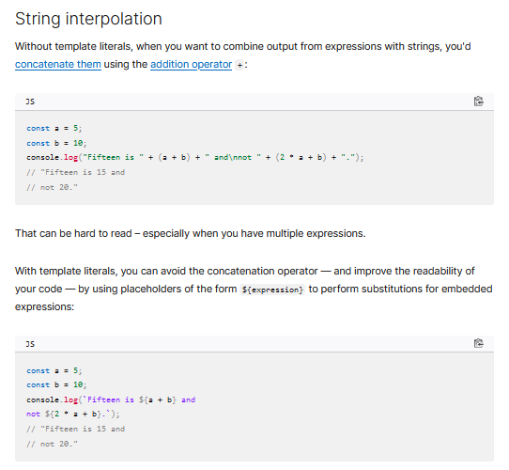

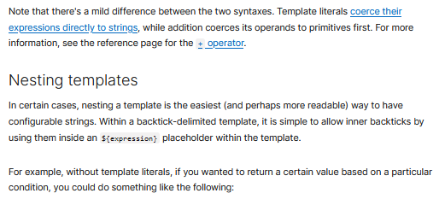

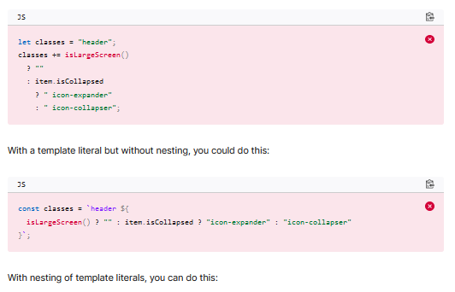

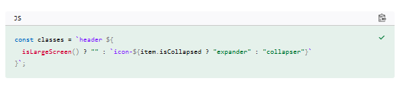

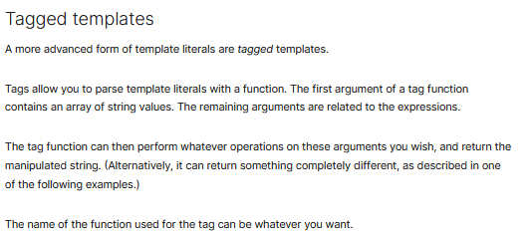

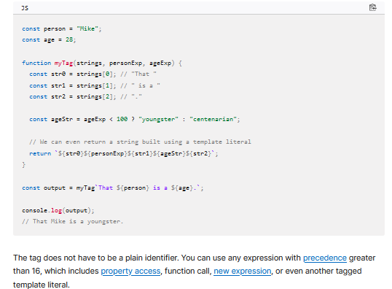

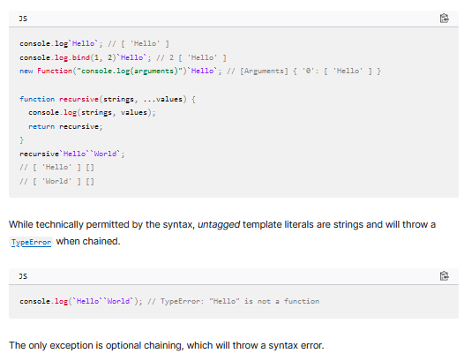

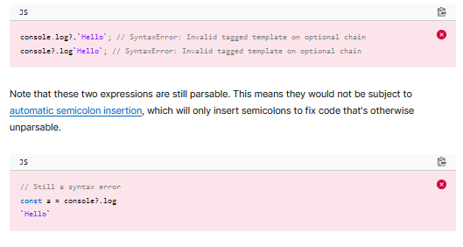

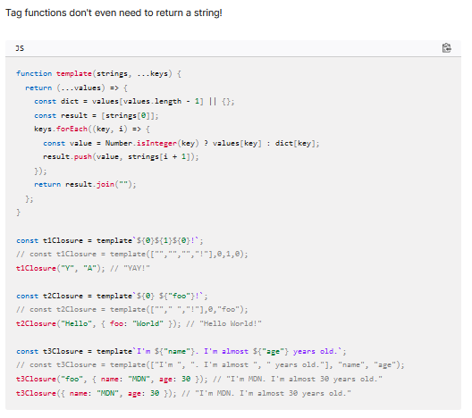

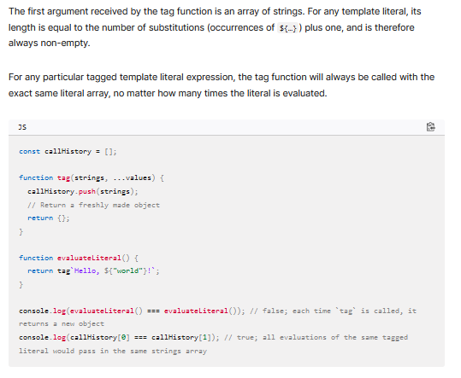

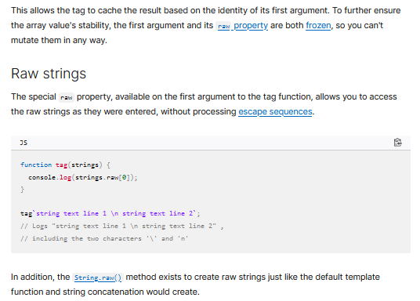

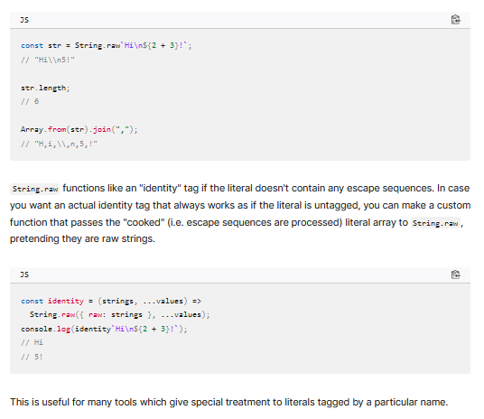

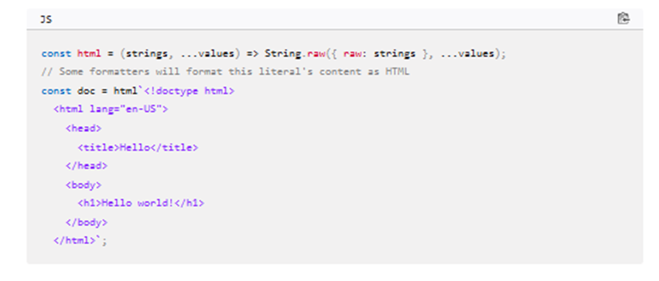

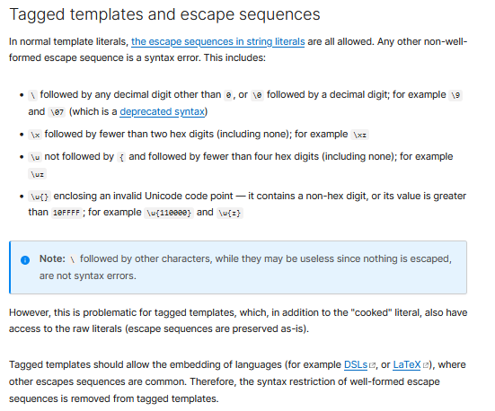

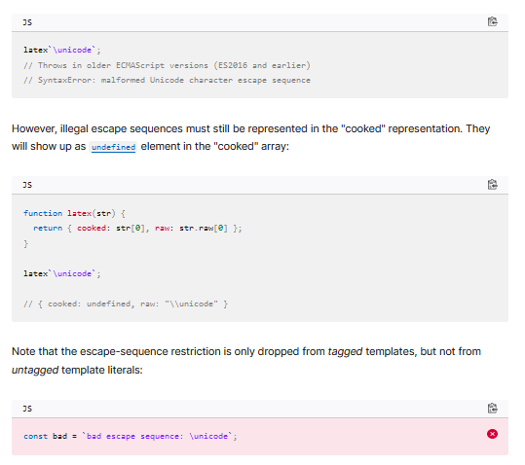

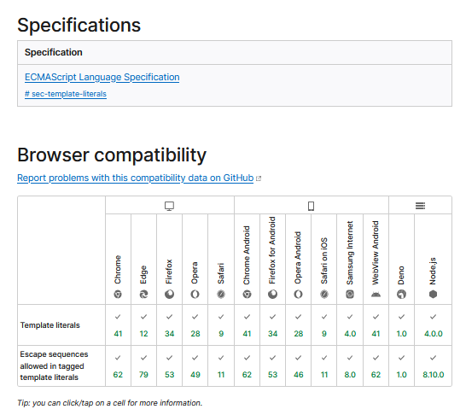

### Check Your Understanding

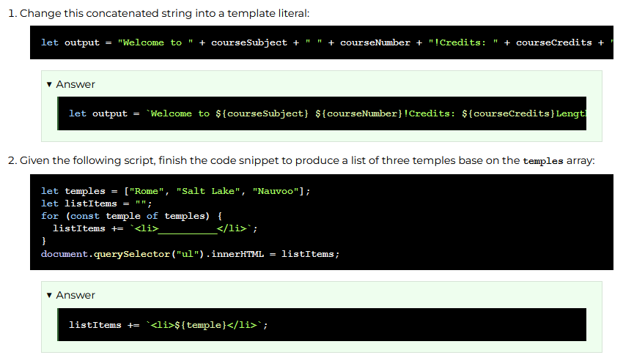

## Manipulating Documents using the DOM

### Overview

The Document Object Model or DOM represents the logical tree structure of a document. The DOM allows us to connect to the document through programming languages, including JavaScript.

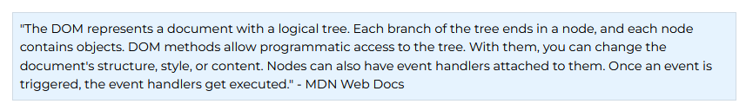

### Prepare

#### Document Object Model



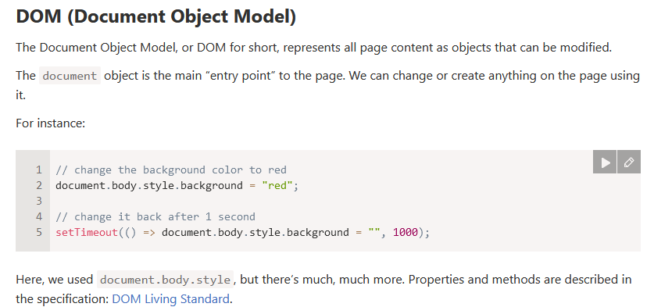

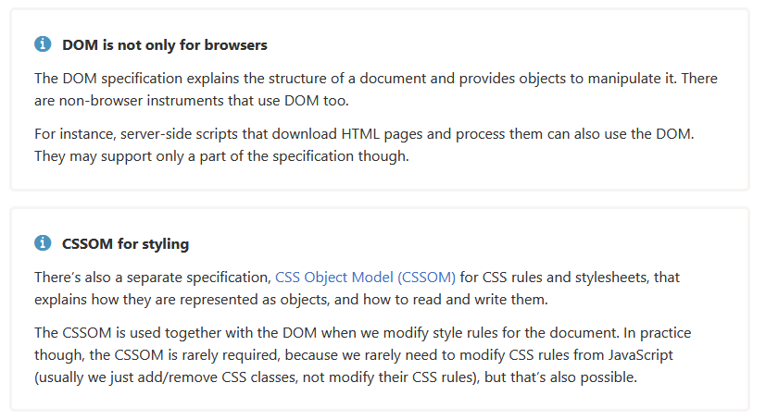

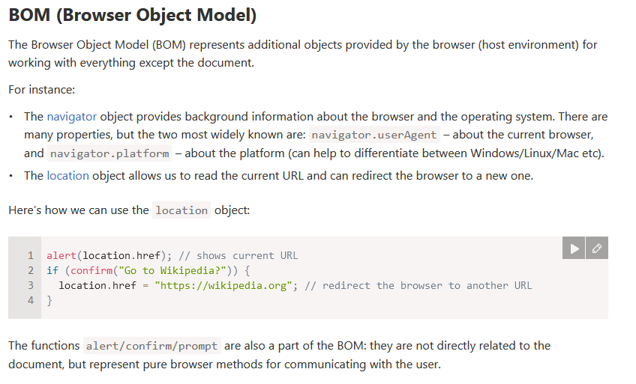

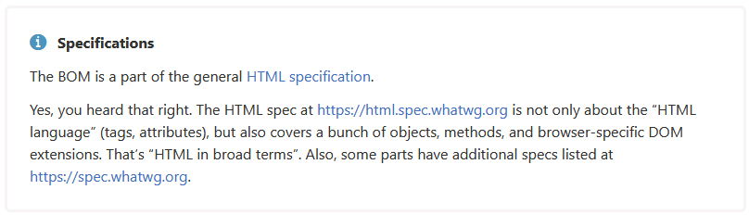

#### Dom Tree

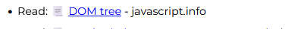

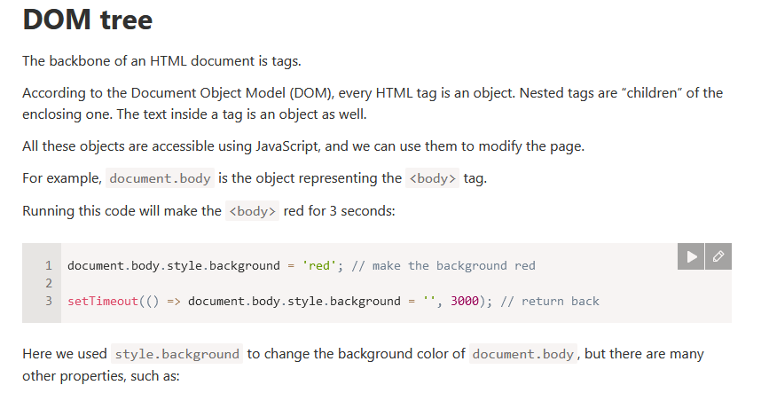

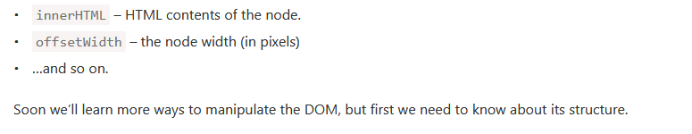

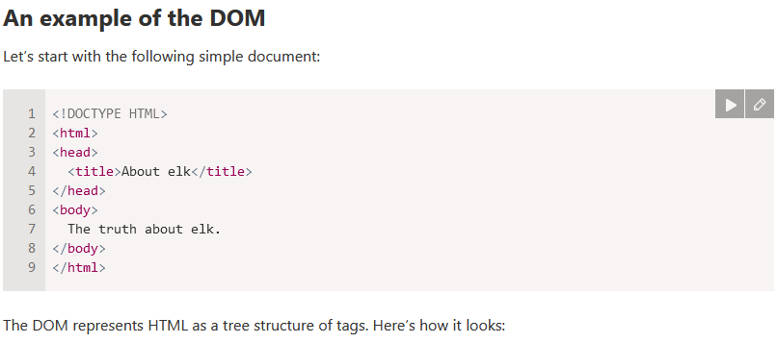

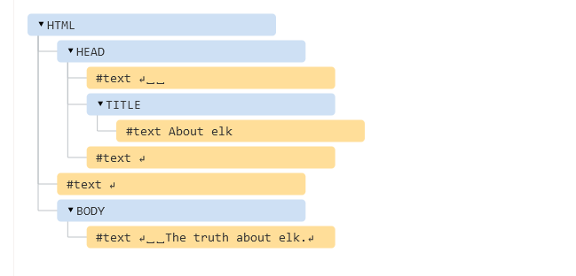

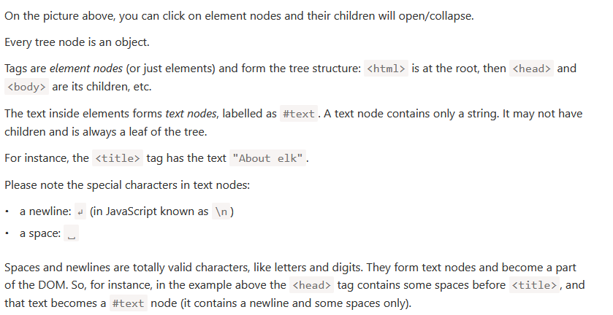

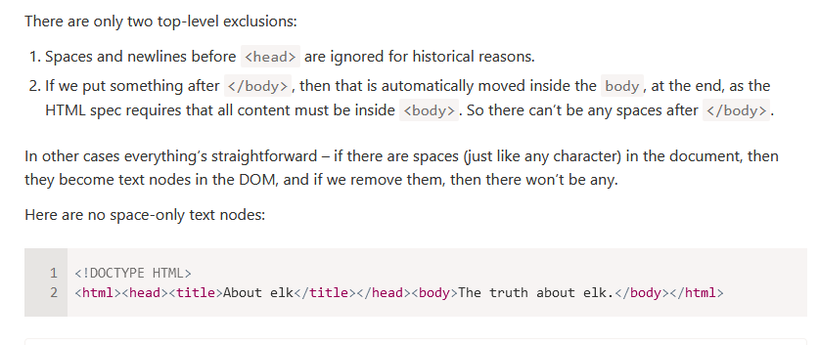

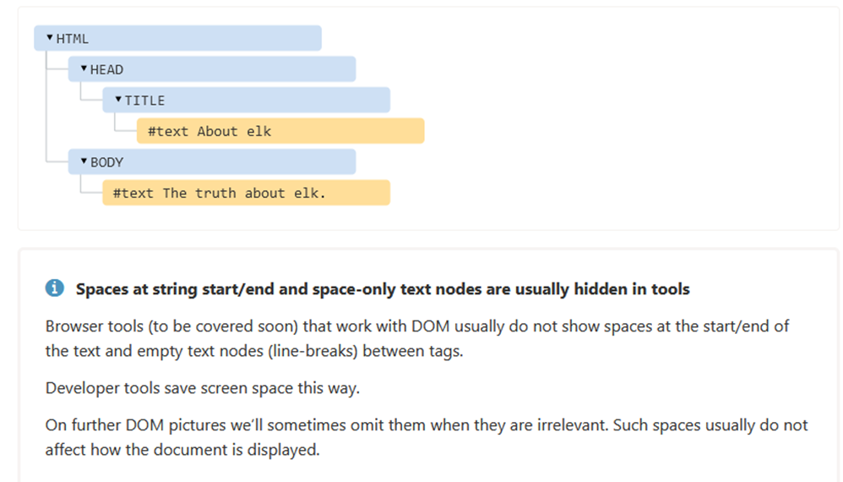

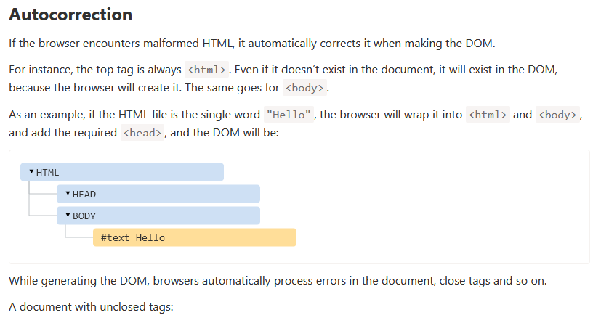

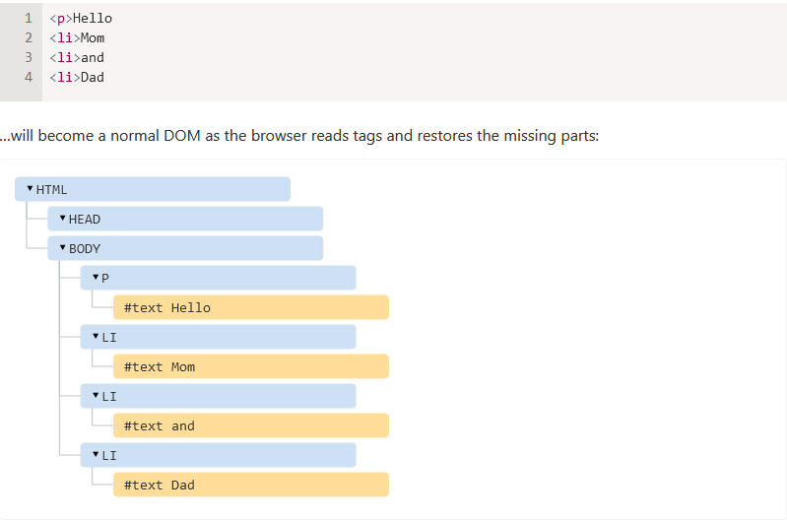

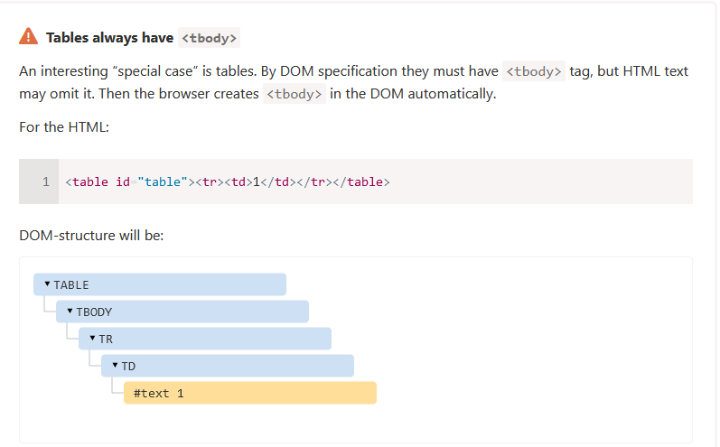



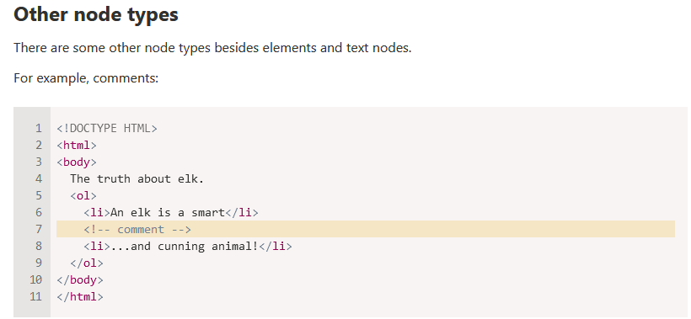

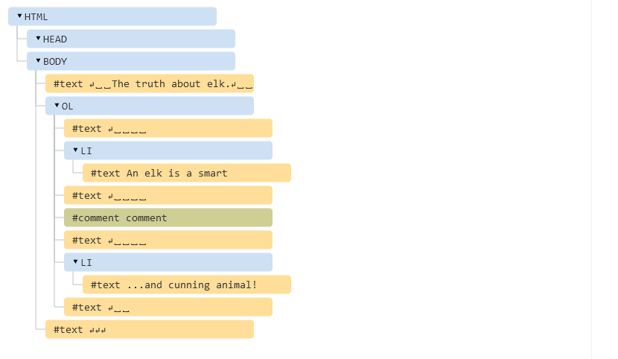

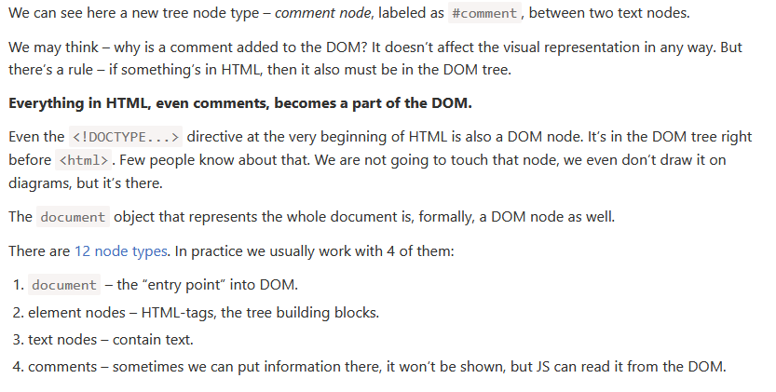

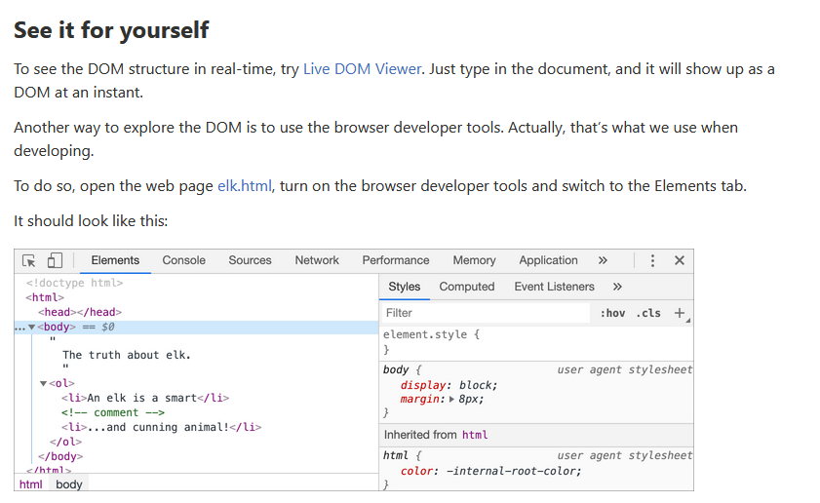

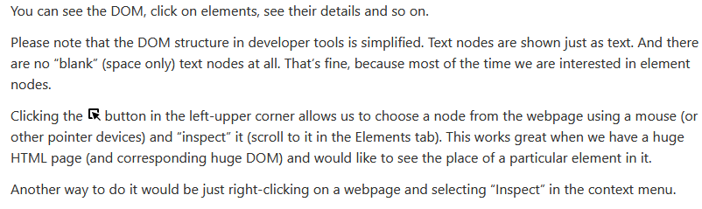

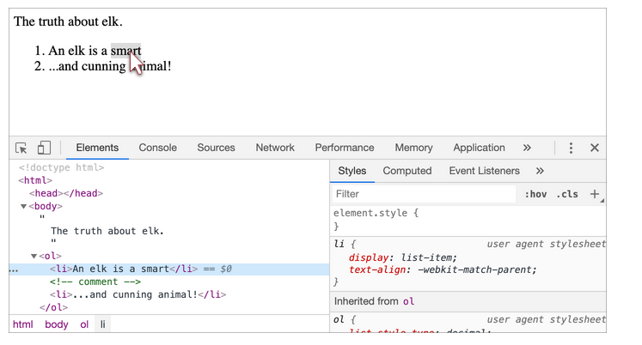

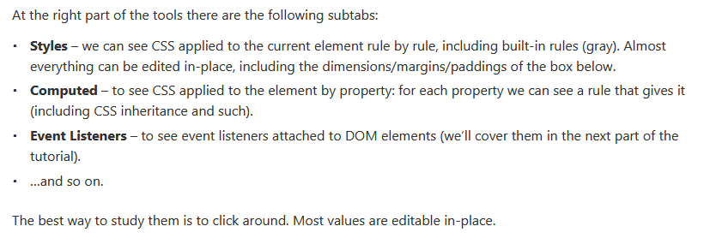

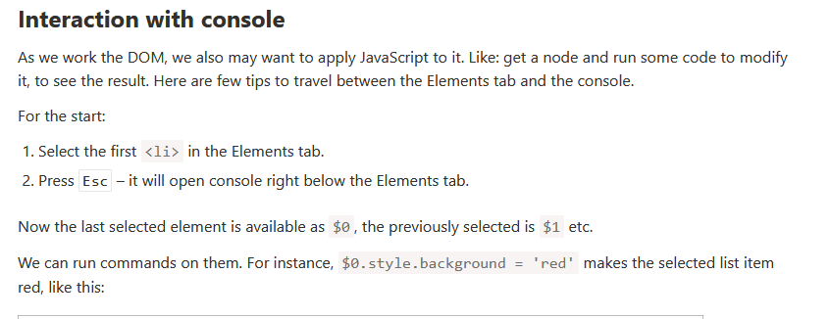

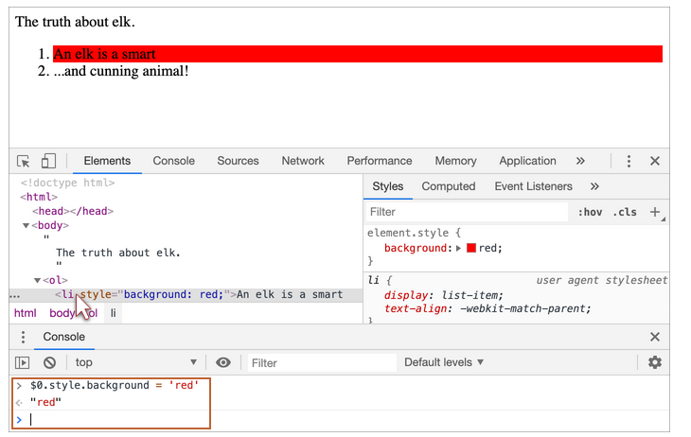

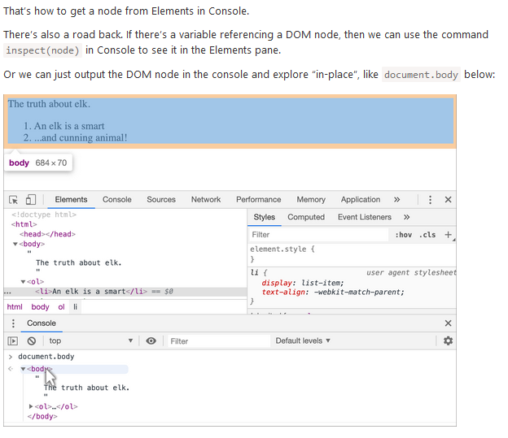

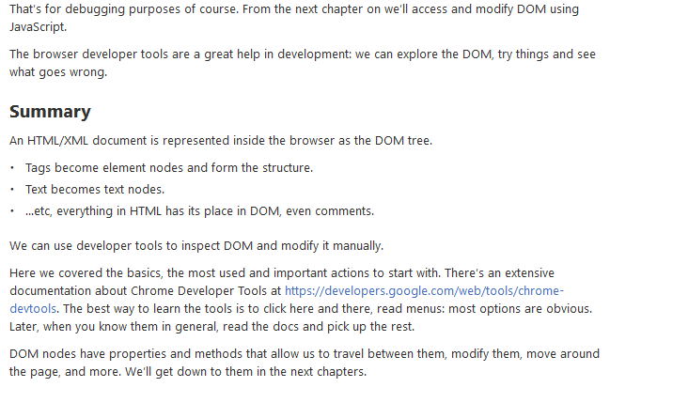

#### Manipulating Documents



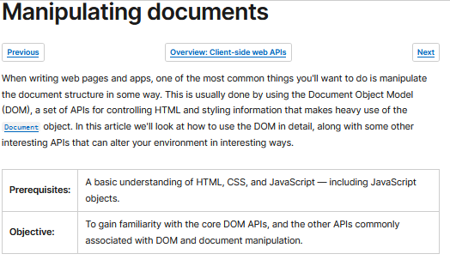

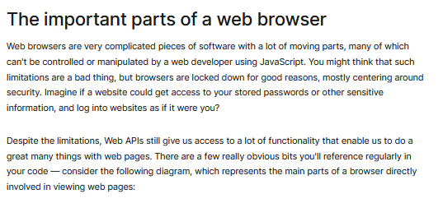

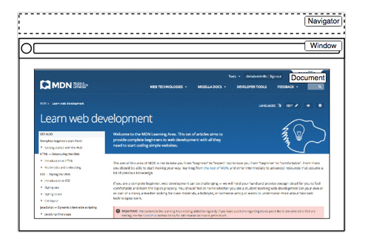

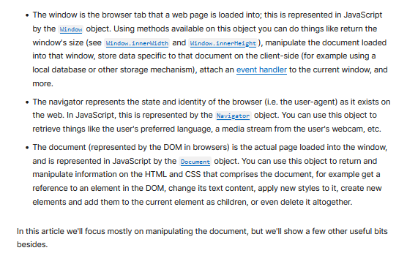

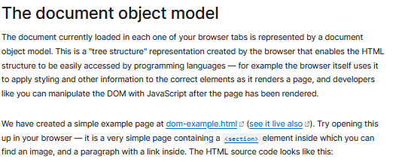

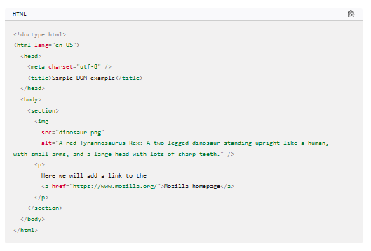

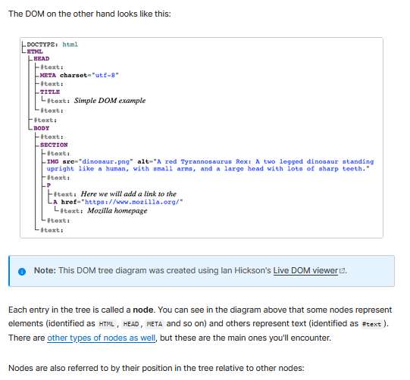

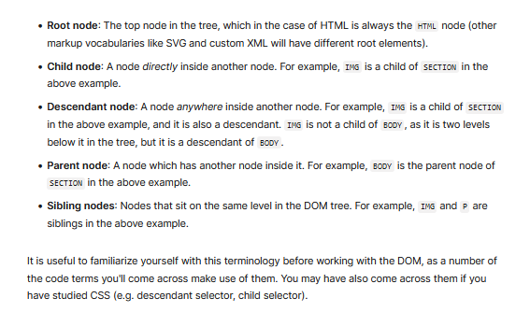

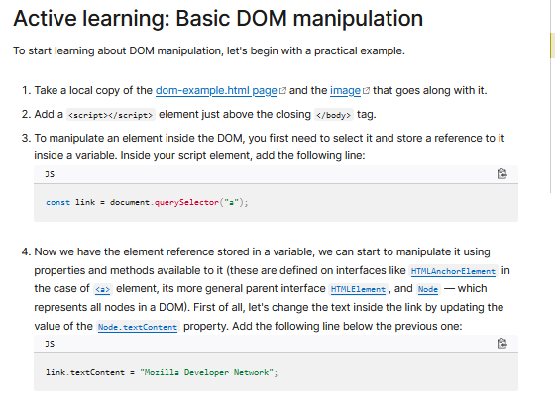

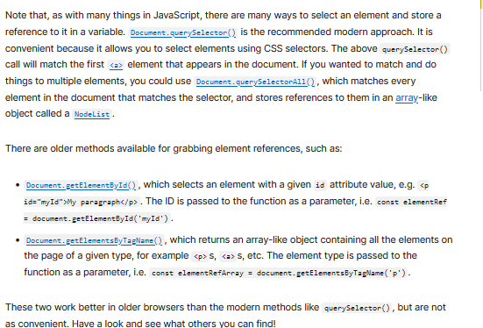

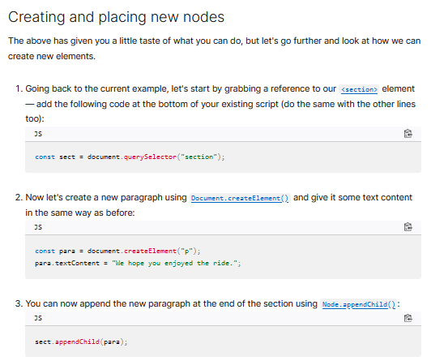

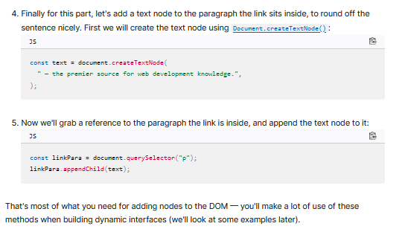

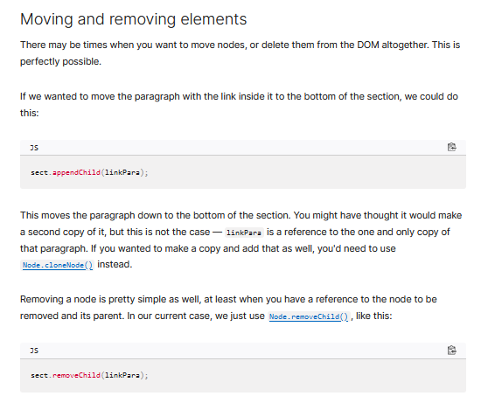

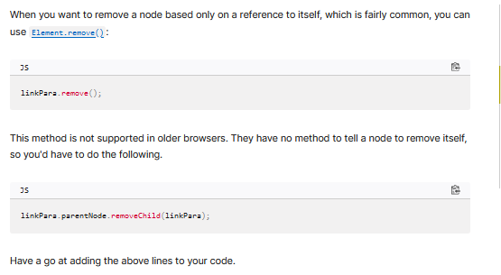

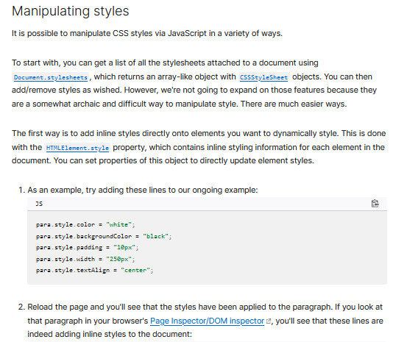

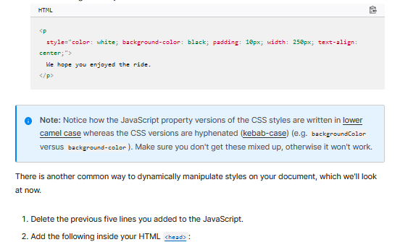

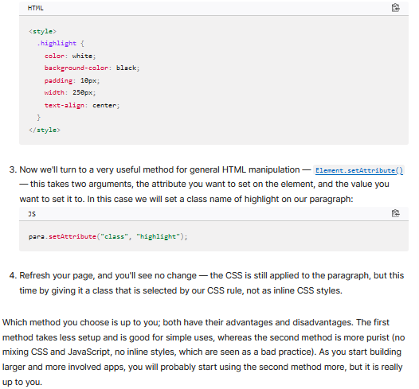

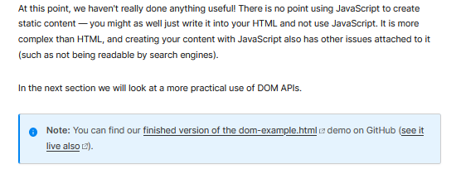

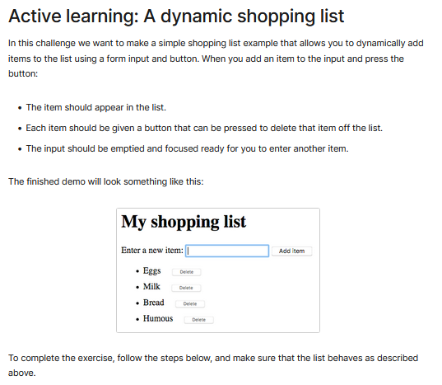

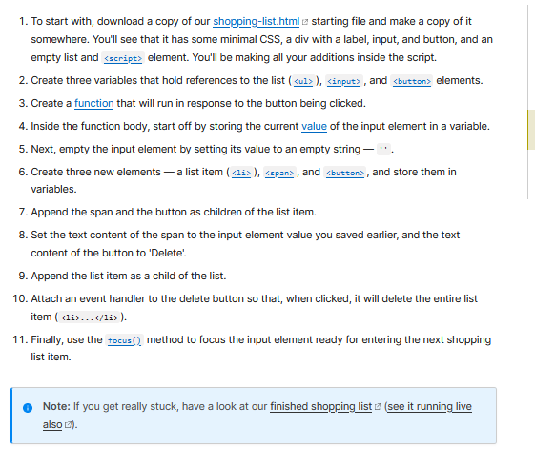

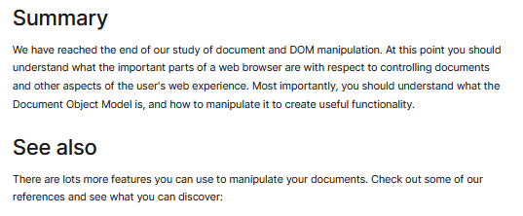

### Check Your Understanding



#### Dom Basics

DOM Basics - Ponder activities.

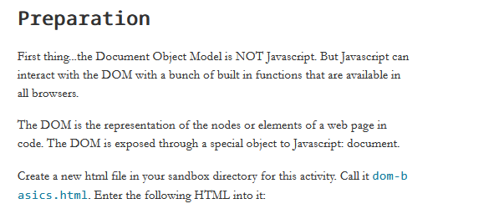

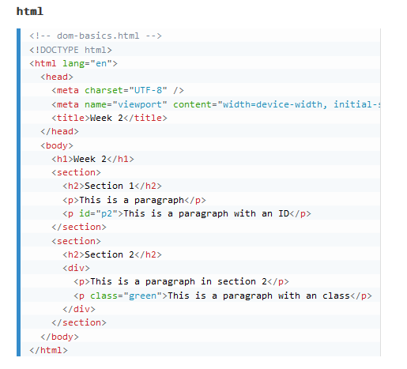

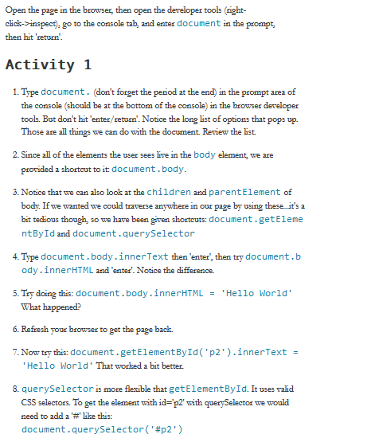

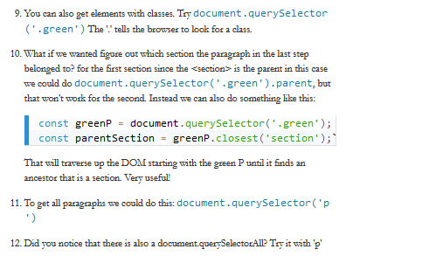

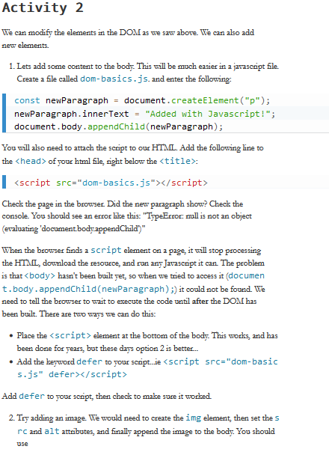

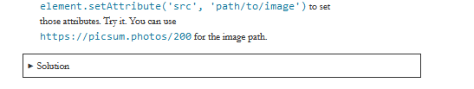

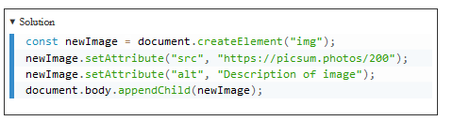

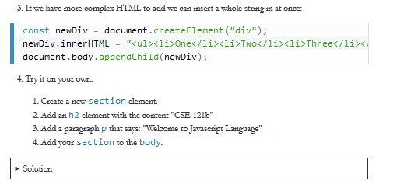

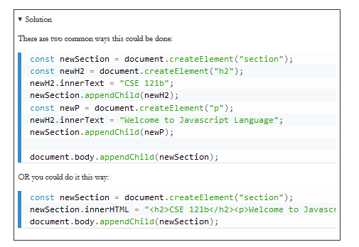

# WEEK 3

## JavaScript Conditions and Branching

### Overview

There are common control structures in all programming languages that allow you to control the flow of the program including sequence, branching, looping, and functions. In JavaScript, these decision blocks are the if, else, else if, switch, and case statements. These statements allow you to control the flow of the program based on the Boolean result of a condition.

### Prepare

#### Conditionals and Branching

**JS Operators - Conditionals and Branching**

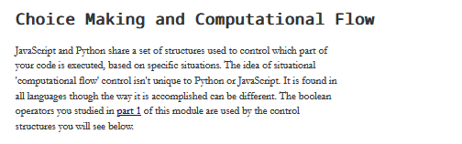

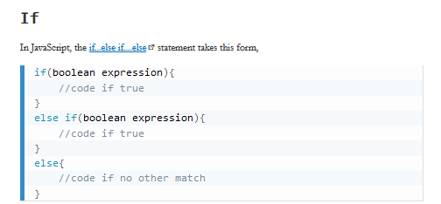

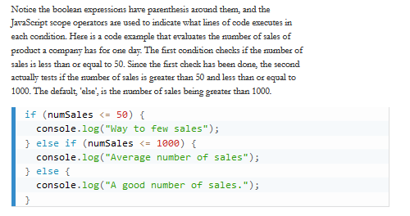

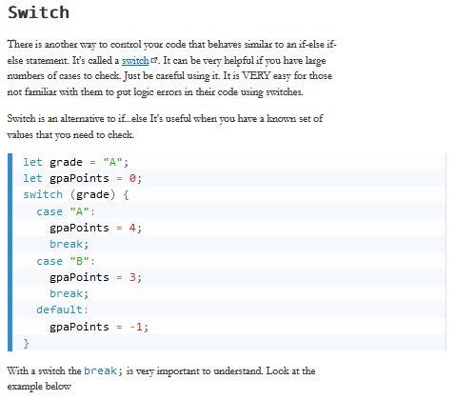

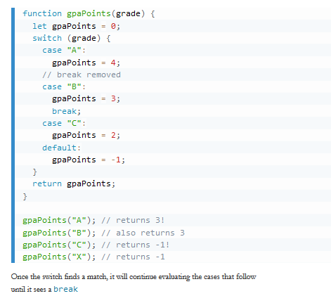

#### Making decisions in your code conditionals

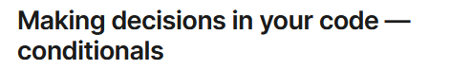

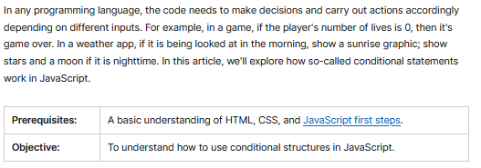

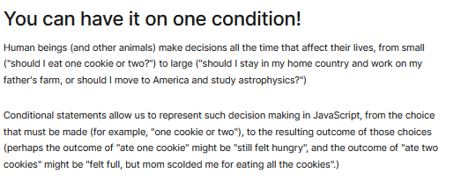

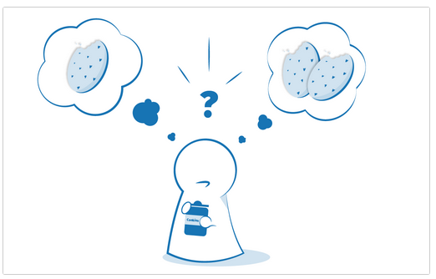

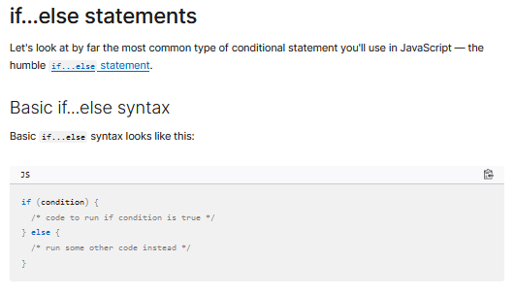

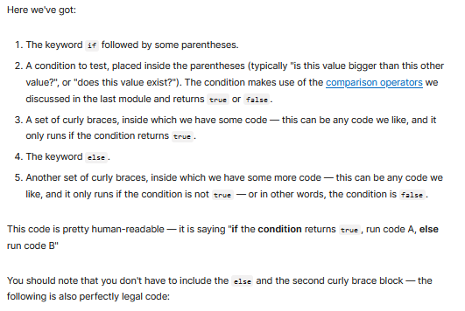

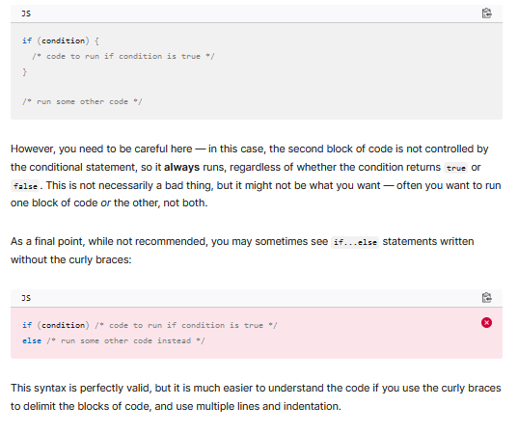

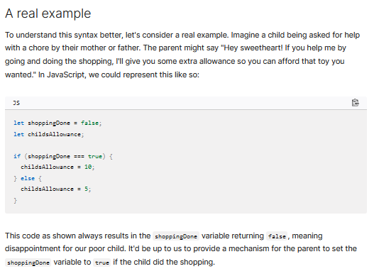

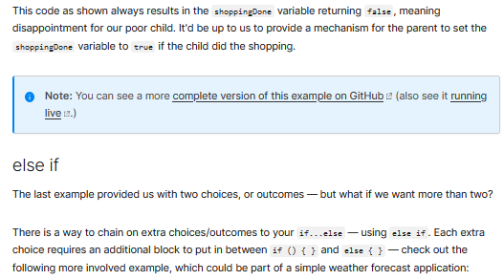

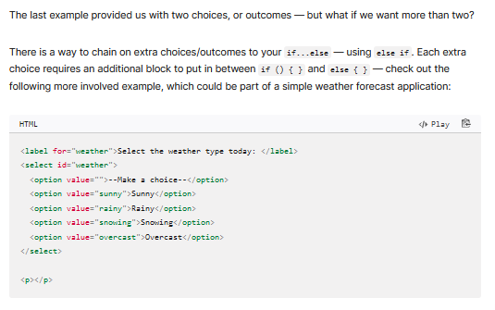

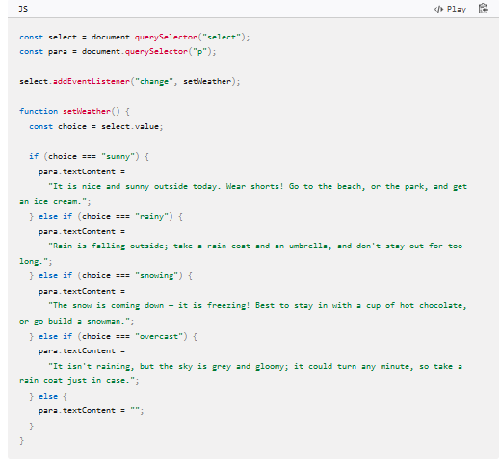

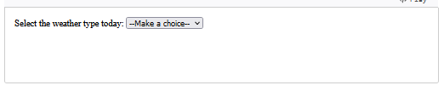

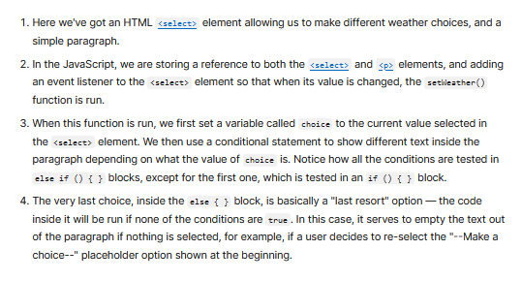

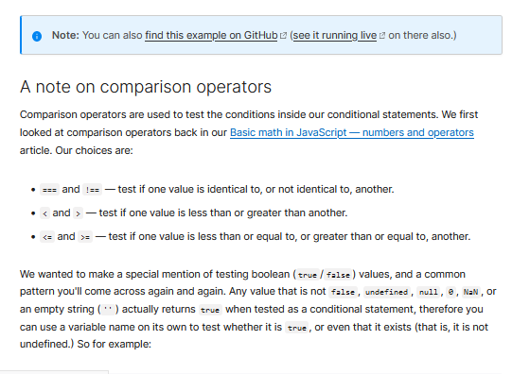

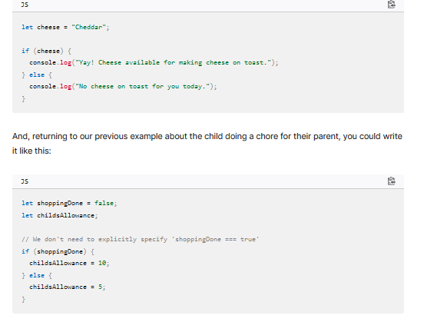

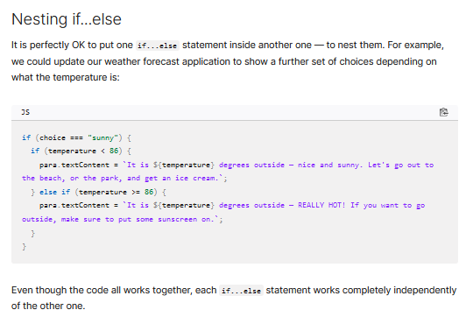

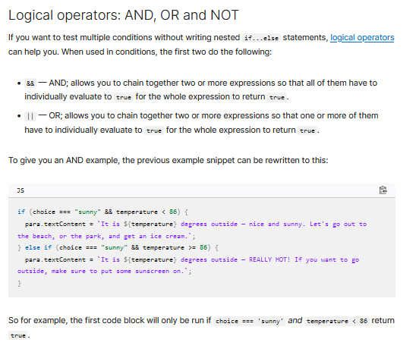

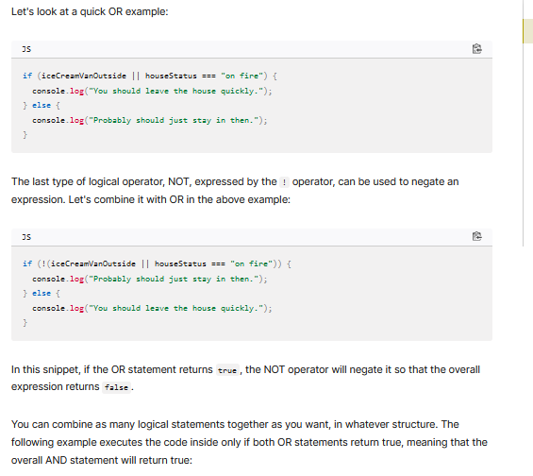

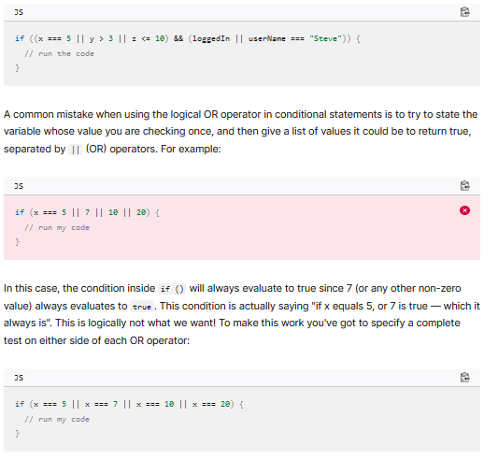

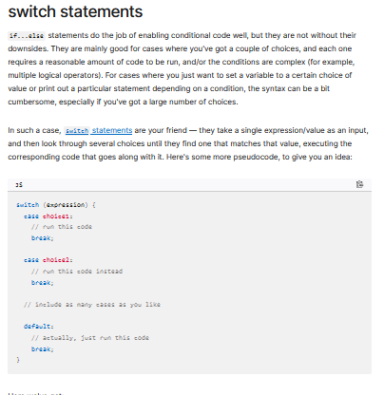

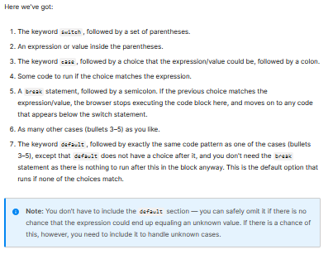

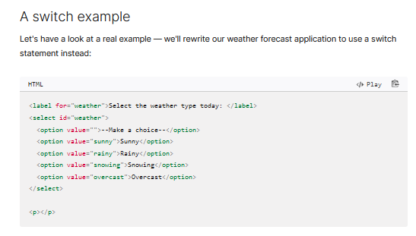

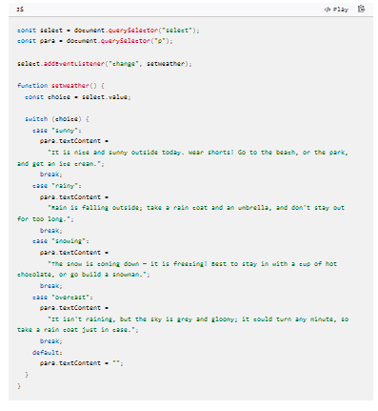

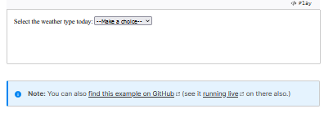

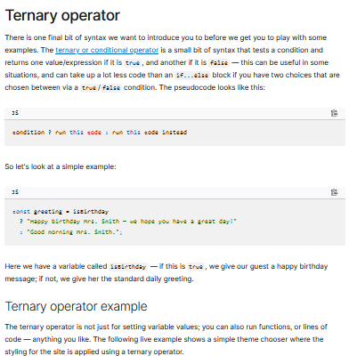

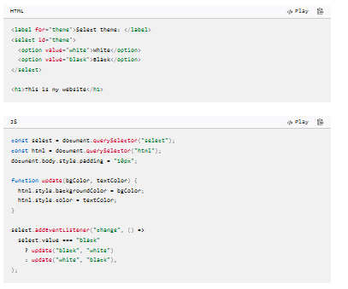

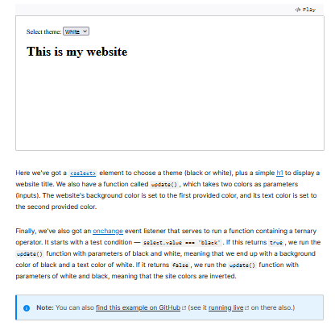

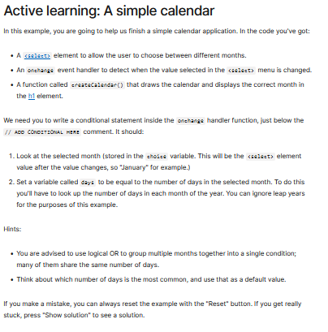

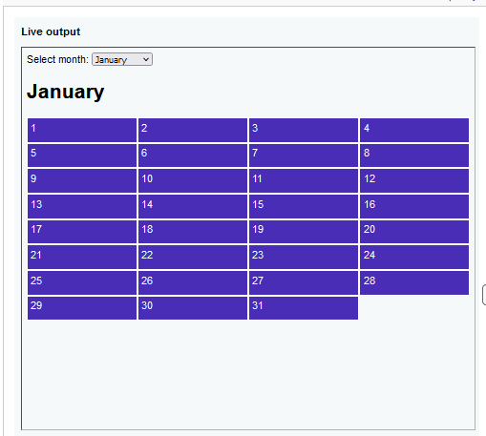

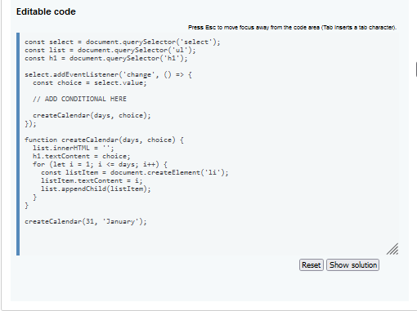

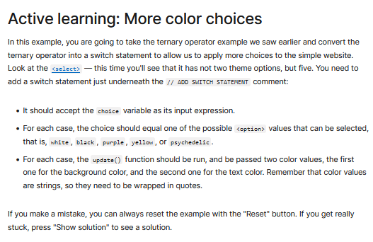

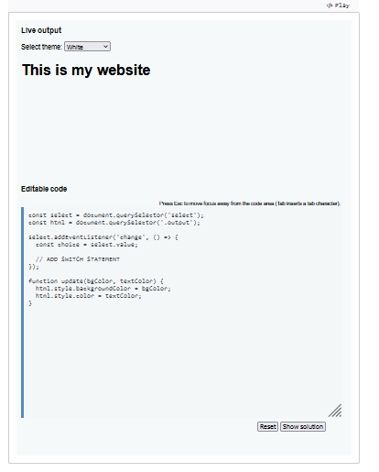

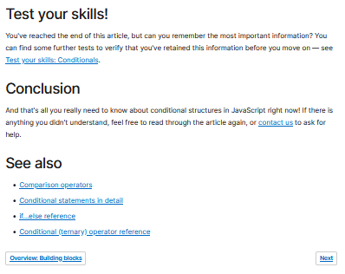

### Check Your Understanding

#### JS Operator

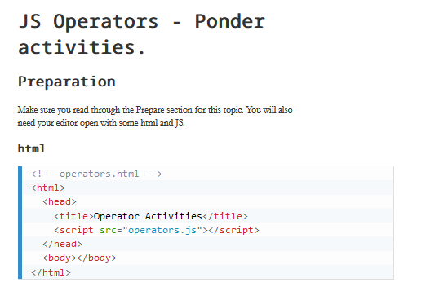

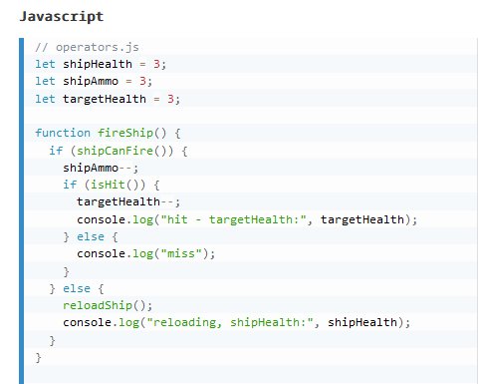

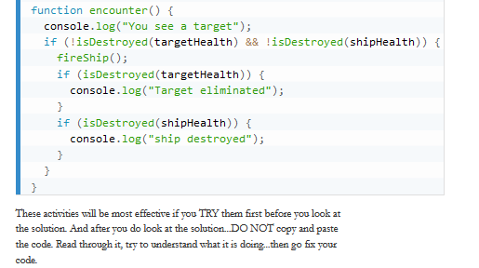

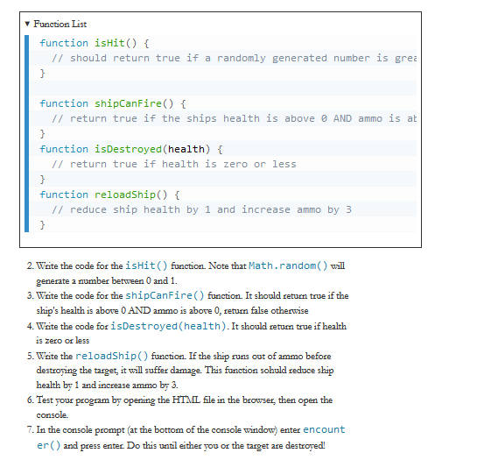

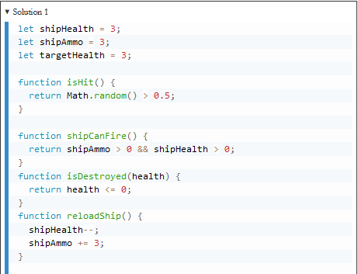

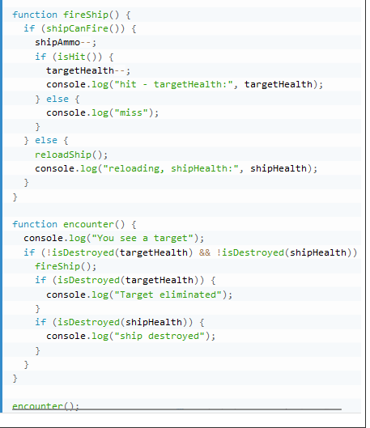

## Functions

### Overview

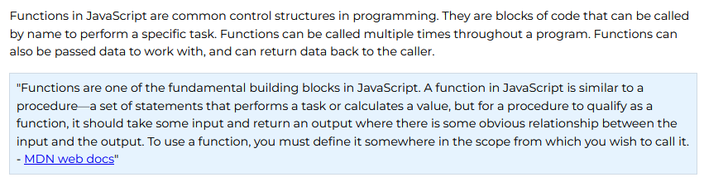

### Prepare

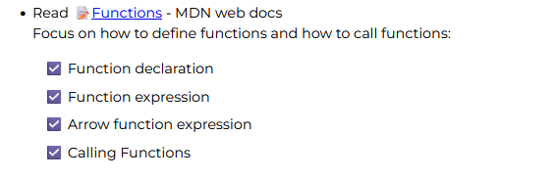

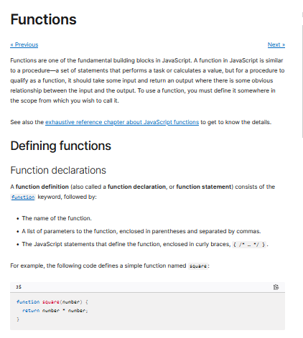

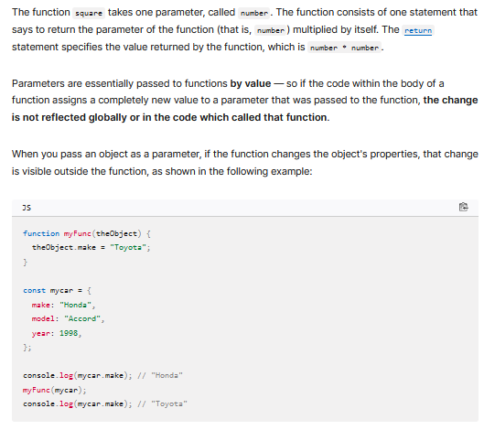

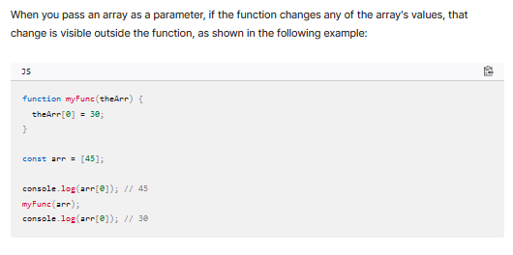



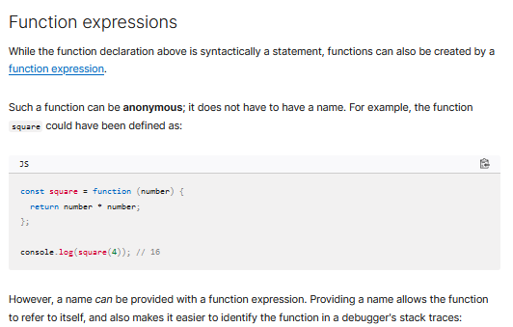

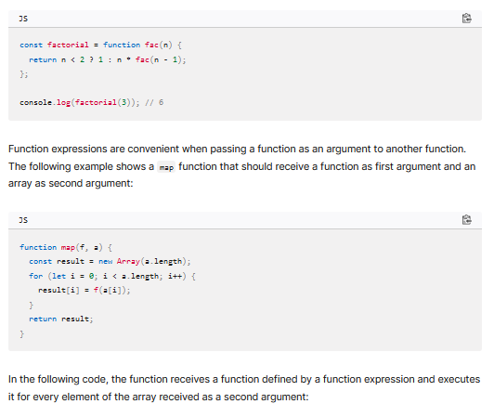

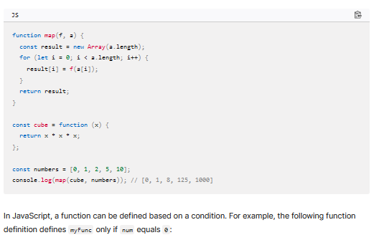

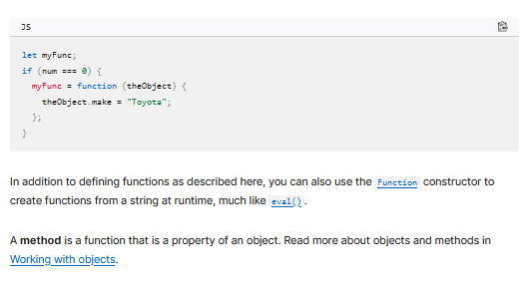

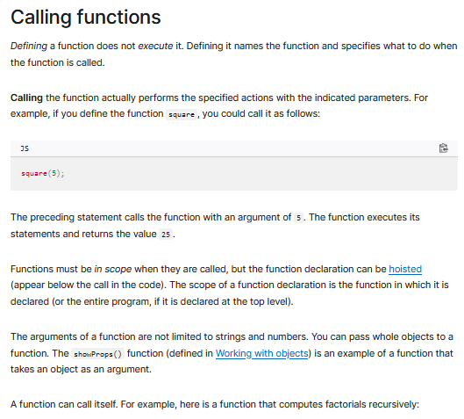

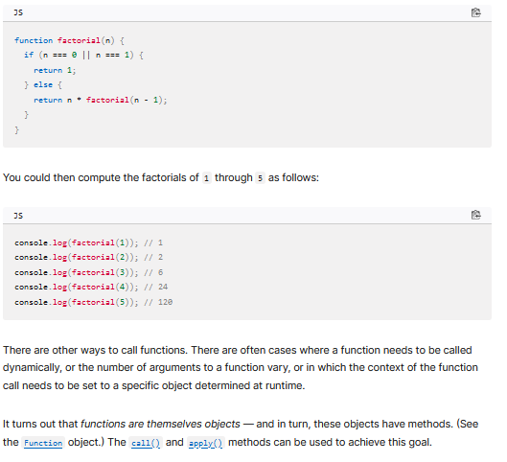

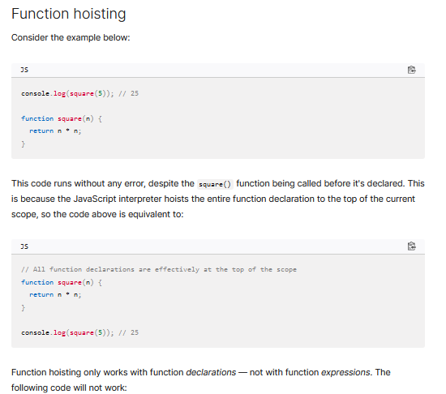

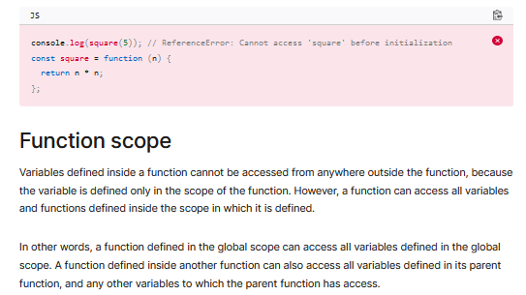

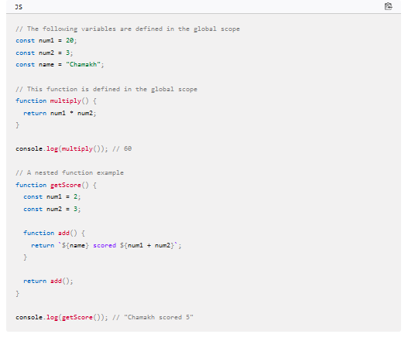

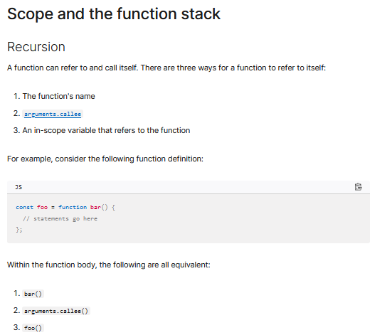

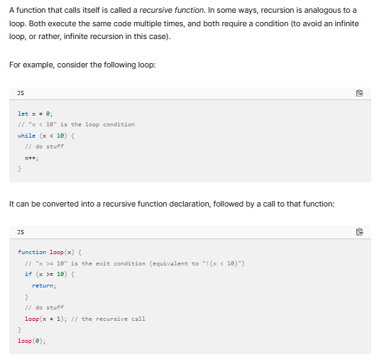

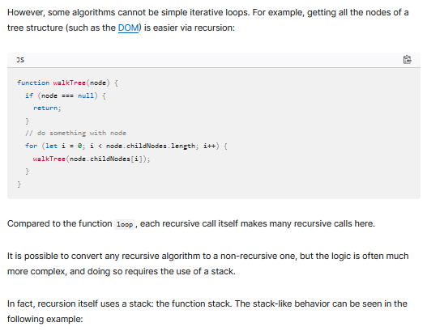

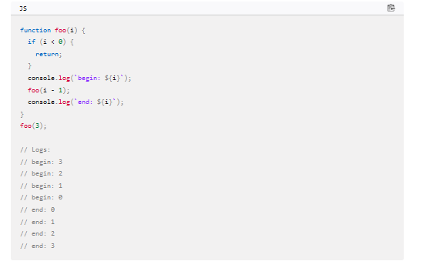

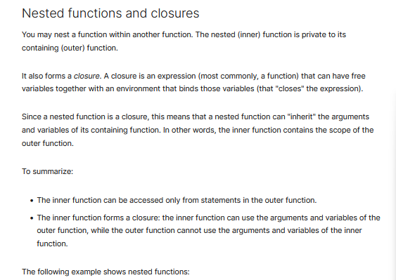

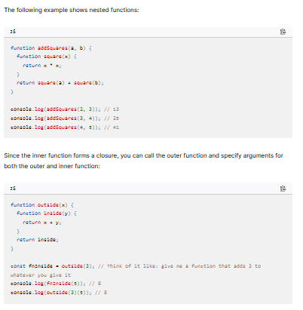

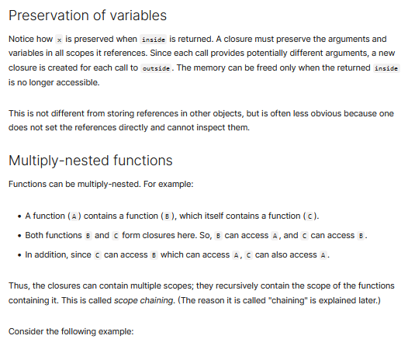

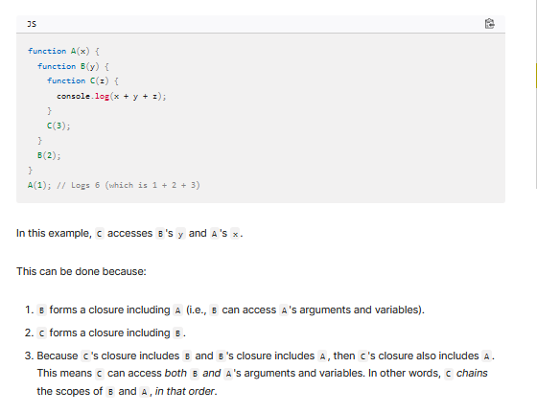

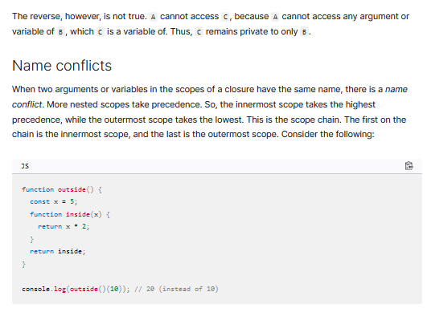

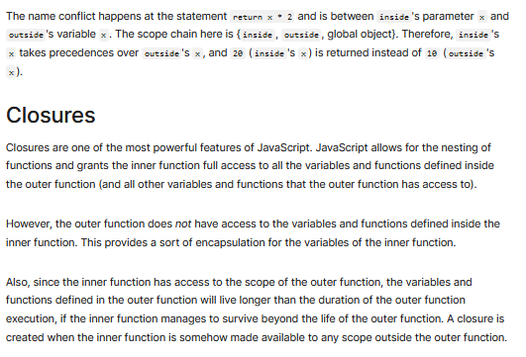

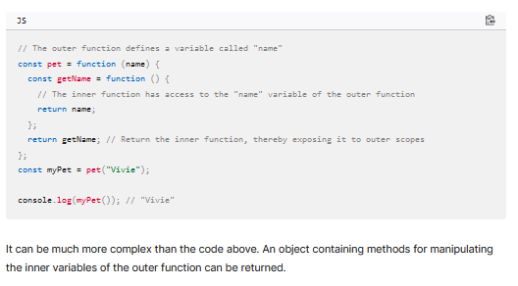

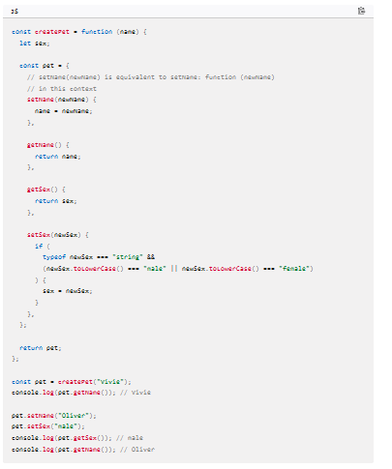

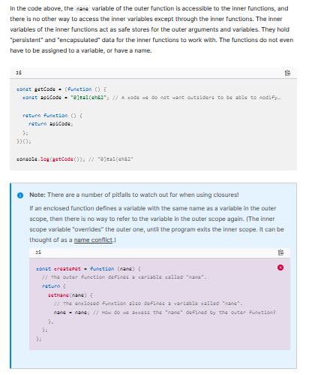

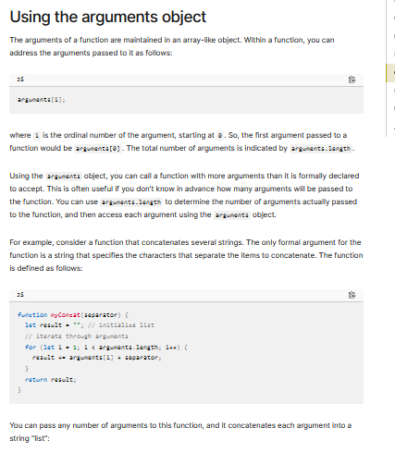

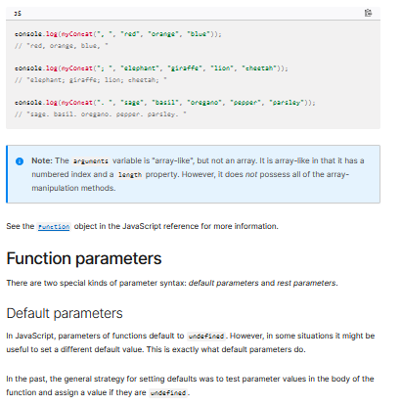

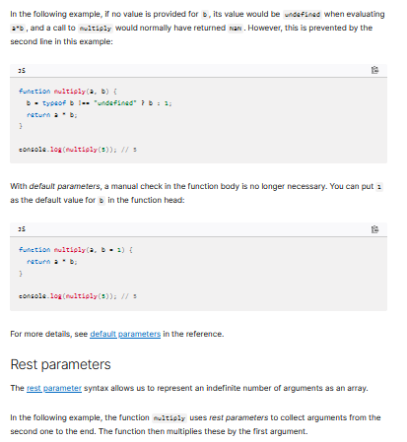

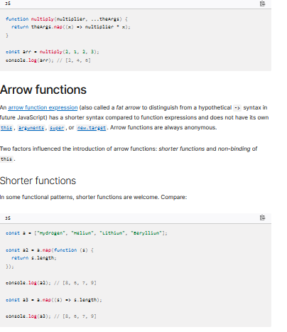

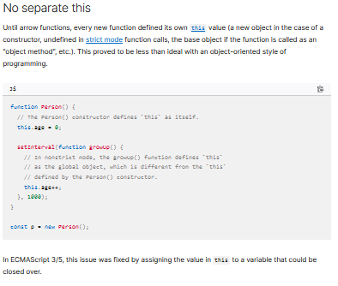

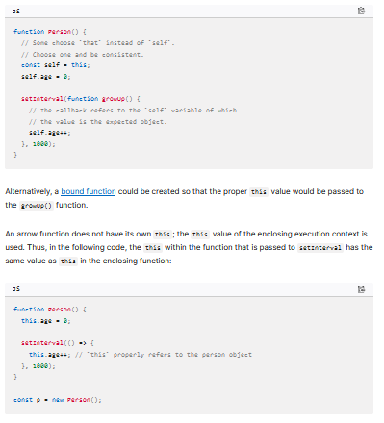

### Check Your Understanding

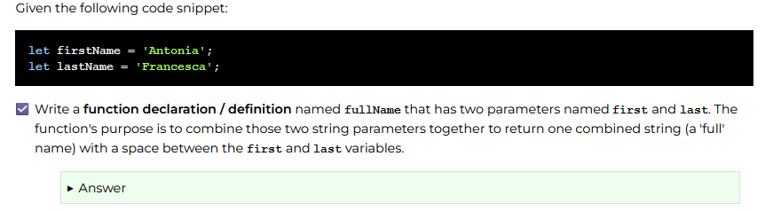

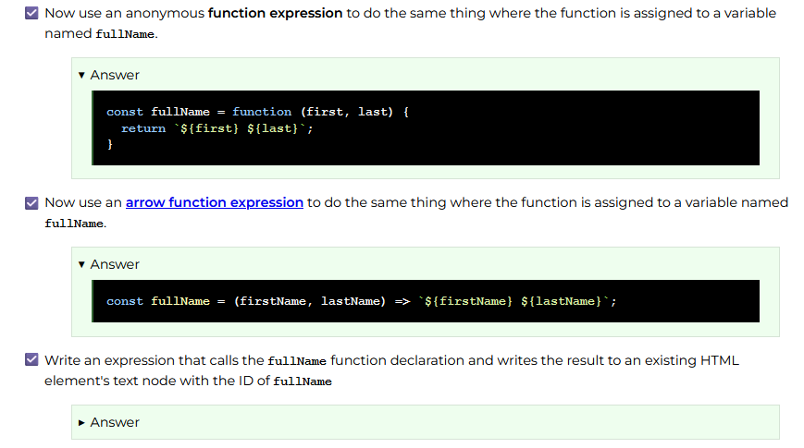

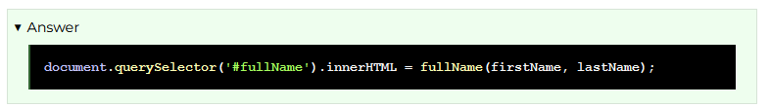

## Array Methods for Functional Programming

### Overview

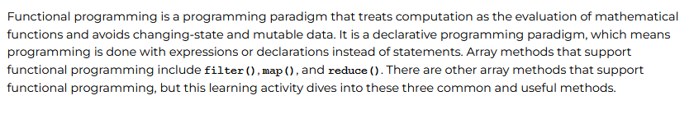

### Prepare

#### array.filter()

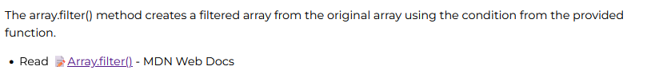

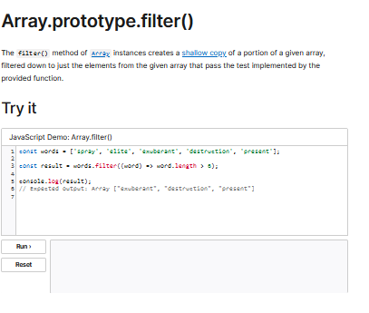

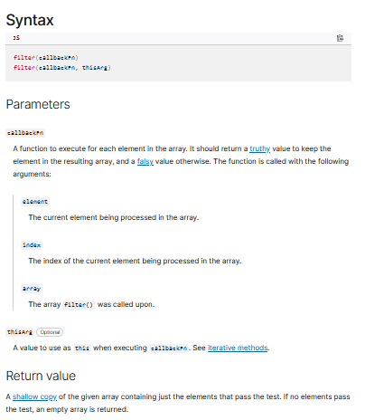

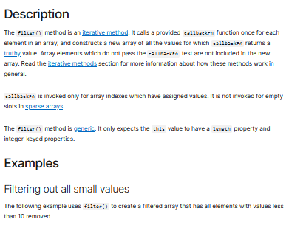

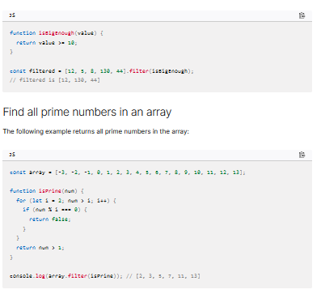

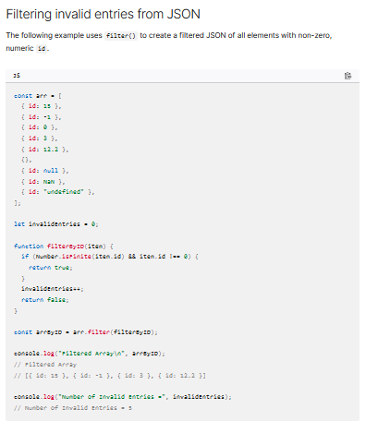

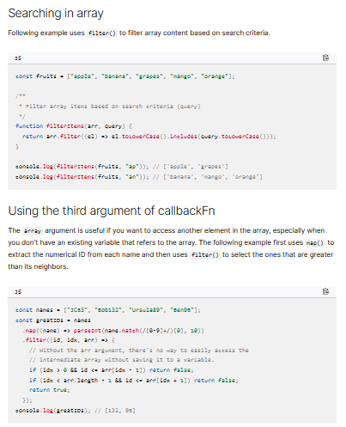

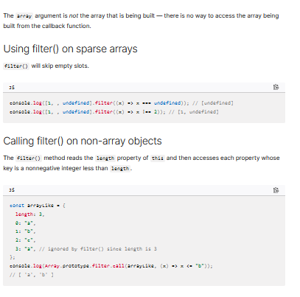

#### array.map()

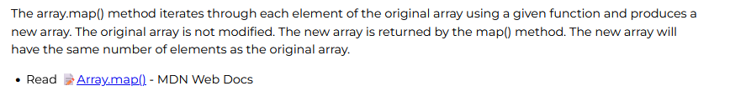

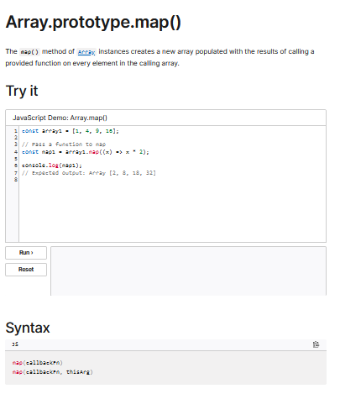

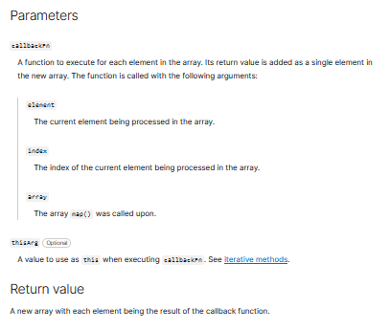

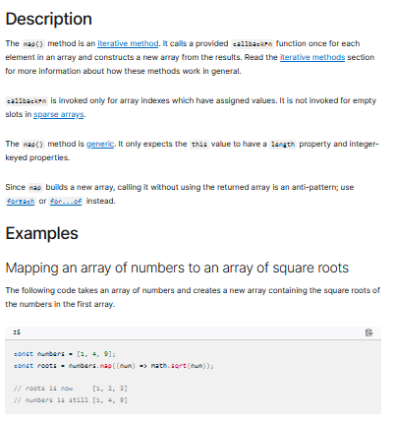

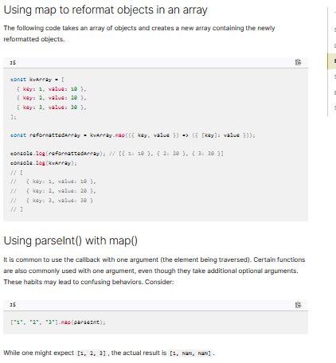

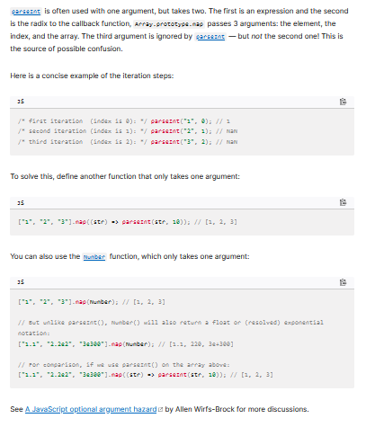

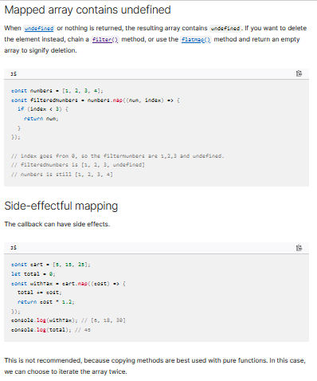

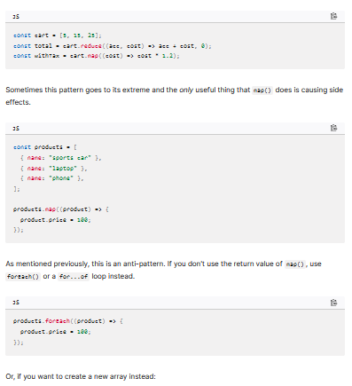

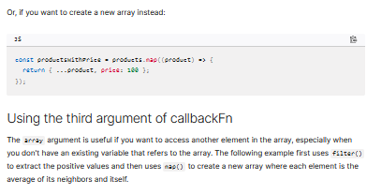

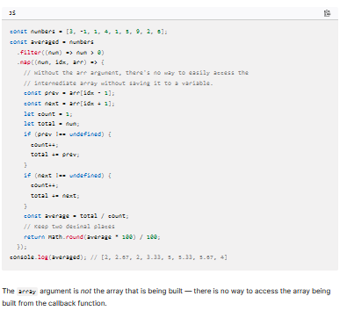

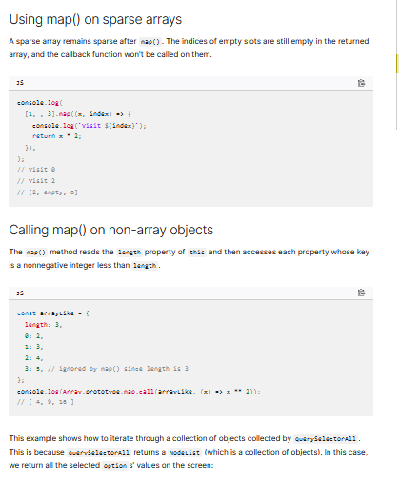

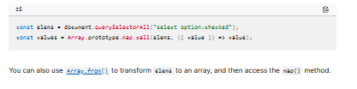

#### array.reduce()

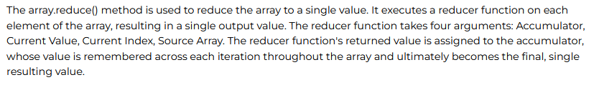



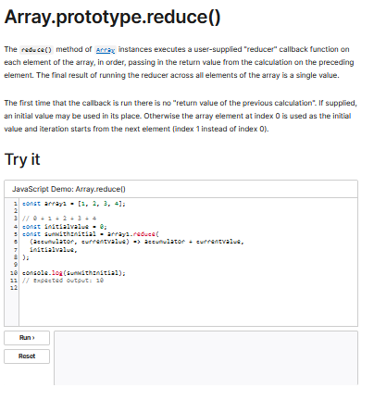

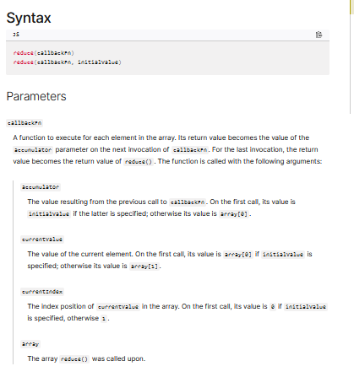

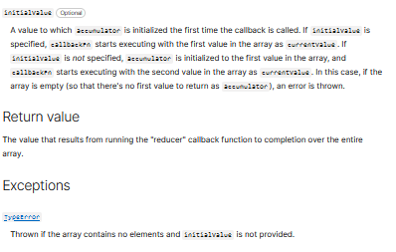

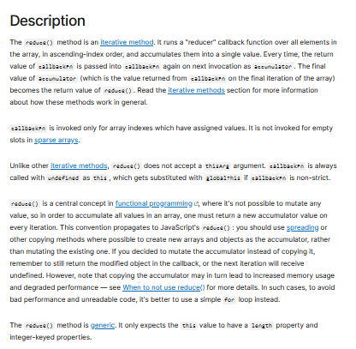

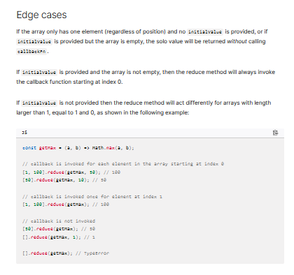

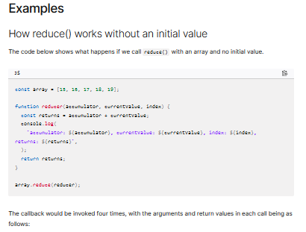

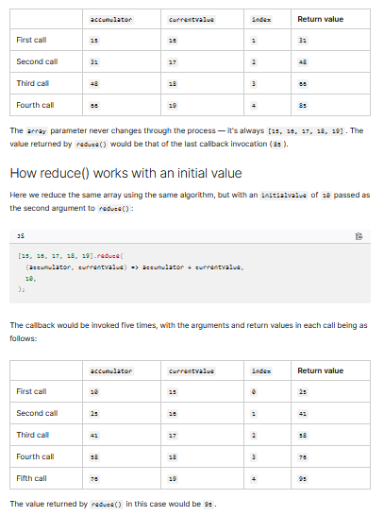

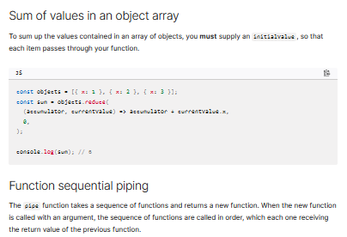

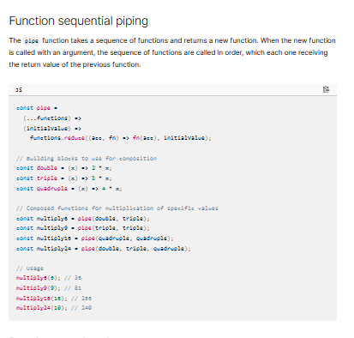

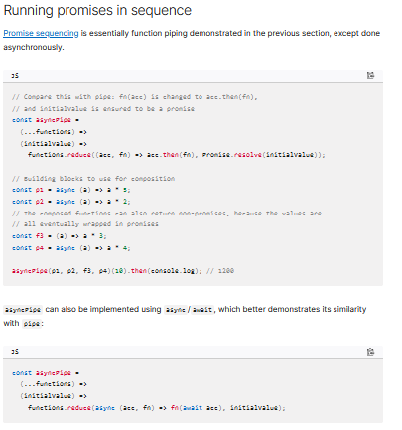

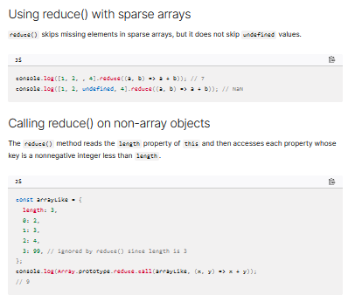

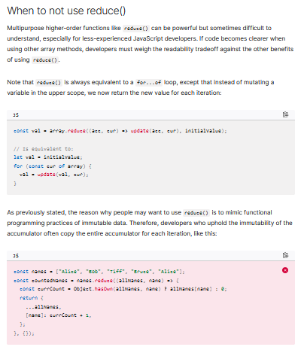

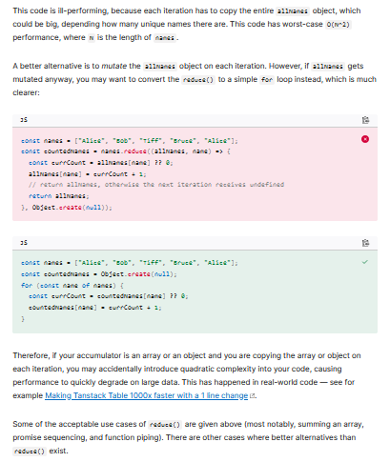

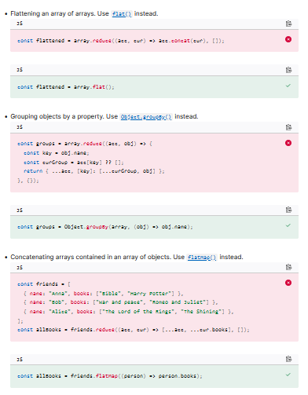

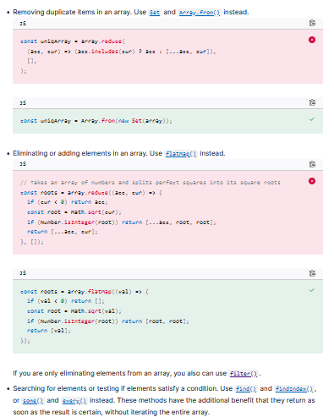

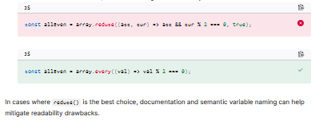

### Check Your Understanding

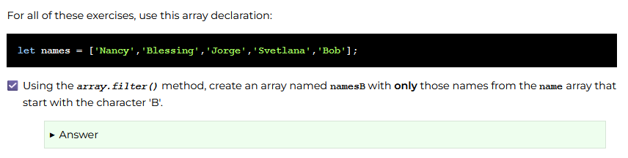

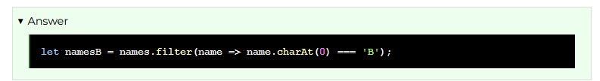

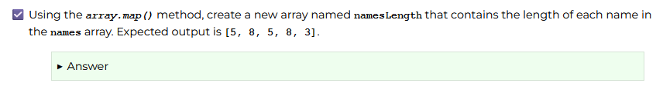

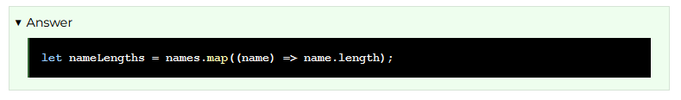

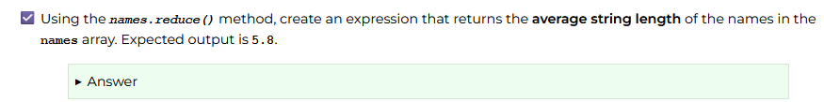

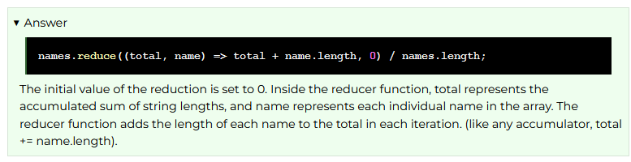

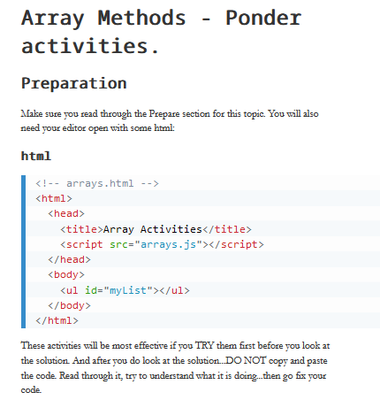

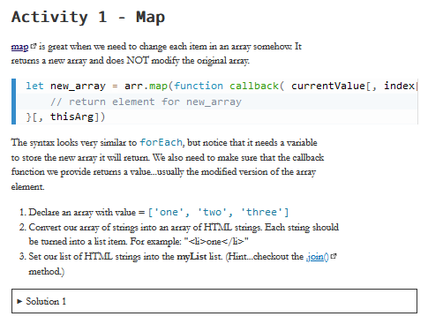

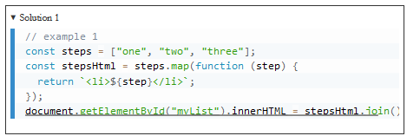

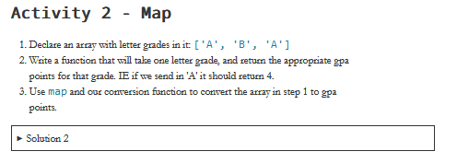

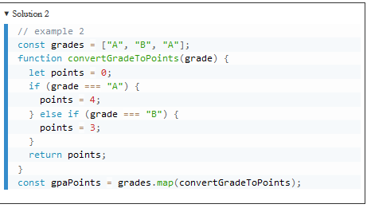

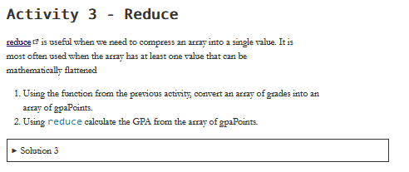

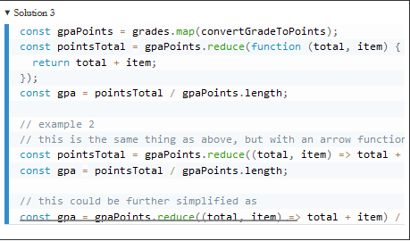

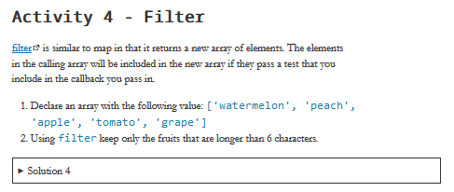

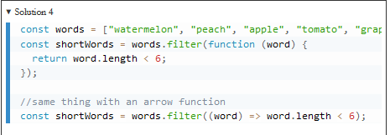

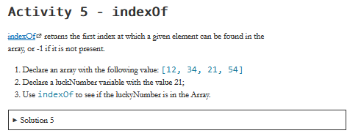

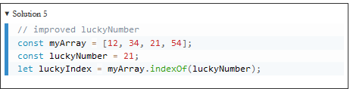

## Event Handling

### Overview

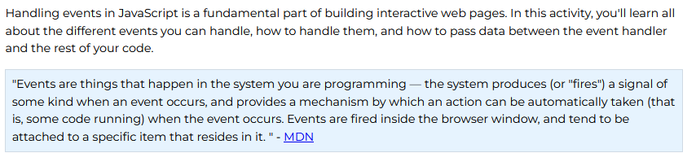

### Prepare

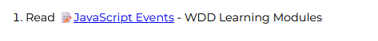

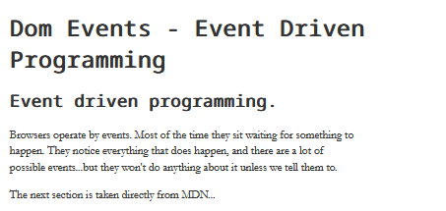

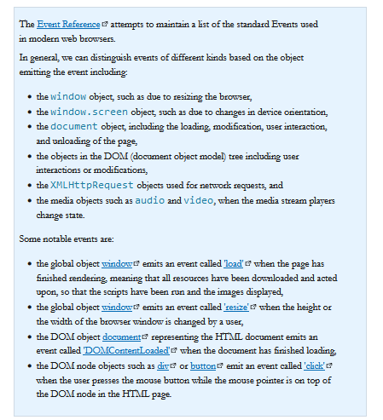

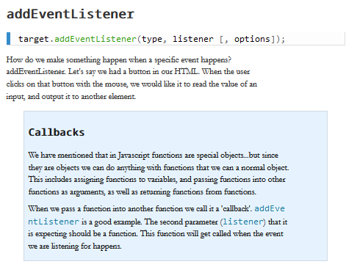

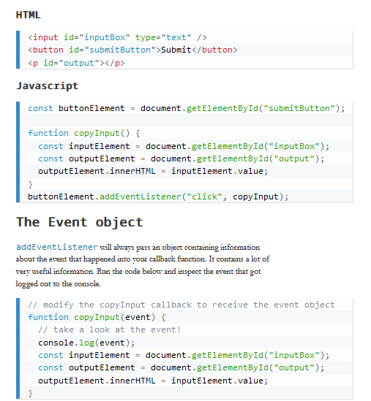

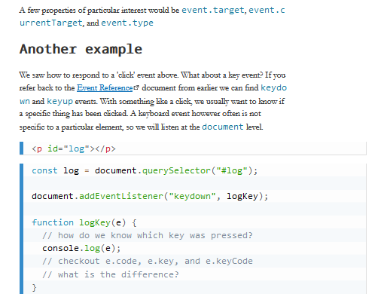

### Check Your Understanding



